SEC Form 3
FORM 3 | UNITED STATES SECURITIES AND EXCHANGE COMMISSION  Washington, D.C. 20549  INITIAL STATEMENT OF BENEFICIAL OWNERSHIP OF SECURITIES  Filed pursuant to Section 16(a) of the Securities Exchange Act of 1934  or Section 30(h) of the Investment Company Act of 1940
  OMB APPROVAL
  OMB Number: | 3235-0104
  Estimated average burden
  hours per response: | 0.5
1. Name and Address of Reporting Person*  (Street) | 2. Date of Event Requiring Statement (Month/Day/Year)  09/14/2026 | 3. Issuer Name and Ticker or Trading Symbol  ASBURY AUTOMOTIVE GROUP INC [ ABG ]  Foreign Trading Symbol
  Reynolds-Dobbs Wendy
  (Last) | (First) | (Middle)
  C/O ASBURY AUTOMOTIVE GROUP
  6655 PEACHTREE DUNWOODY ROAD
  ATLANTA | GA | 30328
  (City) | (State) | (Zip)
 |  | 4. Relationship of Reporting Person(s) to Issuer  (Check all applicable) | 5. If Amendment, Date of Original Filed (Month/Day/Year)
   | Director |  | 10% Owner
   | Officer (give title below) |  | Other (specify below)
  SVP & CHRO
6. Individual or Joint/Group Filing (Check Applicable Line)
Form filed by One Reporting Person
Form filed by More than One Reporting Person

Table I - Non-Derivative Securities Beneficially Owned
1. Title of Security (Instr. 4) | 2. Amount of Securities Beneficially Owned (Instr. 4) | 3. Ownership Form: Direct (D) or Indirect (I) (Instr. 5) | 4. Nature of Indirect Beneficial Ownership (Instr. 5)
Common Stock | 3,583(1) | D
Table II - Derivative Securities Beneficially Owned
(e.g., puts, calls, warrants, options, convertible securities)
1. Title of Derivative Security (Instr. 4) | 2. Date Exercisable and Expiration Date (Month/Day/Year) |  | 3. Title and Amount of Securities Underlying Derivative Security (Instr. 4) |  | 4. Conversion or Exercise Price of Derivative Security | 5. Ownership Form: Direct (D) or Indirect (I) (Instr. 5) | 6. Nature of Indirect Beneficial Ownership (Instr. 5)
1. Title of Derivative Security (Instr. 4) | Date Exercisable | Expiration Date | Title | Amount or Number of Shares | 4. Conversion or Exercise Price of Derivative Security | 5. Ownership Form: Direct (D) or Indirect (I) (Instr. 5) | 6. Nature of Indirect Beneficial Ownership (Instr. 5)
Explanation of Responses:
1. Includes 1,255 unvested restricted share units and 494 unvested Performance Share Units, for which performance achievement has been certified (i.e., those granted on February 20, 2024 and February 19, 2025). Each restricted share unit and performance share unit converts into one share of the Issuer's common stock upon vesting. Vesting will occur as follows: 240 shares will vest on February 9, 2027; 340 shares will vest on February 19, 2027; 347 shares will vest on February 20, 2027; 241 shares will vest on February 9, 2028; 340 shares will vest on February 19, 2028; and 241 shares will vest on February 9, 2029.
Remarks:
Exhibit 24.1 Power of Attorney
 | /s/Dean Calloway, Attorney In-Fact | 09/16/2026
 | ** Signature of Reporting Person | Date
Reminder: Report on a separate line for each class of securities beneficially owned directly or indirectly.
* If the form is filed by more than one reporting person, see Instruction 5 (b)(v).
** Intentional misstatements or omissions of facts constitute Federal Criminal Violations See 18 U.S.C. 1001 and 15 U.S.C. 78ff(a).
Note: File three copies of this Form, one of which must be manually signed. If space is insufficient, see Instruction 6 for procedure.
Persons who respond to the collection of information contained in this form are not required to respond unless the form displays a currently valid OMB Number.
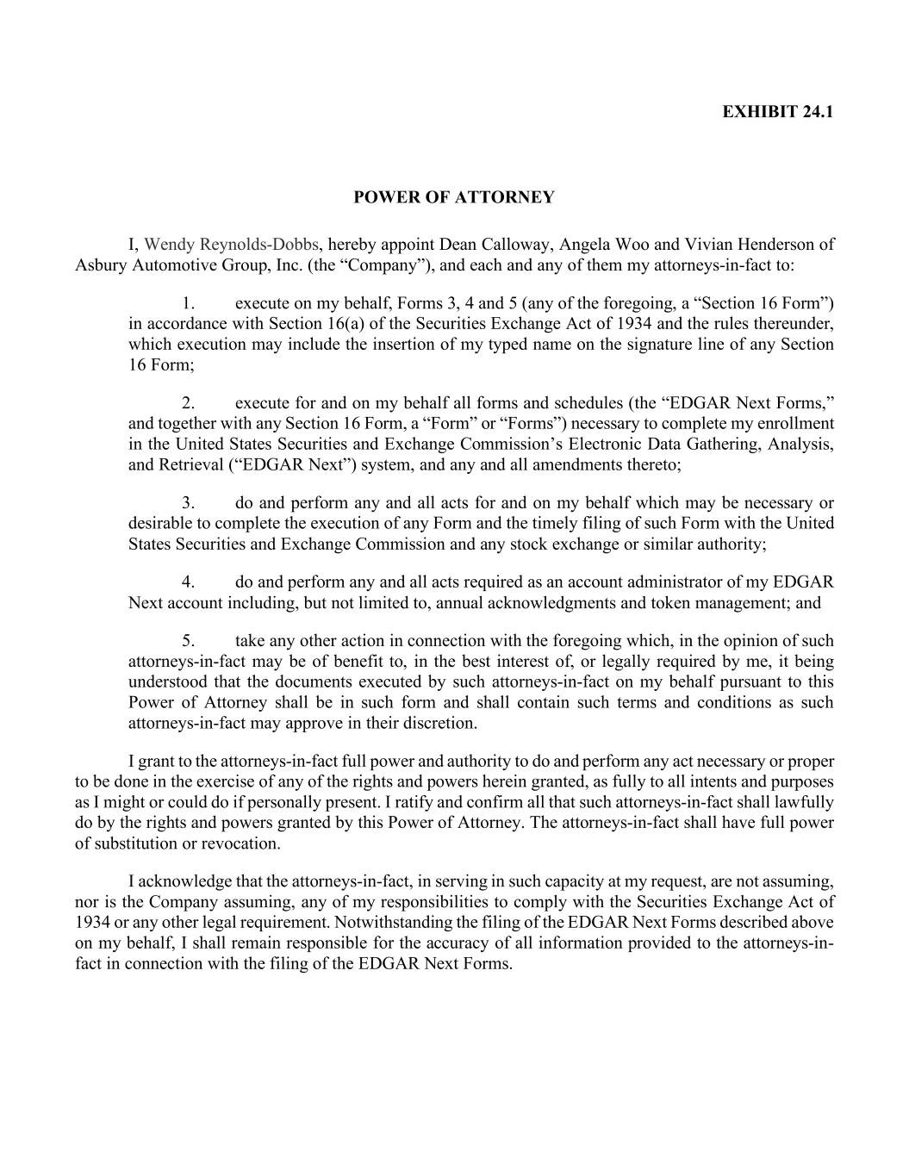
EXHIBIT 24.1 POWER OF ATTORNEY I, Wendy Reynolds-Dobbs, hereby appoint Dean Calloway, Angela Woo and Vivian Henderson of Asbury Automotive Group, Inc. (the “Company”), and each and any of them my attorneys-in-fact to: 1. execute on my behalf, Forms 3, 4 and 5 (any of the foregoing, a “Section 16 Form”) in accordance with Section 16(a) of the Securities Exchange Act of 1934 and the rules thereunder, which execution may include the insertion of my typed name on the signature line of any Section 16 Form; 2. execute for and on my behalf all forms and schedules (the “EDGAR Next Forms,” and together with any Section 16 Form, a “Form” or “Forms”) necessary to complete my enrollment in the United States Securities and Exchange Commission’s Electronic Data Gathering, Analysis, and Retrieval (“EDGAR Next”) system, and any and all amendments thereto; 3. do and perform any and all acts for and on my behalf which may be necessary or desirable to complete the execution of any Form and the timely filing of such Form with the United States Securities and Exchange Commission and any stock exchange or similar authority; 4. do and perform any and all acts required as an account administrator of my EDGAR Next account including, but not limited to, annual acknowledgments and token management; and 5. take any other action in connection with the foregoing which, in the opinion of such attorneys-in-fact may be of benefit to, in the best interest of, or legally required by me, it being understood that the documents executed by such attorneys-in-fact on my behalf pursuant to this Power of Attorney shall be in such form and shall contain such terms and conditions as such attorneys-in-fact may approve in their discretion. I grant to the attorneys-in-fact full power and authority to do and perform any act necessary or proper to be done in the exercise of any of the rights and powers herein granted, as fully to all intents and purposes as I might or could do if personally present. I ratify and confirm all that such attorneys-in-fact shall lawfully do by the rights and powers granted by this Power of Attorney. The attorneys-in-fact shall have full power of substitution or revocation. I acknowledge that the attorneys-in-fact, in serving in such capacity at my request, are not assuming, nor is the Company assuming, any of my responsibilities to comply with the Securities Exchange Act of 1934 or any other legal requirement. Notwithstanding the filing of the EDGAR Next Forms described above on my behalf, I shall remain responsible for the accuracy of all information provided to the attorneys-in- fact in connection with the filing of the EDGAR Next Forms.

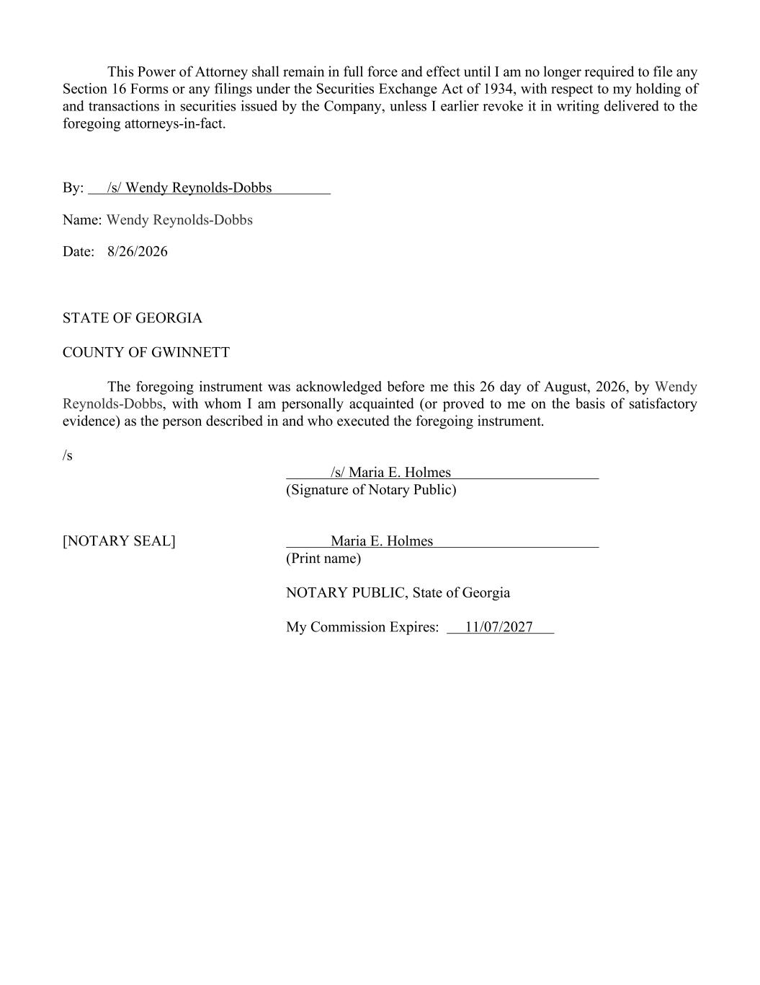
This Power of Attorney shall remain in full force and effect until I am no longer required to file any Section 16 Forms or any filings under the Securities Exchange Act of 1934, with respect to my holding of and transactions in securities issued by the Company, unless I earlier revoke it in writing delivered to the foregoing attorneys-in-fact. By: /s/ Wendy Reynolds-Dobbs Name: Wendy Reynolds-Dobbs Date: 8/26/2026 STATE OF GEORGIA COUNTY OF GWINNETT The foregoing instrument was acknowledged before me this 26 day of August, 2026, by Wendy Reynolds-Dobbs, with whom I am personally acquainted (or proved to me on the basis of satisfactory evidence) as the person described in and who executed the foregoing instrument. /s /s/ Maria E. Holmes (Signature of Notary Public) [NOTARY SEAL] Maria E. Holmes (Print name) NOTARY PUBLIC, State of Georgia My Commission Expires: 11/07/2027

