UNITED STATES
SECURITIES AND EXCHANGE COMMISSION
WASHINGTON, DC 20549
SCHEDULE 14A
Proxy Statement Pursuant to Section 14(a) of the
Securities Exchange Act of 1934
(Amendment No. )
☑ |  |  | Filed by the Registrant
☐ |  |  | Filed by a Party other than the Registrant
Check the appropriate box:
☐ |  |  | Preliminary Proxy Statement
☐ |  |  | Confidential, for Use of the Commission Only (as permitted by Rule 14a-6(e)(2))
☑ |  |  | Definitive Proxy Statement
☐ |  |  | Definitive Additional Materials
☐ |  |  | Soliciting Material Pursuant to §240.14a-12

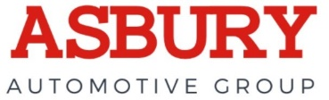
Asbury Automotive Group, Inc.
(Name of Registrant as Specified In Its Charter)
(Name of Person(s) Filing Proxy Statement, if other than the Registrant)
Payment of Filing Fee (Check the appropriate box):
☑ |  |  | No fee required
☐ |  |  | Fee paid previously with preliminary materials.
☐ |  |  | Fee computed on table in exhibit required by Item 25(b) per Exchange Act Rules 14a-6(i)(1) and 0-11.

Asbury Automotive Group, Inc.
6655 Peachtree Dunwoody Road
Atlanta, GA 30328
(770) 418-8200

March 24, 2026

Dear Stockholders,
On behalf of the Board of Directors and management of Asbury Automotive Group, Inc., we cordially invite you to attend our 2026 Annual Meeting of Stockholders.
As you know, an important aspect of the annual meeting process is the vote by stockholders on corporate business. The matters to be voted on are described in the notice of meeting and the proxy statement. We value your vote and urge you to exercise your rights as a stockholder to vote. Whether or not you plan to attend the meeting, please read the enclosed proxy statement and complete, sign and date the enclosed proxy card and return it as promptly as possible in the accompanying postage paid envelope or vote by telephone or the Internet. This will ensure that your shares are represented at the meeting
Sincerely,
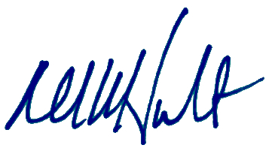
David W. Hult
President, Chief Executive Officer and Director

YOUR VOTE IS IMPORTANT

Asbury Automotive Group, Inc.
6655 Peachtree Dunwoody Road
Atlanta, GA 30328

NOTICE OF THE 2026 ANNUAL MEETING OF STOCKHOLDERS
AND IMPORTANT NOTICE REGARDING THE AVAILABILITY OF PROXY MATERIALS
FOR THE ANNUAL MEETING OF STOCKHOLDERS
TO BE HELD ON MAY 4, 2026
To Our Stockholders:
The 2026 Annual Meeting of Stockholders of Asbury Automotive Group, Inc. (the “2026 Annual Meeting”) will be held at our corporate headquarters located at 6655 Peachtree Dunwoody Road, Atlanta, GA 30328 on May 4, 2026, at 12:00 p.m., Eastern Time, for the purpose of considering and acting upon the following proposals:
 |  |  | Proposal 1: |  |  | election of eleven director nominees to hold office until the 2027 Annual Meeting of Stockholders or until their successors are duly elected and qualified;
 |  |  | Proposal 2: |  |  | approval, on an advisory basis, of the compensation of our named executive officers;
 |  |  | Proposal 3: |  |  | ratification of the appointment of Ernst & Young LLP as our independent registered public accounting firm for the year ending December 31, 2026;
 |  |  | Proposal 4: |  |  | approval to amend our Amended and Restated Certificate of Incorporation (the "Charter") to eliminate supermajority voting requirements;
 |  |  | Proposal 5: |  |  | stockholder proposal regarding special stockholder meetings; and
 |  |  | Proposal 6: |  |  | any other matters that may properly come before the 2026 Annual Meeting or any adjournments or postponements of the 2026 Annual Meeting.
Only stockholders of record, as of 5:00 p.m., Eastern Time, on March 18, 2026 (the "Record Date") are entitled to notice of, to attend, and to vote at, the 2026 Annual Meeting and any adjournments or postponements of the 2026 Annual Meeting. A list of these stockholders will be available for inspection by stockholders during normal business hours during the ten-day period immediately prior to the 2026 Annual Meeting at our corporate headquarters located at 6655 Peachtree Dunwoody Road, Atlanta, GA 30328.
Your vote is important. Please vote as promptly as possible using any of the following methods:
 |  |  | Internet: |  |  | Visit www.ProxyVote.com. You will need the control number included in your proxy card, voter instruction form or notice.
 |  |  | Phone: |  |  | Call 1-800-690-6903 or the number on your voter instruction form. You will need the control number included in your proxy card, voter instruction form or notice.
 |  |  | Mail: |  |  | Send your completed and signed proxy card or voter instruction form to the address on your proxy card or voter instruction form.
 |  |  | In Person: |  |  | Stockholders of record who attend the 2026 Annual Meeting and wish to vote in person will be given a ballot at the meeting. All other stockholders (those whose shares are held in the name of your bank, broker or other nominee) will need to obtain a proxy from the institution that holds your shares indicating that you were the beneficial owner of our common stock as of the Record Date for the 2026 Annual Meeting.
This proxy statement and the Company’s 2025 Annual Report on Form 10-K are available on the Internet at www.proxyvote.com.
BY ORDER OF THE BOARD OF DIRECTORS,
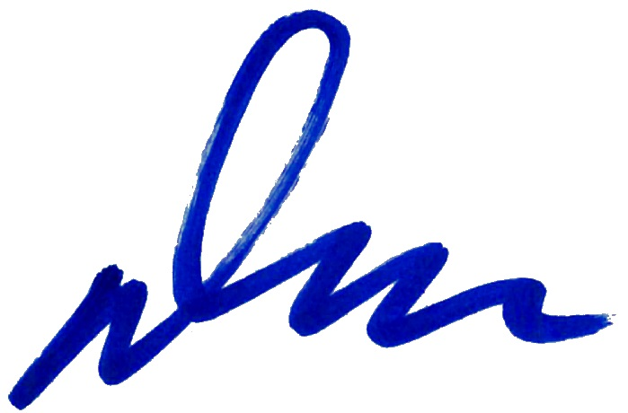
Dean A. Calloway
Senior Vice President, General Counsel & Secretary

TABLE OF CONTENTS
INFORMATION ABOUT THE MEETING |  |  | 1
SECURITIES OWNED BY MANAGEMENT & CERTAIN BENEFICIAL OWNERS |  |  | 4
Equity Ownership Guidelines |  |  | 6
Policy Regarding Hedging or Pledging of Asbury Stock |  |  | 6
Insider Trading Policy |  |  | 6
Delinquent Section 16(a) Reports |  |  | 6
PROPOSAL 1 - ELECTION OF DIRECTORS |  |  | 7
GOVERNANCE OF THE COMPANY |  |  | 15
Board Leadership Structure |  |  | 15
Independence of Directors |  |  | 15
Committees of the Board |  |  | 16
Code of Business Conduct and Ethics and Corporate Governance Guidelines |  |  | 18
The Board’s Risk Oversight Role |  |  | 18
Corporate Responsibility |  |  | 18
Nomination of Directors |  |  | 19
Service Limitations |  |  | 20
Communications with the Board |  |  | 21
Related Person Transactions |  |  | 21
DIRECTOR COMPENSATION |  |  | 22
Director Fees |  |  | 22
Meeting Attendance |  |  | 22
2025 Director Compensation Table |  |  | 23
EXECUTIVE OFFICERS |  |  | 24
COMPENSATION DISCUSSION & ANALYSIS |  |  | 25
Overview |  |  | 25
Incentive Compensation Programs |  |  | 26
Compensation Philosophy & Guidelines |  |  | 26
Elements of Compensation |  |  | 27
Total Compensation Program Supporting Attainment of Operating & Strategic Imperatives |  |  | 27
Policies and Practices |  |  | 28
The Role of Stockholder Say-on-Pay Votes and Related Considerations |  |  | 29
Independent Compensation Consultant |  |  | 29
Reviewing Executive Compensation |  |  | 29
Additional Considerations in Making Executive Compensation Decisions |  |  | 30
Review of 2025 Total Compensation |  |  | 30
Employment, Severance and Change in Control Arrangements |  |  | 36
Tax Treatment of Certain Compensation |  |  | 36
BLE OF CONTENTS
COMPENSATION & HUMAN RESOURCES COMMITTEE REPORT |  |  | 37
COMPENSATION COMMITTEE INTERLOCKS & INSIDER PARTICIPATION |  |  | 37
EXECUTIVE COMPENSATION |  |  | 38
2025 Summary Compensation Table |  |  | 38
2025 Grants of Plan-Based Awards |  |  | 39
Outstanding Equity Awards at 2025 Fiscal Year-End |  |  | 40
2025 Option Exercises and Stock Vested |  |  | 41
POTENTIAL PAYMENTS UPON TERMINATION OR CHANGE IN CONTROL |  |  | 42
CEO PAY RATIO |  |  | 46
PAY VERSUS PERFORMANCE |  |  | 47
SECURITIES AUTHORIZED FOR ISSUANCE UNDER EQUITY COMPENSATION PLANS |  |  | 50
PROPOSAL 2 - ADVISORY APPROVAL OF NAMED EXECUTIVE OFFICER COMPENSATION |  |  | 51
AUDIT COMMITTEE REPORT |  |  | 52
PROPOSAL 3 - RATIFICATION OF APPOINTMENT OF INDEPENDENT REGISTERED PUBLIC ACCOUNTING FIRM |  |  | 53
Independent Registered Public Accounting Firm Fees |  |  | 53
Audit Committee’s Pre-Approval Policies and Procedures |  |  | 53
PROPOSAL 4 - APPROVAL TO AMEND OUR CHARTER TO ELIMINATE SUPERMAJORITY PROVISIONS |  |  | 54
STOCKHOLDER PROPOSAL |  |  | 56
OTHER MATTERS |  |  | 58
Stockholder Proposals for the 2027 Annual Meeting |  |  | 58
Compliance with Universal Proxy Rules for Director Nominations |  |  | 58
Delivery of Proxy Materials to Households |  |  | 58
Additional Information |  |  | 58
APPENDIX A |  |  | 60
APPENDIX B |  |  | 63

Table of Contents
Asbury Automotive Group, Inc.
6655 Peachtree Dunwoody Road
Atlanta, GA 30328

PROXY STATEMENT
This proxy statement is furnished in connection with the solicitation of proxies by Asbury Automotive Group, Inc. (“Asbury”, the “Company”, “we”, “us” or “our”) on behalf of the Board of Directors (the “Board”) for the 2026 Annual Meeting of Stockholders (the "2026 Annual Meeting"), including all adjournments or postponements of the 2026 Annual Meeting. The accompanying Notice of the 2026 Annual Meeting and Important Notice Regarding the Availability of Proxy Materials for the 2026 Annual Meeting to be held on May 4, 2026, this proxy statement and proxy card are first being mailed to stockholders, and made available on the Internet, on or about March 24, 2026. A copy of the Company’s Annual Report on Form 10-K for the year ended December 31, 2025 is included with these materials.

INFORMATION ABOUT THE MEETING
What is the purpose of the 2026 Annual Meeting?
At the 2026 Annual Meeting, stockholders will be asked to consider and vote on the following proposals:
Proposal |  |  | Matter |  |  | Board Vote Recommendations
1 |  |  | Election of Directors |  |  | FOR each nominee
2 |  |  | Approval, on an advisory basis, of the 2025 compensation of our named executive officers |  |  | FOR
3 |  |  | Ratification of the appointment of Ernst & Young LLP as our independent registered public accounting firm for the year ending December 31, 2026 |  |  | FOR
4 |  |  | Approval to amend our Charter to eliminate supermajority voting requirements |  |  | FOR
5 |  |  | Stockholder proposal regarding special stockholder meetings |  |  | AGAINST
We will also transact any other business that may properly come before the 2026 Annual Meeting. Representatives from our independent registered public accounting firm, Ernst & Young LLP, are expected to be present at the meeting to make a statement if they so desire and to respond to appropriate questions from stockholders.
Who is entitled to vote?
The record date for the 2026 Annual Meeting is March 18, 2026 (the "Record Date"). Only stockholders of record as of 5:00 p.m., Eastern Time, on the Record Date are entitled to notice of, and to vote at, the 2026 Annual Meeting. Attendance at the 2026 Annual Meeting will be limited to such stockholders of record, beneficial owners having evidence of ownership on the Record Date, their proxies and approved representatives.
Our sole outstanding class of capital stock is our common stock, par value $0.01 per share. Except as otherwise required by law, or as described in this proxy statement, each holder of our common stock is entitled to one vote per share with respect to each director nominee and on each other matter submitted at the 2026 Annual Meeting. As of the Record Date, there were 19,295,721 shares of our common stock issued and outstanding and entitled to vote on each matter to be voted upon at the 2026 Annual Meeting.
How many shares must be present to hold the 2026 Annual Meeting?
A quorum must be present at the 2026 Annual Meeting for any business to be conducted. The presence at the 2026 Annual Meeting, in person or by proxy, of at least 9,647,861 shares, which represents a majority of the shares of common stock outstanding on the Record Date, will constitute a quorum. Proxies received but marked as abstentions or broker non-votes will be counted for the purpose of determining the presence of a quorum.
What if a quorum is not present at the 2026 Annual Meeting?
If a quorum is not present at the scheduled time of the 2026 Annual Meeting, the chair of the 2026 Annual Meeting may adjourn or postpone the 2026 Annual Meeting until a quorum is present. The time and place of the adjourned or postponed 2026 Annual Meeting will be announced at the time the adjournment or postponement is taken, and, unless
1
Table of Contents
such adjournment or postponement is for more than 30 days, no other notice will be given. An adjournment or postponement will have no effect on the business that may be conducted at the 2026 Annual Meeting.
How do I vote?
* |  |  | You may vote by mail. If you properly complete and sign the accompanying proxy card or voter instruction form and return it in the enclosed envelope, your shares will be voted in accordance with your instructions. The enclosed envelope requires no additional postage if mailed in the United States.
( |  |  | You may vote by telephone. If you are a stockholder of record (your shares are registered directly in your name with our transfer agent), you may vote by telephone at 1-800-690-6903. If your shares are held in “street name” by a bank, broker or other nominee, you may also be able to vote by phone. Please check the voting instruction form provided by your bank, broker or other nominee to see if it offers this option.
: |  |  | You may vote by Internet. Stockholders of record may vote via the Internet at www.proxyvote.com by following the voting instructions on the proxy card. If your shares are held in “street name” by a bank, broker or other nominee, you may also be able to vote by Internet. Please check the voting instruction form provided by your bank, broker or other nominee to see if it offers this option.
m |  |  | You may vote in person at the 2026 Annual Meeting. If you are a stockholder of record and attend the 2026 Annual Meeting and wish to vote in person, you will be given a ballot at the meeting. However, if your shares are held in the name of your bank, broker or other nominee, you will need to obtain a proxy from the institution that holds your shares indicating that you were the beneficial owner of our common stock as of the Record Date for the 2026 Annual Meeting. Please contact the bank, broker or other nominee holding your shares directly if you would like to obtain a proxy to vote your shares directly at the 2026 Annual Meeting. Even if you plan to attend the 2026 Annual Meeting, please complete, sign and return your proxy card, or vote by telephone or the Internet, to ensure that your shares are represented. If you attend the 2026 Annual Meeting, any votes you cast at the meeting will supersede your proxy.
Can I change my vote after I submit my proxy?
Yes, you may revoke your proxy and change your vote at any time before the polls close at the 2026 Annual Meeting by:
–signing and properly submitting another proxy with a later date;
–voting by telephone or the Internet;
–giving written notice of the revocation of your proxy, which must be received by our Corporate Secretary at our corporate headquarters prior to the 2026 Annual Meeting; or
–voting in person at the 2026 Annual Meeting.
What if I return an executed proxy but do not specify how my shares are to be voted?
If you properly execute and return your proxy but do not indicate any voting instructions with respect to one or more matters to be voted upon at the 2026 Annual Meeting, or if your voting instructions are unclear, your shares will be voted in accordance with the recommendation of the Board as to all such matters.
What are abstentions, broker non-votes and withheld votes, and how are they treated?
A share voted "abstain" with respect to any proposal is considered present and entitled to vote with respect to that proposal and will be included for purposes of calculating the presence of a quorum at the 2026 Annual Meeting. You may abstain from voting on any proposal to be voted on at the 2026 Annual Meeting other than the election of directors, which by virtue of the vote required to approve such proposal, does not provide for abstentions under applicable law.
A broker non-vote with respect to a proposal occurs when shares are held by a bank, broker or other nominee in "street name", and the bank, broker or other nominee does not receive voting instructions from the beneficial owner of these shares as to how to vote such shares, and the bank, broker or other nominee does not have the authority to exercise discretion to vote on such proposal. Banks, brokers and other nominees are only able to, but are not required to, exercise discretionary voting authority on routine matters. The proposal related to the ratification of our independent registered public accounting firm (Proposal 3) is the only item on the agenda for the 2026 Annual Meeting that is considered a routine matter. If a bank, broker or other nominee does not receive specific voting instructions with respect to one or more non-routine matters, such nominee may not cast a vote on the proposal, resulting in a broker non-vote. Broker non-votes will be included for purposes of calculating the presence of a quorum at the 2026 Annual Meeting.
With respect to the election of directors (Proposal 1), our directors are elected by a plurality of the votes cast but are subject to our director voting policy set forth in our Corporate Governance Guidelines, which can be found on our website at https://investors.asburyauto.com/corporate-governance. If you vote "withhold" with respect to the election of one or more nominees, your shares will not be voted with respect to those nominees. "Withheld" votes will be counted for
2
Table of Contents
purposes of determining whether there is a quorum and will have a similar effect as a vote "against" that director nominee under our director voting policy.
What vote is required to approve each proposal at the 2026 Annual Meeting?
The table below describes the vote required for approval of each matter to be brought before the 2026 Annual Meeting, as well as the treatment of abstentions, broker non-votes and withheld votes.
Proposal |  |  | Vote Required |  |  | Treatment  of  Abstentions |  |  | Treatment  of Broker  Non-Votes |  |  | Treatment of Withheld Votes
Election of Directors |  |  | Each nominee must receive the affirmative vote of a plurality of the votes cast* |  |  | Not Applicable |  |  | No Effect |  |  | Against
Advisory Approval of Executive Compensation |  |  | The affirmative vote of the holders of a majority of the voting power of shares present in person or represented by proxy and entitled to vote |  |  | Against |  |  | No Effect |  |  | Not Applicable
Ratification of Independent Registered Public Accounting Firm |  |  | The affirmative vote of the holders of a majority of the voting power of shares present in person or represented by proxy and entitled to vote |  |  | Against |  |  | No Effect |  |  | Not Applicable
Approval to Amend our Charter to Eliminate Supermajority Provisions |  |  | The affirmative vote of the holders of at least 80% of the voting power of the common stock then outstanding as of the Record Date, voting together as a single class |  |  | Against |  |  | Against |  |  | Not Applicable
Stockholder Proposal regarding Special Stockholder Meetings |  |  | The affirmative vote of the holders of a majority of the voting power of shares present in person or represented by proxy and entitled to vote |  |  | Against |  |  | No Effect |  |  | Not Applicable
*While directors are elected by a plurality of votes cast, our Corporate Governance Guidelines include a director voting policy. This policy provides that in an uncontested election, any nominee for director who is a current director and who receives a greater number of votes “withheld” from their election than votes “for” their election shall tender their resignation as a director to the Board promptly following the certification of the election results. The Governance & Nominating Committee will consider each resignation tendered and recommend to the Board whether to accept or reject it. The Board will act on each tendered resignation within 90 days following the certification of the election results.
Only votes “for” or “withheld” are counted in determining whether a plurality has been cast in favor of a director nominee. If you vote “Withhold” with respect to the election of one or more nominees, your shares will not be voted with respect to those nominees. For a “withheld” vote, your shares will be counted for purposes of determining whether there is a quorum and will have a similar effect as a vote “against” that director nominee under our director voting policy. Broker non-votes will not be deemed to be votes “for” or “against” a director nominee.
Will any other business be conducted at the 2026 Annual Meeting?
The Board is not aware of any other business that will be presented at the 2026 Annual Meeting. If any other business properly comes before the stockholders for a vote at the 2026 Annual Meeting, the proxy holders will vote the shares for which they have been granted a proxy as recommended by our Board, or if no recommendation is given, in accordance with their own discretion.
Who pays for the costs of soliciting proxies?
We will pay the cost of soliciting proxies, including the expenses of preparing, printing and mailing the proxy materials to stockholders. We have retained Innisfree M&A Incorporated to aid in the broker search and the solicitation of proxies for a fee of approximately $16,500, plus reasonable out-of-pocket expenses and disbursements. We will also reimburse brokerage firms and other custodians, nominees and fiduciaries for reasonable expenses incurred by them in sending proxy materials to the beneficial owners of our common stock. Our directors, officers and other employees may also solicit proxies without additional compensation. This solicitation may be in person or by telephone, email or other electronic communication methods.

3
Table of Contents
SECURITIES OWNED BY MANAGEMENT & CERTAIN BENEFICIAL OWNERS
The following table sets forth certain information as of the Record Date with respect to the beneficial ownership of shares of the Company’s common stock by (i) each of our directors and director nominees, (ii) each of our named executive officers, and (iii) our directors and executive officers as a group. In addition, the table sets forth information about all other persons known to the Company to be the beneficial owner of more than five percent of the Company’s common stock. Except as set forth below, the following information is given as of the Record Date. In the case of percentage ownership, the information is based on 19,295,721 shares of the Company’s common stock being outstanding as of the Record Date.
Name of Beneficial Owner |  |  | Shares Beneficially Owned(†)
 |  |  | Number |  |  | %
Principal Stockholders
BlackRock, Inc.(1) |  |  | 2,935,074 |  |  | 15.2 |  | %
The Vanguard Group(2) |  |  | 2,319,293 |  |  | 12.0 |  | %
Abrams Capital Management, LP(3) |  |  | 2,116,040 |  |  | 11.0 |  | %
Impactive Capital LP(4) |  |  | 1,247,027 |  |  | 6.5 |  | %
Dimensional Fund Advisors LP(5) |  |  | 1,098,488 |  |  | 5.7 |  | %
Eminence Capital, LP(6) |  |  | 972,405 |  |  | 5.0 |  | %
Current Directors, Including Director Nominees
Joel Alsfine |  |  | 9,979 |  |  | *
Daniel E. Clara |  |  | 3,816 |  |  | *
B. Christopher DiSantis |  |  | 6,243 |  |  | *
William D. Fay |  |  | 4,367 |  |  | *
David W. Hult |  |  | 55,420 |  |  | *
Juanita T. James |  |  | 7,396 |  |  | *
Philip F. Maritz |  |  | 7,864 |  |  | *
Maureen F. Morrison |  |  | 6,756 |  |  | *
Shamla Naidoo |  |  | 1,068 |  |  | *
Thomas J. Reddin |  |  | 11,470 |  |  | *
Bridget Ryan-Berman |  |  | 7,897 |  |  | *
Hilliard C. Terry, III |  |  | 3,889 |  |  | *
Named Executive Officers Who Are Not Directors or Director Nominees
Dean A. Calloway |  |  | 3,083 |  |  | *
Jed M. Milstein |  |  | 6,948 |  |  | *
Michael D. Welch |  |  | 9,122 |  |  | *
Current Directors & Executive Officers
As a group (15 persons) |  |  | 145,318 |  |  | *
(†)The number of shares beneficially owned is determined under rules promulgated by the Securities and Exchange Commission (the “SEC”), and the information is not necessarily indicative of beneficial ownership for any other purpose. Under such rules, beneficial ownership includes any shares as to which the individual has sole or shared voting power or investment power and also any shares which the individual has the right to acquire within 60 days after the Record Date, including shares issuable upon the vesting of performance share units and restricted share units within 60 days after the Record Date. Inclusion in the table of such shares, however, does not constitute an admission that the director, director-nominee, named executive officer or other executive officer is a direct or indirect beneficial owner of such shares. Except as otherwise indicated, the persons listed in the table have sole voting and investment power with respect to the securities included in the table.
(*)Denotes less than 1% of the Company’s common stock.
(1)Based on a Schedule 13G/A filed with the SEC on April 30, 2025. BlackRock, Inc. has sole voting power with respect to 2,898,782 shares and sole dispositive power with respect to 2,935,074 shares. The business address of BlackRock, Inc. is 50 Hudson Yards, New York, NY 10001.
4
Table of Contents
(2)Based on a Schedule 13G/A filed with the SEC on February 13, 2024. The Vanguard Group has sole dispositive power with respect to 2,282,674 shares, shared voting power with respective to 15,658 shares and shared dispositive power with respect to 36,619 shares. The business address of The Vanguard Group is 100 Vanguard Boulevard, Malvern, PA 19355.
(3)Based on a Schedule 13G/A filed with the SEC on February 9, 2024 by Abrams Capital Management L.P. (“Abrams CM LP”). Represents shares owned by and on behalf of each of Abrams Capital Partners II, L.P. (“ACP II”), Abrams Capital, LLC (“Abrams Capital”), Abrams Capital Management, LLC (“Abrams CM LLC”), Abrams CM LP and David Abrams. Abrams Capital serves as general partner for a number of private investment funds. Abrams CM LP serves as investment manager for a number of private investment funds. Abrams CM LLC is the general partner of Abrams CM LP. Mr. Abrams is the managing member of Abrams Capital and Abrams CM LLC and may be deemed to have voting and dispositive power over shares held for the accounts of the private investment funds managed by him. ACP II has shared voting and dispositive power with respect to 1,716,441 shares. Abrams Capital has shared voting and dispositive power with respect to 2,025,144 shares. Abrams CM LLC and Abrams CM LP have shared voting and dispositive power with respect to 2,108,540 shares. Mr. Abrams has shared voting and dispositive power with respect to all 2,116,040 shares. The business address of ACP II, Abrams Capital, Abrams CM LLC, Abrams CM LP and Mr. Abrams is 222 Berkeley Street, 21st Floor, Boston, MA 02116.
(4)Based on a Schedule 13D/A filed with the SEC on June 24, 2025 by (i) Impactive Capital LP, a Delaware limited partnership ("Impactive Capital"), as the investment manager of certain funds and/or accounts (the "Impactive Funds"), with respect to the Shares directly owned by the Impactive Funds, (ii) Impactive Capital LLC, a Delaware limited liability company ("Impactive Capital GP"), as the general partner of Impactive Capital, and (iii) Lauren Taylor Wolfe and Christian Asmar, each a Managing Member of Impactive Capital GP. The reporting entities and persons each reported the shared voting power and shared dispositive power with respect to 1,247,027 shares. The business address for the reporting entities and persons is 450 West 14th Street, 12th Floor, New York, New York 10014.
(5)Based on a Schedule 13G filed with the SEC on October 31, 2024 by Dimensional Fund Advisors, L.P. ("Dimensional Fund"). Dimensional Fund has sole voting power with respect to 1,064,939 shares and sole dispositive power with respect to 1,098,488 shares. The business address of Dimensional Fund is 6300 Bee Cave Road, Building One, Austin, TX 78746.
(6)Based on a Schedule 13G/A filed with the SEC on November 14, 2025 by Eminence Capital, LP (“Eminence Capital”). Eminence Capital has shared voting power with respect to 972,405 shares and shared dispositive power with respect to 972,405 shares. The business address of Eminence Capital is 399 Park Avenue, 25th Floor, New York, NY 10022.

5
Table of Contents
Equity Ownership Guidelines
We have adopted equity ownership guidelines that are applicable to our directors and named executive officers. Under our guidelines:
–each non-employee director is expected to own at least five times their annual retainer in value of Asbury shares;
–our Chief Executive Officer is expected to own at least five times his base salary in value of Asbury shares;
–our Chief Financial Officer and Chief Operating Officer are expected to own at least three times their base salaries in value of Asbury shares; and
–our current other named executive officers are expected to own at least two times their base salary in value of Asbury shares.
Equity ownership, for the purposes of these guidelines, includes the following:
–owned shares;
–unvested restricted shares and unvested restricted share units; and
–earned, but unvested, performance share units.
We expect our directors and named executive officers to comply with these guidelines within five years after the date of their election or appointment. All of our current directors and named executive officers have achieved their ownership requirements or have additional time under these guidelines to achieve them.
Our equity ownership guidelines are contained in our Corporate Governance Guidelines, which can be found on our website at https://investors.asburyauto.com/corporate-governance.

Policy Regarding Hedging or Pledging of Asbury Stock
Insiders of Asbury are strongly discouraged from trading in Asbury common stock on a short-term basis. In addition, Asbury prohibits its directors and officers who are subject to the reporting requirements of the Securities Exchange Act of 1934, as amended (the "Exchange Act"), from pledging Asbury common stock or otherwise hedging or subjecting Asbury common stock to margin calls or the ability to be sold outside of the owner’s control. All insiders of Asbury are prohibited from engaging in hedging activities involving Asbury common stock.

Insider Trading Policy
To preserve Asbury's reputation and integrity, we have adopted an Insider Trading Policy governing transactions in our securities by our directors, officers and employees that we believe is reasonably designed to promote compliance with the applicable laws, rules and regulations of the SEC and the New York Stock Exchange ("NYSE"). Asbury also follows these procedures for the repurchase of its securities. The foregoing summary of the Insider Trading Policy does not purport to be complete and is qualified in its entirety by reference to the full text of the Insider Trading Policy, a copy of which can be found as Exhibit 19.1 to the Company’s Annual Report on Form 10-K for the year ended December 31, 2025.

Delinquent Section 16(a) Reports
Section 16(a) of the Exchange Act requires the Company’s directors, executive officers and persons who beneficially own more than 10% of a registered class of the Company’s equity securities to file with the SEC reports on Forms 3, 4 and 5 concerning their ownership of, and transactions in, the Common Stock and other equity securities of the Company. As a practical matter, the Company assists its directors and executive officers with completing and filing Section 16(a) reports on their behalf. Based solely on the Company’s review of copies of such reports filed with the SEC and written representations from its directors and executive officers, we believe all Section 16(a) filing requirements were met during the year ended December 31, 2025.

6
Table of Contents
PROPOSAL 1 - ELECTION OF DIRECTORS
Nominees for Election as Directors
Directors are elected by a plurality of the votes cast, and the authorized number of directors is eleven. This means that each of the eleven director-nominees will be elected if they receive more affirmative votes than any other person. The director voting policy in our Corporate Governance Guidelines states that in an uncontested election, any nominee for director who is a current director and who receives a greater number of votes “withheld” from their election than votes “for” their election shall tender their resignation as a director to the Board promptly following the certification of the election results. The Governance & Nominating Committee will consider each resignation tendered and recommend to the Board whether to accept or reject it. The Board will act on each tendered resignation within 90 days following the certification of the election results.
Each director-nominee has consented to being named in this proxy statement and has agreed to serve if elected. Management has no reason to believe that the director-nominees will not serve if elected. If a director-nominee is unable or unwilling to stand for election, the Board may designate a substitute director-nominee or may choose to reduce the size of the Board. If a substitute director-nominee is designated, the proxy holders will vote your shares for the substitute director-nominee, unless you have withheld authority for the director-nominee who is not standing for election.
The terms of office of all current directors will expire at the 2026 Annual Meeting. In January 2026, Mr. Maritz, who has served as a director since April 2002, notified the Board of his decision to not stand for re-election at the 2026 Annual Meeting. Mr. Maritz intends to serve on the Board until the 2026 Annual Meeting. Other than Mr. DiSantis and Mr. Clara, each nominee was elected by the stockholders at the Company’s most recent annual meeting. The Board appointed Mr. DiSantis to the Board, effective March 1, 2026, upon recommendation of the Governance & Nominating Committee. Mr. DiSantis was brought to the attention of the Governance & Nominating Committee as a potential candidate based on feedback received from a stockholder of the Company through our long-standing engagement program and was evaluated with the assistance of a third-party search firm.
Upon the recommendation of the Governance & Nominating Committee, our Board has nominated each of the eleven director-nominees listed below to stand for election for a term expiring at the 2027 Annual Meeting of Stockholders or until their successors are duly elected and qualified. On the pages that follow is certain information about our director-nominees, their principal occupation, business experience as well as other matters, and the Board’s assessment of their individual qualifications to serve on our Board. For certain additional information regarding the director-nominees, see the sections entitled “Securities Owned by Management & Certain Beneficial Owners,” and “Governance of the Company” in this proxy statement.
7
Table of Contents
Thomas J. Reddin
  Non-Executive Board Chair  Independent Director  Age: 65  Director since: 2014  Committees:  –Capital Allocation & Risk Management  –Compensation & Human Resources  –Governance & Nominating  –Executive  –Transaction |  |  | Mr. Reddin has served as the managing partner and owner of Red Dog Ventures LLC, a venture capital and advisory firm he founded, since 2009. Red Dog Ventures focuses on helping grow early-stage digital companies, and its portfolio has included positions in data, data analytics, artificial intelligence and machine learning, internet lead generation, search engine optimization, native advertising and data center management. Mr. Reddin was an early-stage member of the team that built LendingTree.com, a leader in online lending and e-commerce, and from 1999 to 2007 he held various senior executive positions, including Chief Executive Officer, President & Operating Officer, and Chief Marketing Officer. Mr. Reddin also previously worked in the consumer goods industry, spending 5 years at Coca-Cola USA where he was responsible for the Coca-Cola brand and played a lead role in the company’s entry into the bottled water category. He also spent 12 years at Kraft General Foods in various capacities related to brand management and finance. Mr. Reddin serves as a director, Chair of the Compensation Committee, and member of the Nominating & Governance Committee of Tanger, Inc. He also serves as a director, Chair of the Governance Committee and member of the Compensation Committee of Deluxe Corporation. Mr. Reddin previously served on the board of Premier Farnell plc from September 2010 to October 2016, on the Board of Valassis Communications Inc. from July 2010 to February 2014 and on the board of R.H. Donnelley from July 2007 to January 2010.  Mr. Reddin brings over 30 years of executive and management experience in consumer marketing, e-commerce and lending, and has spent approximately two decades years in brand management and finance capacities in his previous roles. He also has cybersecurity experience as evidenced by a CERT Certification in Cybersecurity Oversight, which he obtained from Carnegie Mellon University, Software Engineering Institute. His extensive experience in emerging digital technology provides a significant insight into sales and marketing which are critical to the automotive retail industry. In addition, given his current and past experience serving as a director of public companies, the Board has determined that he has a broad range of experience as a director and a deep understanding of board oversight upon which to draw as he serves as the Non-Executive Board Chair, and as a member of our Governance & Nominating Committee, Compensation & Human Resources Committee, Capital Allocation & Risk Management Committee, Executive Committee and Transaction Committee.

Joel Alsfine
  Independent Director  Age: 56  Director since: 2015  Committees:  –Capital Allocation & Risk Management  –Compensation & Human Resources  –Transaction |  |  | Mr. Alsfine is the Chief Investment Officer of Rugger Management, LLC.and has served in this role since 2023. Prior to joining Rugger Management, Mr. Alsfine spent 21 years with MSD Capital L.P. in New York, the investment firm formed in 1998 to exclusively manage the capital of Michael Dell and his family. Mr. Alsfine joined MSD Capital in 2002, serving as a partner from 2014 to 2020 and as senior advisor from 2020 to 2023. From 2000 to 2002, Mr. Alsfine was Managing Director of TG Capital Corp. in Florida. Prior to 2000, he held the post of Engagement Manager with McKinsey & Co. in New York, and also worked with Fisher Hoffman Stride in Johannesburg, South Africa. Additionally, Mr. Alsfine serves as a director and member of the Audit Committee and the Capital Allocation Committee of the Life Time Group Holdings Inc.board of directors and previously served on the boards of CC Neuberger Principal Holdings II and Party City Holdco Inc. until 2022 and 2023, respectively.  With his extensive capital markets experience and financial and investment experience as a former partner and senior advisor at MSD Capital, the Board has determined that Mr. Alsfine has an astute understanding of market complexities, which provides valuable insights into effective strategy, including within the retail automotive industry. In addition, the Board believes that Mr. Alsfine’s years of financial and risk management-related experience at various private equity firms make him a valuable member of our Capital Allocation & Risk Management Committee, our Compensation & Human Resources Committee and our Transaction Committee, and position him well to provide valuable insight into capital allocation and risk management issues.
8
Table of Contents
Daniel E. Clara
  Executive Director Nominee  Age: 46  Director since: N/A  Committees: N/A |  |  | Mr. Clara has served as our Chief Operating Officer since February 2025. Prior to his appointment as Chief Operating Officer, Mr. Clara served as Senior Vice President, Operations from January 2020 to February 2025. Since joining the Company in 2002, Mr. Clara has held numerous leadership positions, including Vice President of Market Operations, Managing Market Director, General Manager, General Sales Manager, Used Car Manager, New Car Sales Manager, F&I Manager, and Client Advisor. Mr. Clara earned a bachelor’s degree in International Business from Northwood University. Also, Mr. Clara completed the Advanced Management Program from The Wharton School, University of Pennsylvania.  Mr. Clara brings more than two decades of experience in automotive retail operations and possesses an in-depth understanding of the Company’s business and markets developed through progressive leadership roles. Mr. Clara’s demonstrated ability to execute strategic priorities, drive operational performance, and lead complex, multi-market organizations provides the Board with valuable insight into enterprise risks, strategic opportunities, talent development, and customer experience initiatives. Based on these qualifications, the Board has determined that it is appropriate for Mr. Clara to serve on the Board of Directors in anticipation of his appointment to the role of President & Chief Executive Officer effective as of the 2026 Annual Meeting.

B. Christopher DiSantis
  Independent Director  Age: 54  Director since: 2026  Committees:  –Audit  –Compensation & Human Resources |  |  | Mr. DiSantis is a Partner at American Securities, a private equity firm he joined in 2019. He is a member of the Operating Committee and leads the Resources Group, which assists their portfolio companies in value creation and the implementation of their strategic agendas. During his time at American Securities, Mr. DiSantis has also served in interim leadership roles for several of their companies. Before joining American Securities, Mr. DiSantis served as CEO of Verso Corporation, a North American producer of paper, packaging, and pulp. Prior to Verso, Mr. DiSantis served as CEO of H-D Advanced Manufacturing, a diversified motion-control technology enterprise serving the aerospace and industrial markets; CEO of Latrobe Specialty Metals, Inc., a manufacturer of premium alloys; and President of Hawk Corporation, which designed, manufactured, and distributed precision-engineered components.  Mr. DiSantis brings more than three decades of management experience, driving human capital initiatives, complex transformations and post-acquisition integration. The Board has determined that Mr. DiSantis has demonstrated a consistent track record of creating value through both operational excellence and transformative growth strategies, operating in various industries, including the automotive parts supply sector. In addition, the Board believes that his deep management experience as CEO of several companies and value-creation experience demonstrated through repeated scaling, transformation, and performance improvement across complex operating environments position Mr. DiSantis to provide valuable strategic insights as a member of the Audit Committee and the Compensation & Human Resources Committee.

9
Table of Contents
William D. Fay
  Independent Director  Age: 70  Director since: 2021  Committees:  –Audit  –Capital Allocation & Risk Management (Chair)  –Governance & Nominating  –Transaction |  |  | Mr. Fay is a former senior executive of Toyota Motor North America, Inc. and Toyota Motor Sales, USA, Inc. (collectively “Toyota”). During his career with Toyota, which began in 1982, Mr. Fay held senior management roles with Toyota, including most recently as Senior Vice President of Automotive Operations of Toyota North America (Toyota & Lexus Divisions) from 2017-2020. Prior to that, Mr. Fay held management roles with Toyota Motor Sales, including Group Vice President & General Manager (Toyota Division) from 2014-2017; Group Vice President – Toyota Marketing (Toyota Division) from 2010-2014; Vice President – Toyota Sales from 2007-2010; and General Manager (Boston/Los Angeles Regions) from 1995-2007.  Mr. Fay has approximately four decades of experience as an executive with Toyota, a large vehicle manufacturer. Mr. Fay's broad automotive experience includes sales, marketing, OEM and dealership relations, customer experience and omnichannel. The Board has determined that Mr. Fay brings vast knowledge of the automotive industry and a valuable perspective on automotive manufacturers to the Board. Based on Mr. Fay's broad knowledge and experience in the automotive industry, the Board believes that Mr. Fay is well positioned to serve as the Chair of our Capital Allocation & Risk Management Committee, as a member of our Governance & Nominating Committee, Audit Committee and Transaction Committee.

David W. Hult
  President & CEO  Executive Director  Age: 60  Director since: 2018  Committees:  –Executive |  |  | Mr. Hult has served as our President & Chief Executive Officer since January 2018. Prior to becoming our President & Chief Executive Officer, Mr. Hult served as our Executive Vice President & Chief Operating Officer since November 2014 after holding the position of Chief Operating Officer at RJL-McLarty-Landers Automotive Holdings, LLC, an automotive franchise and dealership operator, from January 2013 to November 2014. From June 2004 to July 2012, Mr. Hult held several roles with Group One Automotive, Inc., including Vice President of Fixed Operations and Marketing, Regional Vice President - East Region, and Market Director for New England. He has been an operator at the General Manager level, as well as the regional level, for a number of large automotive dealership groups. After serving our country in the U.S. Army, Mr. Hult started his career as a retail sales associate within the automotive industry. Mr. Hult attended the Advanced Management Program at the Harvard Business School.  Mr. Hult has over 20 years of experience as an operations executive at large auto retail companies. In his role as our President & Chief Executive Officer, Mr. Hult has primary responsibility for the day-to-day operations of the Company. Mr. Hult’s in-depth knowledge of the Company allows him to effectively identify strategic priorities, provide valuable input during Board discussions, and execute the Company’s strategy and business plans. Because of Mr. Hult’s position and significant experience in overseeing auto retail operations at the Company, the Board has determined that it is appropriate for Mr. Hult to also serve on the Board.
10
Table of Contents
Juanita T. James
  Independent Director  Age: 73  Director since: 2007  Committees:  –Audit  –Governance & Nominating (Chair) |  |  | Ms. James served as the President & Chief Executive Officer of Fairfield County’s Community Foundation (“FCCF”) from October 2011 to October 2022. Prior to joining FCCF, Ms. James served as the Vice President and Chief Marketing and Communications Officer for Pitney Bowes, Inc. from May 2007 until November 2010, during which time she also served on its Chief Executive Officer Council and its Corporate Social Responsibility Committee. From October 2006 to May 2007, Ms. James served as the Vice President and Chief Communications Officer for Pitney Bowes. From October 2004 until October 2006, Ms. James served as the Vice President of Direct Marketing Strategy and Business Development for Pitney Bowes. From 2002 until 2004, Ms. James served as the Vice President, Project Leader of Human Resources Transformation for Pitney Bowes, where she led a global SAP Human Resources and Payroll implementation and launched the company’s first shared services initiative. Prior to joining Pitney Bowes in 1999, Ms. James was the Executive Vice President, Marketing and Editorial, for Doubleday Direct, Inc. Ms. James had a distinguished 20-year career at Time Warner, Inc., including 12 years in senior management positions. Ms. James also formerly served as the Chair of the Compensation Committee of the Board of Trustees of the University of Connecticut and as Chair of the Governance Committee for The Rouse Company.  Based on her management experience at FCCF, Pitney Bowes and Doubleday Direct, the Board has determined that Ms. James brings to the Board demonstrated senior-level leadership experience. Through her various positions at Pitney Bowes, Ms. James also brings to the Board a broad understanding of sales, marketing, brand management, investor relations and general communications matters that affect large companies, which are areas critical to the automotive retail business and to which she can provide valuable insight. As a former member of the audit committee of The Rouse Company, the Board believes that Ms. James has valuable experience dealing with accounting principles, financial reporting rules and regulations, evaluating financial results and generally overseeing public company financial reporting processes. In addition, the Board believes that Ms. James’ service as former Chair of the Nominating and Governance Committee of The Rouse Company, as well as her prior and current service on numerous not-for-profit boards, provides her with additional experience upon which she can draw as a member of our Board and Audit Committee, and as Chair of our Governance & Nominating Committee.

Maureen F. Morrison
  Independent Director  Age: 71  Director since: 2019  Committees:  –Audit  –Capital Allocation & Risk Management  –Compensation & Human Resources (Chair) |  |  | Ms. Morrison is a former partner of PricewaterhouseCoopers (“PwC”), where she began her career in 1976, and became a partner in 1987. Ms. Morrison retired from PwC in 2015. During her career at PwC, Ms. Morrison served as Chair of the Nominating Committee for the Board of Partners, and as a member of the National Admissions Committee, and as a member of the Chief Auditor Network at PwC. Ms. Morrison currently serves as a director, Chair of the Board, member of the Nominating and Corporate Governance Committee and the Audit Committee of ePlus inc. Ms. Morrison previously served on the board of Safeguard Scientifics, Inc. from October 2017 to April 2023.  Ms. Morrison has over 35 years of experience in public accounting, with extensive experience in accounting, finance, mergers and acquisitions and capital markets transactions. She has led audit engagements with prominent multibillion dollar, global, technology corporations, both public and private, and has diversified experience in software, IT-enabled solutions and consulting, hardware, and manufacturing. The Board has determined that as a result of her broad experience with complex accounting, financial and risk-related issues, Ms. Morrison is well-qualified to serve as a member of our Audit Committee and our Capital Allocation & Risk Management Committee, and Chair of our Compensation & Human Resources Committee.
11
Table of Contents
Shamla Naidoo
  Independent Director  Age: 61  Director since: 2024  Committees:  –Audit  –Compensation & Human Resources |  |  | Ms. Naidoo served as the Head of Cloud Strategy and Innovation at Netskope, Inc. from 2021 until 2024, and as Vice President, Technology Risk & Global Chief Information Security Officer for International Business Machines Corporation ("IBM") from 2015 to 2021, where she was responsible for protecting IBM from cybersecurity threats and managing strategic risk in the IBM product portfolio. Ms. Naidoo currently serves as a director for QBE North America, a post she has held since January 2021, and as a director for WisdomTree, Inc., a post she has held since June 2023. Ms. Naidoo has also served as a board member for Reference Point LLC, which was acquired by Resources Connection, Inc. in 2024. She joined the audit committee of the Margaret A. Cargill Philanthropies, a grant-making foundation in July 2025.  Ms. Naidoo has over 30 years in the technology sector and has vast experience with issues related to cybersecurity, regulatory compliance, and risk management. She is a frequent lecturer on the issues of privacy law and emerging technologies and has helped companies implement their digital transformation strategies and technology adoptions. The Board has determined that Ms. Naidoo’s proficiency in technology innovation, security, privacy, and regulatory compliance, coupled with her prior and current executive and director experience, makes her well-positioned to serve as a member of the Audit Committee and Compensation & Human Resources Committee.

Bridget Ryan-Berman
  Independent Director  Age: 65  Director since: 2018  Committees:  –Capital Allocation & Risk Management  –Compensation & Human Resources |  |  | Ms. Ryan-Berman has been an independent consultant since 2018 through her company, Ryan Berman Advisory, LLC, advising multi-channel brands and companies on business innovation and large-scale transformation designed around the consumer experience. From June 2016 to December 2017, Ms. Ryan-Berman served as Chief Experience and Strategy Officer of Enjoy Technology, Inc., a company that provides delivery and setup services for tech products. From 2011 to 2016, Ms. Ryan-Berman served as Chief Executive Officer of Victoria’s Secret Direct, LLC, an online and catalog division of Victoria’s Secret, a specialty retailer of women’s lingerie, beauty, apparel and accessories. She was formerly an independent consultant advising clients in the retail, wholesale and financial investment sectors providing strategic planning, business development and executive coaching services. Ms. Ryan-Berman served as Chief Executive Officer of Giorgio Armani Corp., the wholly owned U.S. subsidiary of Giorgio Armani S.p.A., a provider of fashion and luxury goods products, from 2006 to 2007 and Vice President/Chief Operating Officer of Apple Computer Retail from 2004 to 2005. Ms. Ryan-Berman also served in various executive positions with Polo Ralph Lauren Corporation, including Group President of Polo Ralph Lauren Global Retail, from 1992 to 2004 and held various capacities at The May Department Stores Company, Federated Department Stores, Inc. and Allied Stores Corp. from 1982 to 1992.  Ms. Ryan-Berman serves as Lead Independent Director of the Board, member (prior Chair) of the Compensation Committee and member (prior Chair) of the Nominating and Corporate Governance Committee of Tanger, Inc. Ms. Ryan-Berman also serves as Chair of the Board and member of the Compensation and Human Capital Committee of Newell Brands, Inc. Previously, Ms. Ryan-Berman was an independent director for J Crew Group, Inc., BH Cosmetics, and Tegra Global.  Ms. Ryan-Berman has over 35 years of experience in the retail business and as a senior level executive has helped oversee the strategies and operations of some of the leading fashion and luxury goods groups in the world. The Board believes that Ms. Ryan-Berman’s extensive experience in retailing and other related industries, as well as her prior and current service as a director of both private and public companies, positions her well to serve as a member of our Compensation & Human Resources Committee and our Capital Allocation & Risk Management Committee.
12
Table of Contents
Hilliard C. Terry, III
  Independent Director  Age: 56  Director since: 2022  Committees:  –Audit (Chair)  –Capital Allocation & Risk Management |  |  | Mr. Terry served as Executive Vice President and Chief Financial Officer of Textainer Group Holdings Limited, an intermodal marine container management and leasing company from January 2012 to October 2018. Before joining Textainer, Mr. Terry was Vice President and Treasurer at Agilent Technologies, Inc., a diversified technology company, which he joined in 1999 and headed Investor Relations during Agilent’s spin-off from Hewlett-Packard and subsequent IPO. He previously held positions in investor relations and investment banking with Verifone, Inc., a payments company, from 1995 to 1999, Kenetech Corporation, an alternative energy company, from 1993 to 1995 and Goldman Sachs & Co., a financial services firm, from 1991 to 1993. Mr. Terry serves as a director, member of the Audit and Compliance Committee, member of the Enterprise Risk Management Committee and member of the Nominating & Governance Committee of Columbia Banking System, Inc. He also serves as a director and Chair of the Audit Committee of Upstart Holdings, Inc., a leading artificial intelligence consumer lending platform, and as a director of two private companies.  Mr. Terry is a former public-company CFO with over 30 years of investor-facing and financial leadership experience and an informed perspective on digital transformation in customer-facing environments. The Board believes Mr. Terry's extensive management experience in finance, capital allocation, and corporate development, as well as his current service as a director of both private and public companies, makes him well qualified to be Chair of our Audit Committee and a valuable member of our Capital Allocation & Risk Management Committee.

Nominee Composition
Certain highlights of our Board composition include the following:
81.8% Independent
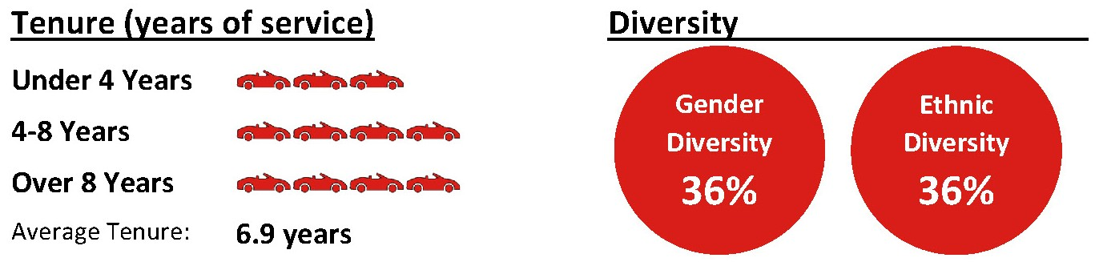
The Board recommends you vote FOR each of these nominees.

13
Table of Contents
Retiring Director
Philip F. Maritz
  Independent Director  Age: 65  Director since: 2002  Committees:  –Capital Allocation & Risk Management  –Governance & Nominating  –Executive |  |  | Mr. Maritz is the co-founder and President of Maritz, Wolff & Co., which manages the Hotel Equity Fund, a private equity investment fund that invests in luxury hotels and resorts. In 1990, he founded Maritz Properties, a commercial real estate development and investment firm where he serves as President. He is also the Managing Director of Broadreach Capital Partners, a private equity real estate investment fund and a member of the Council on Foreign Relations.  Mr. Maritz has served as a member of our Board since 2002 and currently is a valuable member of the Capital Allocation & Risk Management Committee, the Governance & Nominating Committee, and the Executive Committee. During his tenure on the Board, Mr. Maritz served as Chair of the Audit Committee, Chair of the Risk Management Committee, and Chair of the Governance & Nominating Committee. Over the course of his almost 24 years as a Board member, he provided a rare blend of leadership, strategic insights and rigorous analytical inquiries. The Company thanks Mr. Maritz for his many years of service.

14
Table of Contents
GOVERNANCE OF THE COMPANY

Board Leadership Structure
The Chairman of the Board provides leadership to the Board and works with the Board to define its structure and activities in the fulfillment of its responsibilities. The Company believes that the members of the Board possess considerable experience and unique knowledge of the challenges and opportunities the Company faces, and, therefore, are in the best position to evaluate the needs of the Company and how best to organize the capabilities of our directors and senior executives to meet those needs. As a result, the Company believes that the decision as to who should serve as Chairman and as President & Chief Executive Officer, and whether the offices should be combined or separate, is properly the responsibility of the Board, to be exercised from time to time in appropriate consideration of then-existing facts and circumstances. Our Corporate Governance Guidelines provide the Board the flexibility to determine whether or not the separation or combination of the Chairman and President & Chief Executive Officer offices is in the best interests of the Company at any time.
Currently, we maintain separate positions of Chairman and President & Chief Executive Officer, as the Board believes that, based on the skills and responsibilities of the various Board members, our current business environment and other considerations, such separation enhances (i) appropriate oversight of management by the Board, (ii) the accountability to our stockholders by the Board and (iii) our overall leadership structure. We believe this structure is presently appropriate because we compete in an industry with many external forces that may affect our viability and profitability, therefore presenting significant challenges requiring extensive oversight and management capability. As such, we believe that by maintaining a separate Chairman function from that of the President & Chief Executive Officer, our President & Chief Executive Officer can properly focus on managing the business, rather than diverting his efforts to also overseeing the Board.
In order to ensure a significant voice within our non-management directors and to reinforce effective, independent leadership on the Board, the Board has created the position of Lead Independent Director. Under the Company’s Corporate Governance Guidelines, a Lead Independent Director is appointed when the Chairman is the Chief Executive Officer or any other officer or employee of the Company, or if the Chairman is not otherwise independent. In such cases, the Lead Independent Director will act as the principal liaison between the non-management directors and the executive directors and will coordinate the activities of the non-management directors when acting as a group. Since Mr. Reddin is currently our non-executive Chairman of the Board and is not an employee of the Company, we do not currently have a Lead Independent Director.
The Governance & Nominating Committee periodically reviews and makes recommendations to the full Board regarding the Company's leadership structure. In its evaluation, the Governance & Nominating Committee and the Board consider the Company’s unique needs, circumstances, and opportunities. In December 2025, the Company announced that effective following the 2026 Annual Meeting of Stockholders (the "Transition Date"), Mr. Hult will transition from his position as President & Chief Executive Officer to the role of Executive Chair, and Mr. Clara will transition from his position as Chief Operating Officer to the role of President & Chief Executive Officer. In addition, Mr. Reddin's term as Non-Executive Board Chair will expire following the 2026 Annual Meeting. The Board’s decision was the result of a comprehensive and thoughtful evaluation and the culmination of its long-term leadership succession plan to support the continued growth and success of the Company. The Board remains committed to robust independent leadership, and also effective as of the Transition Date, Ms. Ryan-Berman will transition to the role of Lead Independent Director. The Board believes that the foregoing structure, policies, and practices, when combined with the Company’s other governance policies and procedures, provide appropriate opportunities for oversight, discussion and evaluation of decisions and direction from the Board.

Independence of Directors
The Board has determined that all of the directors qualify as independent directors under the rules of the NYSE and the Company’s Corporate Governance Guidelines, other than Mr. Hult and Mr. Clara, who are employees of the Company. In order to qualify as an independent director of the Company, the Board must affirmatively determine, based upon all relevant facts and circumstances, that the director does not have a material relationship with the Company that would affect their independence, either directly or as a partner, stockholder or officer of an organization that has a relationship with the Company.
The Board has adopted the categorical independence standards set forth in the Company’s Corporate Governance Guidelines to assist it in making determinations of director independence. These standards comply with, and in some respects are more stringent than, the NYSE’s categorical standards for director independence. Our Corporate Governance Guidelines can be found on our website at https://investors.asburyauto.com/corporate-governance.

15
Table of Contents

Furthermore, in order for a director to qualify as independent for Audit Committee purposes, the director also must satisfy the additional independence criteria specified in Rule 10A-3 under the Exchange Act. In order for a director to qualify as independent for Compensation & Human Resources Committee purposes, the director must meet the Company’s categorical independence standards described above, and must also be a “non-employee director” for purposes of Rule 16b-3 under the Exchange Act.
In making its independence determinations, the Board considered relationships and transactions pursuant to which any of our non-employee directors or director-nominees, entities associated with those individuals, or members of their immediate families purchased or leased a vehicle at a Company dealership. The Board determined that none of the relationships and transactions it considered impaired the independence of our non-employee directors or director-nominees or disqualified any of our non-employee directors or director-nominees from serving as independent directors under our categorical independence standards set forth in our Corporate Governance Guidelines and the NYSE listing standards.

Committees of the Board
The Board has established five separately designated standing committees to assist the Board in discharging its responsibilities: the Audit Committee, the Capital Allocation & Risk Management Committee, the Compensation & Human Resources Committee, the Governance & Nominating Committee and the Executive Committee. The charters for the Audit Committee, the Capital Allocation & Risk Management Committee, the Compensation & Human Resources Committee and the Governance & Nominating Committee are available on our website at https://investors.asburyauto.com/corporate-governance. In addition, the Board has established a Transaction Committee in connection with the process to review the terms and financing arrangements related to certain potential transactions. Messrs. Reddin, Alsfine and Fay serve as members of this ad hoc committee, which held no meetings in 2025.
The following table sets forth the current membership of each of the standing Committees of the Board:

Director |  |  | Audit Committee |  |  | Capital Allocation & Risk Management Committee |  |  | Compensation  & Human Resources Committee |  |  | Governance & Nominating Committee |  |  | Executive Committee
Thomas J. Reddin(1) |  |  |  |  |  | ü |  |  | ü |  |  | ü |  |  | Chair
Joel Alsfine |  |  |  |  |  | ü |  |  | ü
B. Christopher DiSantis |  |  | ü |  |  |  |  |  | ü
William D. Fay |  |  | ü |  |  | Chair |  |  |  |  |  | ü
David W. Hult |  |  |  |  |  |  |  |  |  |  |  |  |  |  | ü
Juanita T. James |  |  | ü |  |  |  |  |  |  |  |  | Chair
Philip F. Maritz |  |  |  |  |  | ü |  |  |  |  |  | ü |  |  | ü
Maureen F. Morrison(2) |  |  | ü |  |  | ü |  |  | Chair
Shamla Naidoo |  |  | ü |  |  |  |  |  | ü
Bridget Ryan-Berman |  |  |  |  |  | ü |  |  | ü
Hilliard C. Terry, III(2) |  |  | Chair |  |  | ü
(1)Chairman of the Board of Directors
(2)Audit Committee Financial Expert
Audit Committee
The Audit Committee assists the Board in fulfilling its responsibility to oversee management’s conduct of the Company’s financial reporting process, including the development and maintenance of systems of internal accounting and financial controls (including internal controls designed to assess, identify and manage material risks from cybersecurity threats), the integrity of the Company’s financial statements, the Company’s compliance with certain legal and regulatory requirements, the qualifications, independence and performance of the Company’s outside auditors and the performance of the Company’s internal audit functions. The Audit Committee also is directly responsible for the appointment, retention, compensation, termination and oversight of the Company's outside auditors. The Audit Committee also assists the Board in the oversight, review and evaluation of initiatives, programs, policies and/or practices relating to the Company’s environmental, social and governance strategy, and also assists the Board in overseeing the Company’s Chief Information Officer (“CIO”) regarding cybersecurity matters, from time to time as specifically requested by the Board.
Our Board has determined that each member of the Audit Committee meets the requisite independence and other qualification requirements for Audit Committee membership. Additionally, each of Maureen F. Morrison and Hilliard C.
16
Table of Contents

Terry, III qualifies as an “audit committee financial expert” within the meaning of Item 407(d)(5) of Regulation S-K under the Exchange Act. Designation or identification of a person as an “audit committee financial expert” does not impose any duties, obligations or liability that are greater than the duties, obligations and liability imposed on such person as a member of the Audit Committee and the Board of Directors in the absence of such designation or identification.
The Audit Committee held eleven meetings in 2025, one of which was a joint meeting with the Capital Allocation & Risk Management Committee.
Capital Allocation & Risk Management Committee
The Capital Allocation & Risk Management Committee (i) assists the Board in the oversight, review and evaluation of the Company's capital allocation strategy, (ii) assists management in the evaluation of major financial transactions, including acquisitions and divestitures, and (iii) assists the Board in fulfilling its responsibility of overseeing the identification, assessment and management of our key financial, strategic and operational risks, and (iv) assists the Board in overseeing the CIO regarding cybersecurity matters. The Capital Allocation & Risk Management Committee also assists the Board in the oversight, review and evaluation of initiatives, programs, policies and/or practices relating to the Company’s environmental, social and governance strategy, from time to time as specifically requested by the Board.
The Capital Allocation & Risk Management Committee held seven meetings in 2025, one of which was a joint meeting with the Audit Committee and one of which was a joint meeting with the Compensation & Human Resources Committee.
Compensation & Human Resources Committee
The Compensation & Human Resources Committee: (i) establishes and reviews our general compensation philosophy with the input of management; (ii) oversees the development and implementation of our compensation philosophy to ensure that our compensation plans are consistent with our general compensation philosophy; (iii) establishes the compensation to be paid to the Chief Executive Officer; (iv) reviews the recommendations of the Chief Executive Officer as to the appropriate compensation of our other corporate officers: (v) approves employment agreements, severance arrangements or change-in-control arrangements with, and any special or supplemental benefits for, the corporate officers of the Company; (vi) generally administers and issues awards under our equity incentive plans; (vii) oversees our other benefit plans; and (vii) assists the Board in succession planning. The Committee may, in its discretion, delegate all or a portion of its duties and responsibilities to a subcommittee of the Committee. See “Compensation Discussion & Analysis” for a discussion of our compensation philosophy and how the Compensation & Human Resources Committee determines the compensation of our executive officers. The Compensation & Human Resources Committee also assists the Board in the oversight, review and evaluation of initiatives, programs, policies and/or practices relating to the Company’s environmental, social and governance strategy, from time to time as specifically requested by the Board.
Our Board has determined that each member of the Compensation & Human Resources Committee meets the requisite independence requirements for Compensation Committee membership, including qualifying as a “non-employee director” within the meaning of Rule 16b-3 under the Exchange Act.
The Compensation & Human Resources Committee held eight meetings in 2025, one of which was a joint meeting with the Capital Allocation & Risk Management Committee.
Governance & Nominating Committee
The Governance & Nominating Committee assists the Board by identifying qualified individuals to become directors, recommending the composition of the Board and its committees, and the compensation to be paid to the directors. It is also responsible for monitoring the process to assess the Board’s effectiveness, developing and implementing our Corporate Governance Guidelines and many of our corporate governance policies, including the oversight of compliance under our Equity Ownership Guidelines, our Code of Business Conduct and Ethics and our Related Person Transaction Policy. In addition, the Governance & Nominating Committee is responsible for developing and reviewing a management succession plan designed to ensure leadership continuity for the Company. The Governance & Nominating Committee also assists the Board in the oversight, review and evaluation of initiatives, programs, policies and/or practices relating to the Company’s environmental, social and governance strategy, from time to time as specifically requested by the Board.
Our Board has determined that each member of the Governance & Nominating Committee meets the requisite independence requirements for Governance & Nominating Committee membership under NYSE listing standards and the categorical independence standards set forth in the Corporate Governance Guidelines.
The Governance & Nominating Committee held five meetings in 2025.
Executive Committee
The Executive Committee has exercised and may exercise all the authority of the Board when the Board is not in session, except that it does not have the authority to: (i) approve or propose to stockholders actions required by the Delaware General Corporation Law to be approved by stockholders; (ii) adopt, amend or repeal our By-laws; (iii) authorize
17
Table of Contents

distributions; (iv) fill vacancies on the Board or any of its committees; (v) approve a plan of merger, consolidation or reorganization not requiring stockholder approval; (vi) authorize or approve the repurchase of shares, except according to a formula or method prescribed by the Board; or (vii) authorize or approve the issuance or sale or contract for sale of shares or determine the designation and relative rights, preferences and limitations of a class or series of shares.
The Executive Committee held no meetings in 2025.

Code of Business Conduct and Ethics and Corporate Governance Guidelines
In accordance with the NYSE’s rules and the rules and regulations adopted by the SEC pursuant to the Sarbanes-Oxley Act of 2002, the Board has adopted Corporate Governance Guidelines and a Code of Business Conduct and Ethics applicable to all directors, officers and employees. The Corporate Governance Guidelines, the Code of Business Conduct and Ethics as well as our Audit Committee, Compensation & Human Resources Committee, Governance & Nominating Committee and Capital Allocation & Risk Management Committee charters are available on our website at https://investors.asburyauto.com/corporate-governance.
We will provide our stockholders with copies of the above-mentioned documents free of charge if you call 770-418-8211 or submit a request in writing to the Company's Investor Relations Department at our corporate headquarters.

The Board’s Risk Oversight Role
The Board maintains ultimate oversight responsibility for management of the Company’s enterprise risk management program, which includes material cybersecurity risks. The Board has delegated oversight responsibility for certain areas of potential risk exposure to its committees. Each committee reports to the Board at regular intervals or more frequently, if appropriate, with respect to the risks and matters for which it maintains responsibility. The Company’s Capital Allocation & Risk Management Committee is responsible for further assisting the Board in fulfilling its oversight role by (i) reviewing and evaluating the Company's capital allocation strategy, (ii) identifying, assessing and managing key financial, strategic and operational risks of the Company and (iii) providing management with assistance in evaluating major financial transactions, including acquisitions and divestitures. Management annually reviews with the Capital Allocation & Risk Management Committee our key risks to help evaluate the Company’s risk profile and related risk management processes. In this review, management highlights for the Capital Allocation & Risk Management Committee our most significant risks to facilitate the Capital Allocation & Risk Management Committee’s evaluation of our long-term financial plans, budgets and strategic initiatives. The Capital Allocation & Risk Management Committee, based on such review, considers the appropriate process for managing or mitigating material risks and the appropriate allocation of resources related to such material risks.
Recognizing that the Capital Allocation & Risk Management Committee’s role complements the Audit Committee’s role in risk oversight, our Capital Allocation & Risk Management Committee charter mandates that at least one member of the Audit Committee be a member of the Capital Allocation & Risk Management Committee. Currently, our Capital Allocation & Risk Management Committee consists of seven members, three of whom are members of our Audit Committee: Ms. Morrison, Mr. Fay and Mr. Terry.
The Compensation & Human Resources Committee is primarily responsible for the design and oversight of our executive compensation policies, programs and practices. A key objective of the Compensation & Human Resources Committee, together with the Capital Allocation & Risk Management Committee, is to oversee the implementation and development of our compensation programs to ensure such programs are consistent with the Company’s general philosophy after accounting for the Company’s key risk profile. In 2025, the Compensation & Human Resources Committee and the Capital Allocation & Risk Management Committee reviewed the Company’s risk profile and concluded that our then-current compensation policies and practices for our employees did not create risks reasonably likely to have a material adverse effect on us.

Corporate Responsibility
The Board and its committees oversee the development, refinement and execution of our environmental, social and governance strategy. The Board and management recognize the importance of transparent disclosure concerning our governance and ethics policies, and our commitment to our employees, the environment and the communities in which we operate.

18
Table of Contents

Below are certain highlights of our corporate responsibility strategy:
Environmental |  |  |  |  |  |  |  |  | Governance
 |  |  | Recycling tires, motor oil, cardboard, glass and plastic |  |  |  |  |  | 82% |  |  | Over 80% of our directors and director nominees are independent
 |  |  | Reducing water usage and instituting water reclamation in our car washes |  |  |  |  |  |  |  |  | Annual director elections with plurality plus voting standard
 |  |  | Reducing other water usage by installing motion-activated faucets and lower gallon flush valves |  |  |  |  |  |  |  |  | Board periodically evaluates the composition and experience of its directors
 |  |  | Reducing energy usage in buildings by retrofitting with LED lighting and through the use of occupancy and vacancy sensors |  |  |  |  |  |  |  |  | Board considers diversity of thought, background and experience when evaluating prospective directors
 |  |  |  |  |  |  |  |  |  |  |  | Board is committed to ongoing board refreshment
Social (Community & People)
 |  |  | Expanded the Asbury Cares corporate giving program supporting non-profit community partner organizations that focus on reducing social inequities and disparities in our communities.
 |  |  | Award full-time team members with an additional 40 hours of paid time off per year to volunteer with our community partners with up to 8 hours to be used to support a non-profit of their choice.
 |  |  | Strive to offer competitive compensation and benefits to attract and retain the best people. We offer equity awards to frontline team members because we want them to be owners of our Company and committed to our long-term success. In addition, we offer full income replacement in our paid pregnancy disability program and paid parental leave program.
 |  |  | Maintained an online career path tool to aid team members in every position throughout the company chart their desired career path.
 |  |  | Continued to strive to foster a welcoming and inclusive environment that enhances the experience of our team members, guests and partners.
 |  |  | Invest in team members by expanding our learning and development programs and training offerings to include professional and leadership development, guest centric training, education and operational support training to help us create a culture of continuous growth and development.

Nomination of Directors
The Governance & Nominating Committee identifies, evaluates, and recommends to the full Board, nominees to serve as directors on our Board. The non-employee director nominees for election at the 2026 Annual Meeting are current directors and were originally recommended to the Board by various sources. Candidates are evaluated in light of the then-current composition of the Board, the operating requirements of the Company and the long-term interests of the stockholders. In performing this evaluation, the Governance & Nominating Committee considers the age, qualifications, skills and other experience of the candidate, and other factors it deems appropriate, given the needs of the Board and the Company at the time, to maintain what it considers to be a suitable balance of knowledge, experience and capabilities. Qualified director-nominees are expected to possess an appropriate balance of the following qualities: high moral character and personal integrity, a high level of leadership or managerial experience, experience and knowledge relative to matters affecting the Company, the ability and willingness to contribute to the Board, the ability to exercise sound, independent business judgment, a long-term commitment to the interests of stockholders and growth of the Company, freedom from conflicts of interest, and the ability to dedicate sufficient time, energy and attention to Board activities and the diligent performance of their duties.
The Board will consider director candidates recommended by the Company’s stockholders. In order to make such a nomination, the stockholder must (i) be a record holder of shares of common stock at the time of giving notice as described below, (ii) be entitled to vote for the election of such director(s) and (iii) comply with the notice procedures set forth in the Company’s By-laws. Our By-laws can be found on our website at https://investors.asburyauto.com/corporate-governance.
19
Table of Contents

Notice of a stockholder’s recommendation with regard to nominees for election to the Board must be delivered to, or mailed to and received by, the Corporate Secretary of the Company not later than 90 days or earlier than 120 days prior to the anniversary date of the preceding year’s Annual Meeting of Stockholders. If the Annual Meeting of Stockholders for which the recommendation is submitted is more than 30 days before or more than 60 days after the first anniversary of the preceding year’s Annual Meeting of Stockholders, such recommendation must be received by the Corporate Secretary of the Company not earlier than 120 days prior to the Annual Meeting of Stockholders and not later than 90 days prior to such annual meeting or the 10th day following the day on which public announcement of the annual meeting date is first made by the Company.
The stockholder’s notice shall be signed by the stockholder of record who intends to recommend a nominee, and shall set forth:
(A)as to each person whom the stockholder proposes to nominate for election or reelection as a director: (1) all information relating to such person that is required to be set forth in the notice pursuant to Section 2.07 of the Company’s By-laws (and Items 403 and 404 under Regulation S-K); (2) a written questionnaire with respect to identity, background and qualification of the proposed nominee, (3) a written representation and agreement that the proposed nominee (i) is not and will not become a party to (x) any agreement or similar understanding that the nominee, if elected, will adopt a specific voting commitment on any issue or question that has not been disclosed to the Company or, (y) any voting commitment that could limit or interfere with such person’s fiduciary duty under applicable law, (ii) is not and will not become a party to any agreement or similar understanding with respect to any direct or indirect compensation, reimbursement or indemnification in connection with service as a director, that has not been disclosed to the Company, and (iii) if elected, will comply with all applicable publicly disclosed corporate governance, conflict of interest, confidentiality, stock ownership and trading policies of the Company, and (4) all other information relating to such person that is required to be disclosed in solicitation of proxies for the election of directors, or is otherwise required, in each case pursuant to Regulation 14A under the Exchange Act, including, the nominee’s written consent to being named in the proxy statement as a nominee and to serving as a director if elected; and
(B)as to the stockholder giving the notice and the beneficial owner, if any, on whose behalf the nomination or proposal is made (1) the name and address of such stockholder, as they appear on the Company’s books, and of such beneficial owner, (2) the number of shares of the Company which are owned of record and beneficially by such stockholder and such beneficial owner, (3) a representation that such stockholder is entitled to vote at the meeting and intends to appear virtually or by proxy at the meeting to nominate the person specified in the notice, (4) a representation whether the stockholder or beneficial owner, if any, intends or is part of a group that intends (x) to deliver a proxy statement and/or form of proxy to holders of at least the percentage of the Company’s outstanding capital stock required to elect the nominee and/or (y) otherwise to solicit proxies from stockholders in support of such nomination, (5) a description of any Derivative Interest (as defined in the By-laws), (6) any proxy, contract, or similar understanding that increases or decreases the voting power of such stockholder or beneficial owner, (7) any dividend rights held of record or beneficially by the stockholder on shares of the Company that are separated or severable from the underlying shares, (8) any performance-related fees (other than an asset-based fee) to which the stockholder or beneficial owner may be entitled as a result of any increase or decrease in the value of shares of the Company or Derivative Interests; and (9) any other information relating to such stockholder or beneficial owner that would be required to be disclosed in a proxy statement or other filing required pursuant to Section 14(a) of the Exchange Act.

Service Limitations
Under the Company’s Corporate Governance Guidelines, a director may not stand for re-election if he or she would be age 74 years or older at the date of the election but need not resign until the end of their term. However, the Board may waive this age limitation, on an annual basis, upon the recommendation of the Governance & Nominating Committee if, in light of all the circumstances, a director’s continued service is in the best interests of the Company and its stockholders. In no event may the Board waive the requirement more than twice for any individual director.
In addition, our Corporate Governance Guidelines provide that the Chairman of the Board and the chair of each committee will not serve greater than five years in their respective chair roles, subject to exceptions approved by the Board. The Board had previously determined that it was in the Company’s best interest to grant Mr. Reddin a waiver to serve as Non-Executive Board Chair for two additional years because at the time the Company had undergone significant and transformational growth. Mr. Reddin's term as Non-Executive Board Chair will expire following the 2026 Annual Meeting, and Mr. Hult will transition into the Executive Chair role.

20
Table of Contents

Communications with the Board
We have a Stockholder Communication Policy with established procedures for stockholders and interested parties to communicate directly with the Board, with our non-management directors or with a particular director. The stockholder or interested party should send any written communications to (i) the Lead Independent Director, if applicable, (ii) the Chair of the Board or Chair of the appropriate committee, (iii) the non-management directors, or (iv) an individual director, each in care of the Corporate Secretary at our corporate headquarters. Any communications relating to the Company’s auditing, accounting, internal controls, fraud or unethical behaviors should be directed to the attention of the Chair of the Audit Committee in care of the Corporate Secretary at our corporate headquarters. The Audit Committee will respond to such communication, if appropriate, in accordance with the procedures established with respect to such matters.
Any written communication should include the name and address of the stockholder or interested party sending such communication so that a response can be provided, if necessary or appropriate. Stockholders and interested parties may, however, remain anonymous. If the stockholder or interested party desires that such communication be kept confidential from management, the envelope must be clearly marked “confidential,” and the Corporate Secretary will then forward the communication, unopened, to the individual addressee.

Related Person Transactions
We have adopted a written policy relating to related person transactions, which sets out the criteria for review of transactions between the Company and our affiliates and members of their immediate families. This policy covers our directors and officers, and each stockholder that holds directly or indirectly, more than 5% of our common stock. In addition, we have adopted a written Delegation of Authority Policy, which establishes an executive approval process for many of the Company’s transactions in which certain related person transactions would be included. In reviewing and approving related person transactions under these policies and procedures, senior management and the Board considers, among other things:
–the nature of the related person’s interest in the transaction;
–whether the related person has a direct or indirect material interest in the transaction;
–the material terms of the transaction, including the amount and type of transaction;
–the significance of the transaction to the Company and to the related person;
–whether the terms of the transaction are arms-length; and
–whether the transaction would violate the “Conflicts of Interest” provisions of our Code of Business Conduct and Ethics for Directors, Officers and Employees.
We maintain an employee vehicle purchase program for our officers, directors and other employees, and their respective friends and family members pursuant to which they may purchase or lease vehicles from us at a discount to our advertised prices. This program is designed to incent additional vehicle sales while ensuring that we earn a measure of gross profit on all vehicles sold pursuant to the program. From time to time, including in 2025, certain of our directors and executive officers, or their respective family members, purchased or leased vehicles from us under this program, which vehicles may be valued at over $120,000.

21
Table of Contents

DIRECTOR COMPENSATION

Director Fees
Directors who are employees of the Company do not receive a retainer or any other fees for service on the Board or its committees. All other directors (“non-management directors”) received the annual retainer and meeting fees in 2025 described below. In addition, in 2025, the non-management directors (i) received a grant of common stock valued at approximately $210,000, that vested immediately upon grant and (ii) were offered the use of a motor vehicle (including transporting the vehicle to the director, any taxes payable relating to the vehicle and repair, maintenance and service of the vehicle).
In 2025, the compensation program for non-management directors, was as follows:
Annual Retainers (paid quarterly in advance)
Position |  |  | Annual Retainer
Non-Management Directors |  |  | $ | 55,000
Non-Executive Chairman |  |  | $ | 160,000
Audit Committee Chair |  |  | $ | 25,000
Capital Allocation & Risk Management Committee Chair |  |  | $ | 15,000
Compensation & Human Resources Committee Chair |  |  | $ | 20,000
Governance & Nominating Committee Chair |  |  | $ | 15,000
Meeting Fees (paid quarterly in arrears)
Meeting Type |  |  | Per Meeting Fee
Board, Audit Committee, Compensation & Human Resources Committee, Governance & Nominating Committee and Capital Allocation & Risk Management Committee in person meetings |  |  | $ | 2,000
Board, Compensation & Human Resources Committee, Governance & Nominating Committee and Capital Allocation & Risk Management Committee virtual meetings |  |  | $ | 1,000
Audit Committee virtual meetings and Transaction Committee meetings |  |  | $ | 1,500
Executive Committee meetings, in person or virtual (payable to the Executive Committee chair only) |  |  | $ | 1,500

Meeting Attendance
During 2025, the Board held ten meetings. Each current director attended at least 75% of the total meetings of the Board and committees on which he or she served. In accordance with the NYSE’s rules requiring that non-management directors meet at regularly scheduled executive sessions, our non-management directors held two executive sessions without management present during 2025. Mr. Reddin, as the Non-Executive Chairman, presided over Board meetings, including executive sessions of the Board.
We do not have a formal policy with regard to the attendance of the members of the Board at Annual Meeting of Stockholders, however, we expect each member of the Board and director-nominees to attend our Annual Meeting of Stockholders. All of the members of the Board, who were then serving on the Board, attended our 2025 Annual Meeting of Stockholders.

22
Table of Contents

2025 Director Compensation Table
The following table shows compensation earned by the non-management directors for 2025.
Name |  |  | Fees Earned or Paid in Cash |  |  | Stock  Awards(1) |  |  | All Other Compensation(2) |  |  | Total
Joel Alsfine |  |  | $ | 88,000 |  | $ | 209,979 |  | $ | 16,848 |  | $ | 314,827
B. Christopher DiSantis(3) |  |  | $ | — |  | $ | — |  | $ | — |  | $ | —
William D. Fay |  |  | $ | 119,000 |  | $ | 209,979 |  | $ | 27,869 |  | $ | 356,848
Juanita T. James |  |  | $ | 110,000 |  | $ | 209,979 |  | $ | 28,623 |  | $ | 348,602
Philip F. Maritz |  |  | $ | 86,000 |  | $ | 209,979 |  | $ | 20,831 |  | $ | 316,810
Maureen F. Morrison |  |  | $ | 128,250 |  | $ | 209,979 |  | $ | 17,382 |  | $ | 355,611
Shamla Naidoo |  |  | $ | 98,000 |  | $ | 209,979 |  | $ | 21,266 |  | $ | 329,245
Thomas J. Reddin |  |  | $ | 259,000 |  | $ | 209,979 |  | $ | 1,115 |  | $ | 470,094
Bridget Ryan-Berman |  |  | $ | 85,000 |  | $ | 209,979 |  | $ | 34,305 |  | $ | 329,284
Hilliard C. Terry, III |  |  | $ | 113,750 |  | $ | 209,979 |  | $ | 35,861 |  | $ | 359,590
(1)The amount in this column for each director represents the grant date fair value of 713 shares of common stock granted to each non-management director on February 19, 2025. Amounts were calculated in accordance with Financial Accounting Standards Board (“FASB”) Accounting Standards Codification (“ASC”) Topic 718. For a more detailed discussion of the assumptions used to determine the valuation of the stock awards set forth in this column please see a discussion of such valuation in Note 22 of the Consolidated Financial Statements in our Annual Report on Form 10-K for the year ended December 31, 2025 filed with the SEC on February 20, 2026. No non-management director held option awards or unvested stock awards as of December 31, 2025.
(2)Represents the estimated incremental cost to the Company for the use of a vehicle. The estimated incremental cost is based on rules established by the Internal Revenue Service. The amounts in this column also include the cost of repairs and maintenance for the vehicle.
(3)Mr. DiSantis was appointed to the Board effective March 1, 2026.

23
Table of Contents

EXECUTIVE OFFICERS
Set forth below is information regarding the Company’s executive officers. All our executive officers are elected by and serve at the discretion of the Board.
Name |  |  | Age |  |  | Position
David W. Hult |  |  | 60 |  |  | President & Chief Executive Officer
Daniel E. Clara |  |  | 46 |  |  | Chief Operating Officer
Michael D. Welch |  |  | 51 |  |  | Senior Vice President & Chief Financial Officer
Dean A. Calloway |  |  | 58 |  |  | Senior Vice President, General Counsel & Secretary
Jed M. Milstein |  |  | 57 |  |  | Senior Vice President & Chief Human Resources Officer
Set forth below is a brief description of the business experience of the Company’s executive officers.
David W. Hult Please see Mr. Hult’s biographical information under “Nominees for Election as Directors” above.
Daniel E. Clara Please see Mr. Clara’s biographical information under “Nominees for Election as Directors” above.
Michael D. Welch (age 51) has served as our Senior Vice President & Chief Financial Officer since August 2021. Mr. Welch joined Asbury after holding the position of Vice President and Corporate Controller at Group 1 Automotive, Inc. (“GPI”) since June 2019. From June 2000 until June 2019, Mr. Welch held various other positions with GPI of increasing responsibility, where he gained extensive experience in treasury, financial reporting, financial planning and analysis and internal audit. Mr. Welch began his career at Price Waterhouse. Mr. Welch received his Bachelor of Business Administration from Oklahoma Baptist University and is a Certified Public Accountant in the State of Texas.
Dean A. Calloway (age 58) has served as Senior Vice President, General Counsel & Secretary since July 2024. As General Counsel, Mr. Calloway provides advice to the senior management team and others across the Company on a variety of matters, including automotive franchise laws, corporate governance, litigation, regulatory compliance, cybersecurity, and human resources. Prior to joining Asbury in October 2013, Mr. Calloway worked as a litigation partner in the Atlanta office of an Am Law 15 firm. Mr. Calloway holds a J.D. from The Law School at the University of Chicago, an M.S. from Carnegie Mellon University, and a B.S. from the University of Washington.
Jed M. Milstein (age 57) has served as our Senior Vice President & Chief Human Resources Officer since January 2018. Mr. Milstein joined the Company in July 2016 as Vice President & Chief Human Resources Officer. Prior to joining the Company, Mr. Milstein served as Executive Vice President & Chief Human Resources Officer of AmeriCold Logistics, LLC from May 2013 to July 2016. From December 2011 to May 2013, Mr. Milstein served as Executive Vice President of Human Resources of TransCentra, Inc. From January 2008 to May 2013 Mr. Milstein held various executive management positions at Cerberus Operations & Advisory Company, LLC. Mr. Milstein also served as Vice President HR Shared Services of Broadridge Financial Solutions, Inc. from 2007 to 2008 and ADP from 1998 to 2007. Earlier in his career, Mr. Milstein served as a Deputy Attorney General for the State of New Jersey prior to joining the labor and employment law practice at Carpenter, Bennett and Morrissey in Newark, New Jersey. Mr. Milstein holds a J.D. from George Washington University Law School and a BBA from the University of Michigan.

24
Table of Contents

COMPENSATION DISCUSSION & ANALYSIS
This compensation discussion and analysis (“CD&A”) provides detail on the Company's compensation philosophy, policies and programs as they relate to our executive officers, with certain additional detail about the compensation paid, or payable, to our “named executive officers” in 2025. Our named executive officers ("NEOs") in 2025 were as follows:
–David W. Hult, President & Chief Executive Officer;
–Daniel E. Clara, Chief Operating Officer, who was promoted to this position effective February 17, 2025;
–Michael D. Welch, Senior Vice President & Chief Financial Officer;
–Dean A. Calloway, Senior Vice President, General Counsel & Secretary;
–Jed M. Milstein, Senior Vice President & Chief Human Resources Officer.
The Compensation & Human Resources Committee of the Board (also referred to in this CD&A as the “Committee”) is charged with various matters concerning the compensation of our executive officers, including the development and implementation of our compensation philosophy relating to those individuals. Our philosophy emphasizes a pay-for-results culture designed to align the interests of our executive officers with those of our stockholders through the use of incentive-based pay opportunities. With respect to decisions directly impacting executive compensation, the Committee’s primary responsibilities are to:
–within the construct of our philosophy and guidelines, establish all aspects of compensation for our executive officers, including the named executive officers, and, subject to Board ratification, approve awards to the Chief Executive Officer under our incentive-based compensation plans;
–oversee the development, implementation and administration of our compensation and benefit plans; and
–prepare the Compensation & Human Resources Committee Report and review and discuss with management as required the CD&A to be included in our annual proxy statement.
For additional information regarding the Committee’s function and composition, see “Governance of the Company—Committees of the Board—Compensation & Human Resources Committee.”

Overview
We believe that fostering an entrepreneurial spirit at Asbury is essential to our success. Consistent with our overall business strategy of driving operational excellence through the attraction and retention of the best talent, our executive compensation philosophy is to:
–support the attainment of our vision, business strategy and operating imperatives;
–guide the design and implementation of effective executive compensation and benefit plans;
–reinforce our business values; and
–further align management and stockholder interests by providing appropriate opportunities for meaningful compensation based upon the achievement of various corporate goals set from time to time and generally related to corresponding increases in earnings and stockholder value, subject to limitations designed to discourage unnecessary or excessive risk-taking.
As it has done in prior years, the Committee engaged an independent executive compensation consultant, Pay Governance LLC (“Pay Governance”), to assist with the development and implementation of our executive compensation program for 2025, as described in more detail below. In determining and setting compensation levels and opportunities for our executive officers, the Committee generally considers a number of factors and analyzes comparative data provided by Pay Governance on compensation paid to executive officers in similar positions within a Peer Group (as defined below) of companies. For 2025 executive compensation, the Committee approved and implemented incentive compensation programs designed to appropriately reward and incentivize our executive management team to focus on the long-term interests of our stockholders and further improve the measurable financial metrics described below, which remain a focus of the Board and the Committee when analyzing our financial results and success.
In determining and setting 2025 compensation levels and opportunities for executive officers during 2024, the Committee considered factors including, among other things, the significant expansion of the nature and scope of the individual’s responsibilities to the Company as a result of the Company's growth through recent acquisitions and other independent factors, such as skills, experience, tenure and historical and expected contributions to the Company. In addition, in setting 2025 executive compensation, the Committee considered the Company's financial performance in 2024 (as compared to 2023), including the following:
25
Table of Contents

–our adjusted earnings before non-floor plan interest, taxes, depreciation and amortization (“Adjusted EBITDA”), a metric used by management and that the Committee believes is often used by investors and market analysts in comparing performance and determining enterprise value, was $980 million, a decrease of 13.5% from 2023;
–our adjusted diluted earnings per share ("EPS") was $27.24, a decrease of 16.5% from 2023; and
–our adjusted operating margin was 5.8%, which was the highest amongst the Automotive Peer Group (as defined below).
For an explanation of non-GAAP measures and a reconciliation to GAAP, please see Appendix A to this proxy statement.
For 2025 executive compensation, the Committee analyzed comparative data provided by Pay Governance on compensation paid to executive officers in similar positions within the Peer Group, although the Committee did not specifically benchmark executive compensation against the Peer Group or other companies. In evaluating Peer Group data, selecting metrics and setting appropriate performance targets in connection with the implementation of the Company’s executive compensation programs in 2025, the Committee acknowledged that, as a result of the significant variable components of compensation described in more detail elsewhere in this CD&A, actual total executive compensation may be above or below target compensation and/or the actual compensation paid to executives in similar positions within the Peer Group based on our actual performance when compared to target performance.

Incentive Compensation Programs
Consistent with the approach in prior years, payouts for 2025 were intended to reward a number of significant achievements, particularly in light of our overall, and each individual officer’s, performance, in successfully executing on the Company's success and progress of integrating acquisitions, the advancement of the Company’s strategic initiatives, and the Company's operating margin relative to automotive retail peers. In addition, the following results and achievements in 2025 impacted actual payouts and the overall compensation of our executive officers under our incentive compensation programs for 2025:
–our Adjusted EBITDA was $1,005.6 million, an increase of 2.6% over 2024;
–our adjusted diluted EPS was $28.10, an increase of 3.2% over 2024; and
–our adjusted operating margin was 5.6%, which is the highest amongst the Automotive Peer Group.
For an explanation of non-GAAP measures and a reconciliation to GAAP, please see Appendix A.
In determining the applicable payouts, the Committee considered each of the results above in light of the 2025 seasonally adjusted annual rate (SAAR) level, which impacted gross profits from new vehicle sales.

Compensation Philosophy & Guidelines
The Committee, with the input of Pay Governance, has developed an executive compensation philosophy that sets forth certain general guidelines the Committee considers in making decisions and recommendations related to executive compensation (including our named executive officers’ compensation). The key principles and considerations underlying our compensation philosophy are the following:
–create a “pay-for-results” culture with clear emphasis on pay-for-performance and accountability through the grant of performance-based cash and equity award opportunities;
–effectively manage the cost of compensation programs by providing that a substantial portion of executive pay opportunity is in the form of performance-based compensation;
–set performance goals that are actionable, clearly communicated and understood, and are challenging, yet attainable;
–provide the opportunity for above market total compensation upon the achievement of above target performance;
–consider total compensation opportunities in light of competitive market practices, internal equity considerations, the individual’s experience, skills, tenure and how critical the individual's role is to the Company, historical and expected individual performance and significant contributions, and the nature and scope of the individual’s responsibilities;
–provide a balanced total compensation program to ensure management is not encouraged to take unnecessary or excessive risks;
–further align management and stockholder interests by requiring specified levels of equity ownership by management;
–reinforce teamwork, culture and internal alignment of management; and
26
Table of Contents

–consider stakeholder perceptions and governance practices when formulating pay plans and actions.
In order to effectively communicate expectations regarding our performance and incentivize executive officers to achieve specified performance objectives, we generally make compensation program decisions in the first quarter of a year. All such compensation decisions for our executive officers for 2025 were made at the Committee’s regularly scheduled meeting in the first quarter of 2025. All compensation decisions were consistent with our overall compensation philosophy and guidelines.

Elements of Compensation
The elements of the Company's compensation program, when considered collectively, are intended to support our executive compensation philosophy and objectives by (i) allowing us to attract and retain executive-level talent, (ii) providing an appropriate level of financial certainty through non-variable compensation, (iii) providing opportunities for above market compensation based upon the achievement of specified financial and other appropriate performance objectives, and rewarding such achievement, and (iv) balancing short-term and long-term incentives. The key elements of our executive compensation program are outlined below, together with a summary of the purposes and considerations underlying each compensation element.
Pay Element |  |  | Form |  |  | Philosophy |  |  |  |  |  | Performance Alignment
Base Salary |  |  | Cash |  |  | ü |  |  | Fixed pay to recognize an individual's role and responsibilities |  |  | ü |  |  | Reviewed annually and set based on a review versus the external market, individual performance, and internal equity
Annual Incentive |  |  | Cash |  |  | ü |  |  | Achieve annual goals linked to operating and strategic results |  |  | ü |  |  | Rewards and recognizes annual accomplishment of key operating and strategic objectives
 |  |  |  |  |  | ü |  |  | Provide competitive total cash compensation opportunity
 |  |  |  |  |  | ü |  |  | Encourage internal alignment and teamwork
Long-Term Incentives |  |  | Performance  Share Units/Restricted  Stock Units |  |  | ü |  |  | Align NEOs' interests with stockholders |  |  | ü |  |  | Stockholder value creation
 |  |  |  |  |  | ü |  |  | Balance short-term orientation of other pay elements |  |  | ü |  |  | Achievement of key value drivers
 |  |  |  |  |  | ü |  |  | Retain executive talent |  |  | ü |  |  | Relative EPS performance versus peers
Other |  |  | Employment/Severance  Agreements |  |  | ü |  |  | Ensure management objectivity regarding potential Change in Control transactions |  |  |  |  |  | Align NEOs' interests with stockholders by providing competitive total remuneration allowing us to attract and retain top executive talent
 |  |  |  |  |  | ü |  |  | Protect our interests through appropriate restrictive post-employment covenants, subject to applicable law
 |  |  | Health & Welfare |  |  | ü |  |  | To be competitive in the markets where we compete for executive talent |  |  | ü
 |  |  |  |  |  | ü |  |  | To avoid materially different approaches to benefits among executive and non-executive employees
 |  |  | Limited Perquisites |  |  | ü |  |  | Provide limited job-related and market-driven perquisites in line with our corporate governance philosophies

Total Compensation Program Supporting Attainment of Operating & Strategic Imperatives
Our overall compensation program is implemented in a manner supporting the attainment of various operating and strategic goals set from time to time. The Committee believes the program is appropriately managed by delivering compensation predominantly through variable performance-based compensation elements. Target total compensation(1) is defined as annualized base salary plus cash incentive award opportunities at target level plus regular annual long-term equity award opportunities granted for the year (at target level when such opportunities have the potential for variable payout levels). As indicated below, during 2025, 87% of target total compensation of our President & Chief Executive Officer and an average of 72% of target total compensation of our other named executive officers was delivered through at-risk compensation elements that were subject to vesting and/or performance conditions.
27
Table of Contents

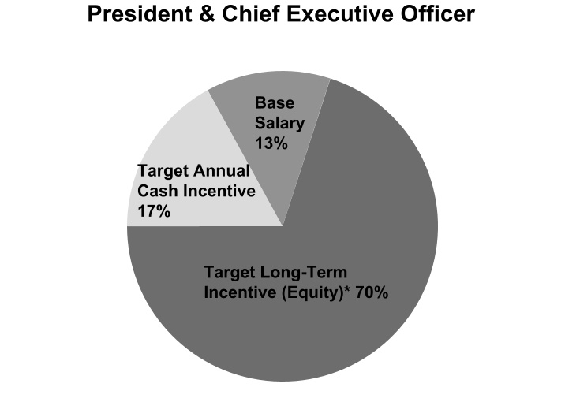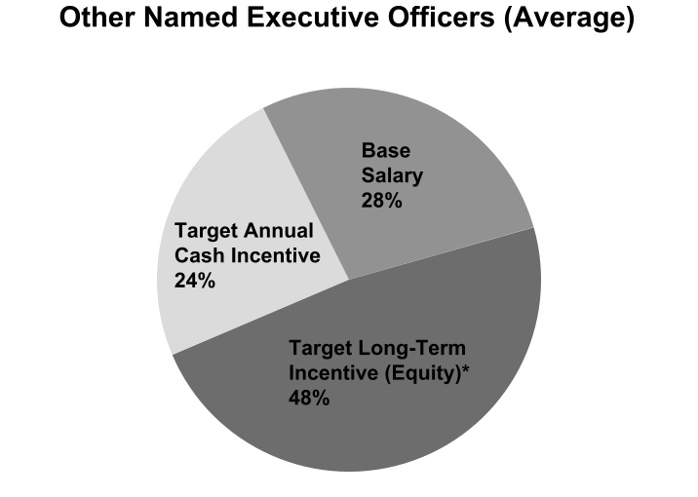
(*)Long-term equity incentive included in these charts for 2025 consists of regular annual awards of performance share units and restricted stock units with vesting as described below.
(1)Other benefits are generally excluded from target total compensation as they do not constitute a material part of compensation paid to our named executive officers.

Policies and Practices
Our compensation philosophy and guidelines are implemented through a number of policies and practices described below. The Committee continually monitors and, as appropriate, adjusts our compensation policies and practices to ensure that they are consistent with our philosophy and, as appropriate, emphasize and reward executives for results that are aligned with long-term stockholder interests and corporate governance best practices. A listing of “what we do” and “what we don’t do” is presented below:
What We Do |  |  |  |  |  |  |  |  | What We Don't Do
ü |  |  | Pay-for-Performance: Majority of pay is performance-based and not guaranteed |  |  |  |  |  | X |  |  | No Excise Tax Gross-Ups: The Company will not enter into any new agreements, or materially amend any existing employment agreements with its executives that provide excise tax gross-ups in the event of a change in control of the Company
ü |  |  | Multiple Performance Metrics and Multi-Year Time Horizon: Use multiple performance metrics and multi-year vesting periods for long-term incentives
ü |  |  | Capped Maximum Incentives: Short- and long-term incentive programs cap the maximum amount payable to help mitigate the potential risk of our programs
 |  |  |  |  |  |  |  |  | X |  |  | No Repricing or Buyouts of Stock Options: The Company’s equity plan prohibits repricing or buyouts of underwater stock options without stockholder approval
ü |  |  | Annual Compensation Risk Review: Annually assess risk in compensation programs
ü |  |  | Double-Trigger Change in Control: Cash severance payments and equity acceleration require both a change in control of the Company and constructive termination (“double-trigger”)
 |  |  |  |  |  |  |  |  | X |  |  | No Hedging or Pledging: NEOs are prohibited from hedging their ownership or pledging Company stock as collateral
ü |  |  | Share Ownership Guidelines: NEOs must comply with share ownership requirements
ü |  |  | Recoupment Policy: We maintain a recoupment policy that provides for recovery of incentive compensation in the event of fraud, embezzlement, theft or a financial restatement
 |  |  |  |  |  |  |  |  | X |  |  | No Dividends on Unearned PSUs: No dividends or dividend equivalents are paid on PSUs until they become vested and earned
ü |  |  | Challenging Performance Objectives: Set challenging performance objectives for annual and long-term incentives
ü |  |  | Use of Independent Consultant: The Compensation Committee has retained an independent compensation consultant that performs no other consulting services for the Company and has no conflicts of interest
ü |  |  | Limited Perquisites: We provide our executive officers with only limited perquisites, such as those which we consider appropriate and typical in our industry

28
Table of Contents

The Role of Stockholder Say-on-Pay Votes and Related Considerations
We provide our stockholders with the opportunity to vote annually, on an advisory basis, on the compensation of our named executive officers (the “say-on-pay vote”). At our 2025 Annual Meeting of Stockholders, approximately 97.6% of the votes cast by stockholders’ on the say-on-pay vote were in favor of the compensation of our named executive officers. The Committee has considered the results of the say-on-pay vote and believes this favorable vote affirms our stockholders’ support of its approach to executive compensation. Stockholders must be given the opportunity to vote, on an advisory basis, on the frequency of future say-on-pay votes at least every six years. The next required advisory vote on the frequency of future say-on-pay votes will occur at the 2029 Annual Meeting of Stockholders.
In addition to consideration given to the results of the say-on-pay vote, at various times throughout the year the Committee considers direct and indirect input from stockholders and other stakeholders, and more general developments in executive compensation principles, in the development and implementation of the Company’s executive compensation philosophy, policies and practices.

Independent Compensation Consultant
In 2025, as in prior years, the Committee retained Pay Governance as its independent executive compensation consultant. At least annually, the Committee conducts a review of its compensation consultant's performance and potential conflicts of interest. In accordance with applicable SEC and NYSE requirements the Committee reviewed the compensation consultant's independence, taking into account the six compensation consultant independence factors adopted by the SEC to guide companies in determining the independence of compensation consultants, and concluded that the work of the compensation consultant did not raise any conflicts of interest.
Pay Governance provides advice to the Committee on matters related to the fulfillment of the Committee’s responsibilities under its charter and on a wide range of executive compensation and related governance matters. As advisor to the Committee, Pay Governance reviews the Company's overall compensation strategy and pay levels for the Company’s executive officers, examines all aspects of the Company’s executive compensation programs to ensure their ongoing support of the Company’s business strategy, informs the Committee of developing legal and regulatory considerations affecting executive compensation and benefit programs, and provides general advice to the Committee with respect to compensation decisions pertaining to the Chief Executive Officer and other executive officers.
At the Committee’s request, Pay Governance (i) reviewed our annual proxy statement disclosures, (ii) provided the Committee with an analysis of the compensation of our named executive officers as reported in the Company’s 2025 proxy statement as compared to the compensation of the named executive officers of companies within our Peer Group as reported in their proxy statements, (iii) provided the Committee with a review of incentive design practices among its peer group and the broader industry, and (iv) reviewed our Peer Group to ensure it continues to represent appropriately comparable companies for evaluating executive pay, and (v) provided the Committee with advice regarding the design and structure of the Company's performance-based compensation plans for 2026.

Reviewing Executive Compensation
With the input and analysis of its independent compensation consultant, the Committee considers a peer group for purposes of evaluating our compensation levels (the “Peer Group”) against executives in similar positions. From time to time, the Committee and its independent compensation consultant evaluate the Peer Group to ensure that the Committee is evaluating appropriately comparable companies. For purposes of 2025 compensation decisions, the Peer Group consisted of the following companies (which were the same companies included in the peer group used for purposes of 2024 compensation decisions):
–Automotive Retailers: AutoNation, Inc., Group 1 Automotive, Inc., Lithia Motors Inc., Penske Automotive Group, Inc. and Sonic Automotive Inc. (collectively, the "Automotive Peer Group")
–Non-Automotive Retailers: Advance Auto Parts, CarMax, Inc., Carvana Co., DICK's Sporting Goods, Inc., Genuine Parts Company, LKQ Corporation, Murphy USA Inc., The Goodyear Tire & Rubber Company, Tractor Supply Company and Williams‐Sonoma Inc., which group has a median annual revenue of approximately $14.6 billion.
The Committee reviewed the executive compensation data of the Peer Group in order to evaluate and confirm whether our executive compensation was within a reasonably competitive range, but did not set 2025 executive compensation levels at a specific target percentile within the Peer Group or any other comparator group. Rather, executive compensation decisions were based on the full consideration of all of the elements discussed above, together with the additional considerations discussed below, all of which provide input into the Committee’s deliberations and inform its decisions.

29
Table of Contents

Additional Considerations in Making Executive Compensation Decisions
As described above, while we do not specifically benchmark our executive compensation to a specific target percentile, the Committee generally aims to establish total compensation for our executive officers at levels it considers competitive with executives in similar positions within our Peer Group. Notwithstanding this, given the Committee's focus on the alignment of management and stockholder interests and the related use of short-term cash incentives and time-vested and performance-based equity compensation as the principal components of compensation, the Committee expects that when our performance exceeds targeted performance levels, the actual payouts received by our executive officers may be above competitive median levels. In addition to considering the evaluations and analyses prepared by Pay Governance, to help evaluate our executive compensation against that of our Peer Group, the Committee considered a number of other factors when setting executive officer compensation for 2025, including:
–the executive’s knowledge, skills, abilities, experience, tenure and how critical the individual's role is to the Company;
–the significant expansion of the nature and scope of the individual’s responsibilities as a result of the Company's growth through recent acquisitions;
–our financial condition and recent operating results; and
–internal equity considerations.

Review of 2025 Total Compensation
For 2025, each named executive officer was initially eligible to receive compensation consisting of the following four primary elements: (i) a base salary; (ii) a short-term (annual) incentive in the form of a cash bonus opportunity pursuant to our 2019 Equity and Incentive Compensation Plan (the "2019 Plan"); (iii) long-term incentives in the form of equity awards under the 2019 Plan; and (iv) certain limited perquisites and other benefits.
Base Salaries
On an annual basis, absent a change in circumstances at another time of year that would make reconsideration appropriate at that time, the Chief Executive Officer makes recommendations to the Committee regarding increases, if any, in base salaries for named executive officers other than himself. The Committee reviews increases in base salary for the Chief Executive Officer, if any. In setting base salary, the Committee takes into account the named executive officer’s experience, skills, tenure and importance to us, historical individual performance, significant contributions, the nature and scope of the individual’s responsibilities and internal equity considerations. The Committee also considers our financial health and the compensation data from our Peer Group received from its independent executive compensation consultant.
Following the regular, annual review of base salaries by the Committee at its regularly scheduled meeting in the first quarter of 2025, the Committee awarded market-based adjustments in base salaries to the named executive officers. Annual base salaries for 2025 for our named executive officers as determined by the Board of Directors in February 2025 except as noted, were as follows:
Name |  |  | Current Position |  |  | 2025 Annualized Base Salary
David W. Hult |  |  | President & Chief Executive Officer |  |  | $ | 1,300,000
Daniel E. Clara |  |  | Chief Operating Officer |  |  | $ | 800,000
Michael D. Welch |  |  | Senior Vice President & Chief Financial Officer |  |  | $ | 750,000
Dean A. Calloway |  |  | Senior Vice President, General Counsel & Secretary |  |  | $ | 675,000
Jed M. Milstein |  |  | Senior Vice President & Chief Human Resources Officer |  |  | $ | 650,000
Annual Cash Incentive Opportunity
As described above, in order to motivate management toward the achievement of certain pre-established corporate goals and to remain competitive in the industry, we believe that a significant portion of each executive officer’s total compensation should be performance-based. We also believe that our executives are motivated by the opportunity to earn incremental cash compensation based upon the achievement of annual performance objectives, and that such opportunity properly fosters effective management, innovative thinking and, in some instances, the implementation of effective cost-saving measures by our executive officers, which may enable us to further enhance our stockholder value. Cash awards paid to our executive officers are paid under the terms of the 2019 Plan.
For 2025, the Committee decided it was appropriate to use a cash incentive plan structure, with potential payouts under the cash incentive plan being dependent upon the achievement of (a) EBITDA (subject to adjustment as described below) correlated with actual United States Annual Automotive Sales (“USAAS”) as reported by Wards Intelligence, which such
30
Table of Contents

metric being assigned an 80% weight, (b) predetermined strategic objectives, which such objectives being assigned a 20% weight, and (c) Committee review of other strategic initiatives.
EBITDA Performance Goals
We define EBITDA as earnings before non-floor plan interest, income taxes and depreciation and amortization. The selection of EBITDA as the performance benchmark for payouts under the annual cash incentive plan reflected the Committee’s continued belief that EBITDA is an important metric used by management from time to time to evaluate and analyze results and the impact on the Company of strategic decisions and actions relating to, among other things, events outside of normal, or “core,” business operations, and is often used by investors and market analysts in comparing performance and in determining enterprise value. Further, the Committee believed it was appropriate to establish award opportunities at various levels of actual USAAS, which is highly uncertain and is beyond the control of management. As a result, the Committee believed it was appropriate to increase target EBITDA at higher levels of USAAS.
In connection with the determination of EBITDA as the appropriate performance metric under the annual cash incentive plan, the Committee further believed it was appropriate to provide for certain potential adjustments to the traditional measure of EBITDA to account for the impact on our financial results of certain potential extraordinary items that are considered outside of normal, or core, business operations.
Under the annual cash incentive plan, to account for the potential for different levels of 2025 USAAS, three EBITDA performance goals were established: (i) a “threshold” level; (ii) a “target” level; and (iii) a “maximum” level at varying levels of USAAS. Under the terms of the annual cash incentive plan, if EBITDA did not meet the established “threshold” level at the actual USAAS, no payouts would be made under the plan. Further, if EBITDA exceeded the established “maximum” level at the actual USAAS, payout under the annual cash incentive plan would be limited as if performance had equaled the maximum performance goal. If actual USAAS was between two established levels, or if the achievement of EBITDA performance goals was between threshold and target levels, or target and maximum levels, participants would be entitled to a ratable portion of any payment due based upon linear interpolation.
In determining what it considered an appropriate “target” performance goal at the various levels of USAAS, the Committee consulted with management and evaluated various internally-prepared models and forecasts. The Committee approved the threshold and maximum performance goals at 85% and 115% of target, respectively.
The table below sets out the threshold, target and maximum EBITDA performance goals approved for 2025, with such goals being assigned an 80% weight.
USAAS  (in millions) |  |  | EBITDA Performance Goals (in millions)
 |  |  | Threshold (85% of Target) 50% Payout |  |  |  | Target (100%)  100% Payout |  |  | Maximum (115% of Target) 200% Payout
14.8 & Lower |  |  | $761.0 |  |  |  | $895.3 |  |  | $1,029.6
15.3 |  |  | $773.1 |  |  |  | $909.5 |  |  | $1,045.9
15.8 |  |  | $780.0 |  |  |  | $917.6 |  |  | $1,055.2
16.3 |  |  | $784.4 |  |  |  | $922.8 |  |  | $1,061.2
16.8 |  |  | $773.7 |  |  |  | $910.2 |  |  | $1,046.7
17.3 |  |  | $768.5 |  |  |  | $904.1 |  |  | $1,039.7
17.8 & Higher |  |  | $762.5 |  |  |  | $897.1 |  |  | $1,031.7
Actual: 16.2 |  |  | $783.6 |  |  |  | $921.9 |  |  | $1,060.2
For 2025, actual USAAS was 16.2 million. Based on this level of USAAS, EBITDA levels for the purpose of determining payouts under the annual cash incentive plan were calculated by interpolation as follows: threshold: $783.6 million; target: $921.9 million; and maximum: $1,060.2 million. The Committee adjusted the Company reported Adjusted EBITDA for the impact on our financial results of certain items that were not considered in the targeted EBITDA, which resulted in an Adjusted EBITDA for purposes of the performance goals of $974.3 million in 2025 and a corresponding formulaic achievement of 138% of target (110% weighted payout percentage) for the EBITDA component.
Strategic Objectives
The strategic objectives established for 2025 consisted of the following four measures of the Company’s performance: (1) management’s continued success and progress with respect to the integration of large acquisitions; (2) Tekion implementation; (3) the Company’s operating margin relative to its peers; and (4) corporate responsibility, with such strategic objectives being assigned an aggregate weight of 20%. The bonus achievement percentage for strategic objectives ranges from 0% for no objectives achieved to a maximum weighted payout percentage of 40% for exceeding achievement of such objectives, based on Committee discretion.
31
Table of Contents

The Committee reviewed the achievements of the Company relative to its four strategic objectives as described above. For the first strategic objective, the Committee took into consideration management’s continued success in integrating its acquired large businesses in the prior five years, including the recent Herb Chambers acquisition. For the second strategic objective, the Committee considered management’s continued implementation of the Tekion dealership management system. For the third strategic objective, the Committee considered the Company’s adjusted operating margin of 5.7%, which ranked highest as compared to that of its auto retail peers. For the last strategic objective, the Committee considered the Company’s achievements related to corporate responsibility, including being recognized as one of the World’s Most Trustworthy Companies for 2025 by Newsweek, the launching of multiple leadership development programs, and charitable donations and activities. Based on the Company's performance as to the strategic objectives described above, the Committee determined a payout factor of 27% for the strategic objectives component.
The Committee may increase the bonus payout by up to ten percentage points based on its evaluation of the achievement of other strategic initiatives, including operational initiatives, acquisitions, divestitures and others in furtherance of the Company's long-term interests. The Committee did not exercise discretion to increase the bonus payout for 2025.
The Company's EBITDA performance combined with the Company's performance against strategic objectives described above resulted in a total bonus payout of 137% of target under the cash incentive plan as set forth in the table below.
Performance Component |  |  | Actual Achievement  (% of Target) |  |  | Weighting |  |  |  |  |  |  |  |  | Weighted Payout
EBITDA |  |  | 138% |  |  | x |  |  | 80% |  |  | = |  |  | 110%
Strategic Objectives: Acquisition Integration Success, Technology Implementation, Operating Margin Relative to Peers, Corporate Responsibility |  |  |  |  |  |  |  |  | 0 to 40% |  |  | = |  |  | 27%
Committee Review of Other Strategic Initiatives |  |  |  |  |  |  |  |  | Up to 10% |  |  |  |  |  | 0%
Final Payout (% of Target) |  |  |  |  |  |  |  |  |  |  |  |  |  |  | 137%
The Committee established incentive opportunities, as a percentage of base salary, for each named executive officer dependent upon each named executive officer's respective current and expected positions, skills, and experience, as well as other factors described above, including the degree of responsibility assumed and expected to be assumed by such individual for aspects of the organization that impact our financial performance. The various incentive opportunities (as a percentage of base salary) and actual dollar amounts paid pursuant to the 2025 annual cash incentive plan are detailed in the table below.
Name |  |  | Threshold Opportunity  (% of Salary) |  |  | Target Opportunity  (% of Salary) |  |  | Maximum Opportunity  (% of Salary) |  |  | Actual Payment (137% of Target)
David W. Hult |  |  | 67.5% |  |  | 135% |  |  | 270% |  |  | $ | 2,404,350
Daniel E. Clara |  |  | 42.5% |  |  | 85% |  |  | 170% |  |  | $ | 931,600
Michael D. Welch |  |  | 42.5% |  |  | 85% |  |  | 170% |  |  | $ | 873,375
Dean A. Calloway |  |  | 42.5% |  |  | 85% |  |  | 170% |  |  | $ | 786,038
Jed M. Milstein |  |  | 42.5% |  |  | 85% |  |  | 170% |  |  | $ | 756,925
Equity-Based Compensation Opportunities
As described elsewhere in this CD&A, the Committee believes it is appropriate that a significant portion of executive officer compensation opportunity be in the form of at-risk equity awards, the payment of which is dependent upon the achievement of either or both of: (i) certain predetermined financial metrics and (ii) continued employment. The Committee generally does not use a specific formula for allocating equity-based compensation opportunity as a percentage of total compensation for the named executive officers. For 2025, consistent with prior years, the Committee considered a number of factors in establishing the level of long-term equity-based compensation opportunity for each named executive officer, primarily:
–Peer Group compensation pay practices and norms for comparable executives;
–general industry pay levels for comparable executives as gathered from publicly-available sources;
–historical individual performance and responsibility of the executive;
–knowledge, skills, abilities, experience, tenure and how critical the individual's role is to the Company;
–expected future responsibilities of the executive;
32
Table of Contents

–the impact of recent historical equity-based compensation decisions, awards and payouts to each executive; and
–internal pay equity considerations.
Annual Equity Awards Program
In evaluating the structure of equity-based compensation awards and type of equity award opportunities, the Committee designed equity-based awards for executive officers in 2025 that are intended to address both the long-term performance and retention objectives of our equity compensation philosophy, while at the same time promoting the achievement of operational excellence. The Committee determined that the value of the annual grant for executives who were employed by the Company when the grants were approved in the first quarter of 2025, assuming target level performance, would consist of:
–60% performance share units; the vesting of which is subject to our achievement of certain financial performance metrics, as described below, as well as the passage of time, which the Committee believes provides an appropriate balance of executive officer focus on our financial success, and economic benefit for continued employment; and
–40% time-vesting restricted stock units; which the Committee believes enhances executive officer retention.
2025 Annual Restricted Stock Unit Award Terms
The annual restricted stock unit awards granted to the named executive officers by the Committee generally vest ratably over three years beginning on the first anniversary of the grant date, as the Committee believes that this provides appropriate officer retention benefits and, assuming the continued employment of the executive, also provides for a level of consistency in future compensation.
In the event that dividends are paid on shares of our common stock at any time when restricted stock unit awards remain unvested, any such dividends will accrue and be payable to the grantee upon vesting of the underlying shares. In the event such shares do not vest, no such dividends will be paid.
2025 Annual Performance Share Unit Award Terms
The annual performance share unit awards granted to the named executive officers had a performance period based on our fiscal year 2025 performance (described below) for all metrics. Based on achievement against the applicable performance goals, the earned portion of these awards (if any) vests ratably over three-years, generally subject to continued employment through the vesting period. These performance share unit awards, if earned, will be paid in shares of our common stock. In developing the structure of the annual performance share unit award program, the Committee believed it was important to set what it considered challenging yet attainable targets for the performance period. The Committee determined that it would be appropriate to measure our performance against multiple performance metrics during 2025. The Committee believes that the blend of fiscal 2025 performance goals along with vesting restrictions over a longer time horizon appropriately recognizes the difficulty in forecasting performance results in the automotive industry, while also promoting alignment with stockholder interests, retention of executives, and the achievement of operational excellence.
The annual performance share unit awards provide each executive with a target number of performance share units that may be earned based on a mix of our absolute performance and our performance relative to the “Automotive Peer Group", (generally referencing each entity's most recent publicly available financial results) with respect to performance metrics approved by the Committee in the first quarter of the year as described below.
The number of performance share units awarded to each executive (other than the Chief Executive Officer) was recommended to the Committee by the Chief Executive Officer based on the factors described above in “Equity Based Compensation Opportunity,” and included but were not limited to each executive’s past performance and level of responsibility. The number of performance share units awarded to the Chief Executive Officer was determined by the Committee and awarded to the Chief Executive Officer based on these same factors.
Under our 2025 annual performance share unit award program, our performance, and the actual number of shares earned was determined or scored based upon the following performance elements, and weightings, which were chosen because the Committee determined them to be key drivers of growth, operational efficiency, stockholder value and long-term performance in our industry, as follows: (a) 70% of the award was based on the Company’s 2025 adjusted EPS compared with the actual EPS targets based on the actual USAAS as reported by Wards Intelligence in the target EPS matrix as set forth below (the "EPS Target") and (b) 30% of the award was based on the Company’s 2025 adjusted EPS growth relative to the 2025 adjusted EPS growth of the companies comprising the Automotive Peer Group (the "EPS Growth Relative to Peer Target"). The Committee may exercise its discretion to assign a payout percentage regarding the relative adjusted EPS performance measure.

33
Table of Contents

USAAS Compared to Target EPS Matrix
70% Weight |  |  |  |  |  |  |  |  |  |  |  |  |  |  | 30% Weight
2025 USAAS |  |  | 1-Year EPS |  |  |  |  |  |  |  |  |  |  |  | Adjusted EPS Growth Relative to Peers
 |  |  | Threshold |  |  | Target |  |  | Maximum
 |  |  | (85)% |  |  | (100)% |  |  | (115)% |  |  |  |  |  | Performance |  |  | Payout % of Target
14.8 & Lower |  |  | $20.71 |  |  | $24.37 |  |  | $28.03 |  |  |  |  |  | Based on Committee Review |  |  | 150%
15.3 |  |  | $21.17 |  |  | $24.90 |  |  | $28.64 |  |  |  |  |  |  |  |  | 125%
15.8 |  |  | $21.43 |  |  | $25.21 |  |  | $28.99 |  |  | + |  |  |  |  |  | 100%
16.3 |  |  | $21.59 |  |  | $25.40 |  |  | $29.21 |  |  |  |  |  |  |  |  | 50%
16.8 |  |  | $21.19 |  |  | $24.93 |  |  | $28.67 |  |  |  |  |  |  |  |  | 0%
17.3 |  |  | $21.00 |  |  | $24.70 |  |  | $28.41
17.8 & Higher |  |  | $20.77 |  |  | $24.44 |  |  | $28.10
Payout % of Target |  |  | 50% |  |  | 100% |  |  | 150%
Actual 16.2 |  |  | $21.56 |  |  | $25.37 |  |  | $29.18
Notwithstanding our performance relative to the Automotive Peer Group, the Committee determined that, if our EPS growth was negative for the performance year, payout under the annual performance share unit awards would be limited to 100% of target. In addition, payout under the annual performance share unit awards is subject to the following total stockholder return (“TSR”) modifiers: (i) if the Company’s TSR increases by more than ten percent (10%) compared to the prior year, then payout will increase by ten percentage points (10%); (ii) if the Company’s TSR decreases by more than ten percent (10%), then payout will decrease by ten percentage points (10%); and (iii) if the Company’s TSR decreases by more than twenty percent (20%), then payout would be limited to 100%. Regardless of the amount of the increase in the Company’s TSR, the maximum payout is limited to 150% of target. The metrics used in the 2025 performance share unit award program were selected because of their relative importance to our financial success.
The Committee reserved the right to adjust performance results under the 2025 performance share unit awards for the Company and each member of the Automotive Peer Group for material, publicly disclosed non-core items.
The scores for each performance element are accumulated, such that the highest achievable score would result in a payout at 150% of target, the lowest achievable score would result in a payout at 0% of target and a score in between would be interpolated.
The actual number of performance share units earned was determined after the end of the 2025 fiscal year based on the Committee’s evaluation of our performance against the applicable metrics.
Based on the guidelines of the annual performance share unit program, the Company achieved adjusted EPS for 2025 of $27.43, resulting in a payout of 127% under the absolute EPS metric. In the Committee's discretion, the weighted payout percentage under the EPS Growth Relative to Peers metric could range between 0 and 45%. Based on the Company’s adjusted EPS growth rate relative to the growth rate of the 2025 adjusted EPS of the companies comprising the Automotive Peer Group, the Committee determined a payout of 11% under the EPS Growth Relative to Peers metric. As a result, after evaluating our performance on a cumulative basis, under each of the two performance metrics discussed above, the Committee determined the actual payout based on performance and established a payout of a number of performance share units at 100% of target.
The Committee determined that the Company's 2025 total stockholder return was -5.5% compared to 2024, which, according to the TSR modifier (described above), resulted in no adjustment to the payout.
Performance Component |  |  | Actual Achievement  (% of Target) |  |  | Weighting |  |  |  |  |  |  |  |  | Weighted Payout
Absolute EPS |  |  | 127% |  |  | x |  |  | 70% |  |  | = |  |  | 89%
Adjusted EPS Growth Relative to Peers |  |  |  |  |  |  |  |  | 0 to 45% |  |  | = |  |  | 11%
Absolute TSR |  |  |  |  |  | +/- 10% Modifier |  |  |  |  |  |  |  |  | 0%
Final Payout (% of Target) |  |  |  |  |  |  |  |  |  |  |  |  |  |  | 100%
34
Table of Contents

Payments of awards pursuant to the 2025 annual performance share unit award program were earned as set forth below.
Name |  |  | Target Number of PSUs Granted |  |  | Number of Shares of Common Stock Earned Under the 2025 Annual Performance Share Unit Award Program(1)
David W. Hult |  |  | 14,261 |  |  | 14,261
Daniel E. Clara |  |  | 3,056 |  |  | 3,056
Michael D. Welch |  |  | 2,852 |  |  | 2,852
Dean A. Calloway |  |  | 2,038 |  |  | 2,038
Jed M. Milstein |  |  | 2,038 |  |  | 2,038
(1)Share amounts adjusted for rounding.
In accordance with the terms of the 2025 annual performance share unit award program, one-third of the award earned by each named executive officer was eligible to vest on the later of the first anniversary of the grant date and the date the payout of a number of shares of our common stock is established by the Committee, with the remainder of the award vesting in equal amounts on the second and third anniversaries of the grant date, subject generally in each case to the executive’s continued employment.
Other Benefits
In 2025, our executive officers were eligible to participate in the employee benefit plans generally available to all our employees in the corporate office, including medical, dental, life and disability insurance plans, as well as to participate in our 401(k) plan.
In the automobile retailing industry, senior executives are typically provided with the use of one or more demonstrator vehicles from a retailer’s inventory of new vehicles in order to, among other things, show support for the retailer’s offered brands. Executives are typically entitled to these vehicles for business and personal use. Management has limited the number of demonstrator vehicles provided to our employees due to the risks associated with the use of such vehicles. To provide a similar benefit, we provide a cash car allowance of $800 per month to certain of our corporate officers, including our NEOs, except Mr. Clara. Mr. Clara received the use of one demonstrator vehicle in lieu of a cash car allowance for 2025. Additionally, in 2025, Mr. Hult was entitled to use one demonstrator vehicle pursuant to the terms of his employment agreement.
Recoupment Policy
In light of rules promulgated by the NYSE and the SEC, we amended our compensation recoupment policy in 2023 to comply with the required standards (the “NYSE Clawback Policy”). The NYSE Clawback Policy provides for the prompt recovery (or clawback) of certain excess incentive-based compensation received during an applicable three-year recovery period by current or former executive officers in the event we are required to prepare an accounting restatement due to material noncompliance with any financial reporting requirement under the securities laws. Excess incentive-based compensation for these purposes generally means the amount of incentive-based compensation received (on or after October 2, 2023) by such executive officer that exceeds the amount of incentive-based compensation that would have been received by such executive officer had it been determined based on the restated amounts, without regard to any taxes paid. Incentive-based compensation potentially subject to recovery under the NYSE Clawback Policy is in general limited to any compensation granted, earned or vested based wholly or in part on the attainment of a financial reporting measure. In addition, our recoupment policy permits us to recoup actual compensation paid to any employee to cover any amounts that may have been embezzled, stolen or otherwise misappropriated by such employees, as well as recoup compensation on a after-tax basis upon certain other events including when an employee has received more compensation (whether cash or equity related) due to accounting, clerical, administrative, mathematical or other error.
In general, we may utilize a broad range of recoupment methods under the NYSE Clawback Policy. The NYSE Clawback Policy does not condition clawback on the fault of the executive officer, and clawback thereunder is generally mandatory, except in limited circumstances where the Board has made a determination that recovery would be impracticable and (1) we have already attempted to recover such amounts but the direct expenses paid to a third party in an effort to enforce the NYSE Clawback Policy would exceed the amount to be recovered, (2) the recovery of amounts would violate applicable home country law, or (3) the recovery would cause the non-compliance of a tax-qualified retirement plan under the Internal Revenue Code and applicable regulations. The foregoing summary of our NYSE Clawback Policy is qualified in its entirety by reference to the complete text of our NYSE Clawback Policy contained in our Corporate Governance Guidelines, which can be found on our website at https://investors.asburyauto.com/corporate-governance.

35
Table of Contents

Employment, Severance and Change in Control Arrangements
General Provisions of Employment and Severance Agreements
We have entered into an employment agreement with Mr. Hult. In addition, we are party to certain agreements relating to severance pay with each of Messrs. Welch, Clara, Milstein and Calloway. These agreements provide for the allocation of certain benefits in the event of involuntary termination of the employment of the named executive officer without cause or by the named executive officer where good reason exists.
We believe that our severance arrangements serve as appropriate retention and motivational tools for our continuing named executive officers by generally providing a measure of financial security in the event of an unplanned termination of employment, with the exception of a termination for cause. Furthermore, from time to time, we examine various strategic alternatives, and the provisions of these agreements are important to retain these key people whose continued employment might be at risk in certain changes of control, although such transactions may otherwise be in the best interests of our stockholders. As a corporate policy, we believe that it may be difficult to attract and retain talented executives with provisions in our severance arrangements that deny severance benefits in the event of a termination for other than performance-related issues.
On December 8, 2025, the Company announced that Mr. Hult will transition from his position as President and Chief Executive Officer to the role of Executive Chairman effective following the 2026 Annual Meeting. In connection with Mr. Hult’s transition to Executive Chairman, Mr. Hult and the Company entered into an amendment to Mr. Hult’s employment agreement.
A description of the terms of our named executive officers' employment, severance and separation agreements, including the potential payouts to these individuals pursuant to applicable severance provisions thereof, are summarized in the “Potential Payments Upon Termination or Change in Control” section of this proxy statement.

Tax Treatment of Certain Compensation
In making decisions about executive compensation, we continue to consider the impact of regulatory provisions, including the provisions of Section 409A regarding deferred compensation and the “golden parachute” provisions of Section 280G of the Code. We also consider how various elements of compensation will impact our financial results. In this regard, we consider the impact of applicable stock compensation accounting rules, which determine how we recognize the cost of employee services received in exchange for awards of equity instruments.

36
Table of Contents

COMPENSATION & HUMAN RESOURCES COMMITTEE REPORT
The Compensation & Human Resources Committee has reviewed and discussed with management the "Compensation Discussion & Analysis" section of the proxy statement required by Item 402(b) of Regulation S-K of the Exchange Act and, based on such review and discussions, the Compensation & Human Resources Committee recommended to the Board that the "Compensation Discussion & Analysis" section be included in this proxy statement and incorporated by reference in the Company’s Annual Report on Form 10-K for the fiscal year ended December 31, 2025.
Members of the Compensation & Human Resources Committee
Maureen F. Morrison (Chair)
Joel Alsfine
B. Christopher DiSantis
Shamla Naidoo
Thomas J. Reddin
Bridget Ryan-Berman

COMPENSATION COMMITTEE INTERLOCKS & INSIDER PARTICIPATION
During 2025, Ms. Morrison (Chair), Mr. Alsfine, Ms. Naidoo, Mr. Reddin and Ms. Ryan-Berman, none of whom is or was formerly an officer or employee of the Company, served as members of the Compensation & Human Resources Committee of our Board. None of the Compensation & Human Resources Committee members or other members of the Board serves as an executive officer of any entity for which one of the Company’s executive officers serves as a director or member of such other entity’s compensation committee.

37
Table of Contents

EXECUTIVE COMPENSATION
The following table (the "Summary Compensation Table" or "SCT"), footnotes and related narrative show the compensation of the named executive officers for each of the last three or fewer fiscal years during which such individuals were named executive officers. Our NEOs during fiscal year 2025 include our CEO, our CFO, and the three most highly compensated executive officers (other than the CEO and CFO) who were serving as executive officers at the end of 2025. For a more detailed discussion about the compensation arrangements for these named executive officers, see “Compensation Discussion & Analysis.”

2025 Summary Compensation Table
Name and Principal Position |  |  | Year |  |  | Salary |  |  | Bonus |  |  | Stock  Awards(1) |  |  | Non-Equity Incentive Plan Compensation(2) |  |  | All Other Compensation |  |  | Total
David W. Hult  President & Chief Executive  Officer (3) |  |  | 2025 |  |  | $ | 1,300,000 |  | $ | — |  | $ | 6,999,971 |  | $ | 2,404,350 |  | $ | 31,582 |  | $ | 10,735,903
 |  |  | 2024 |  |  | $ | 1,300,000 |  | $ | — |  | $ | 6,000,045 |  | $ | 1,667,250 |  | $ | 31,835 |  | $ | 8,999,130
 |  |  | 2023 |  |  | $ | 1,300,000 |  | $ | — |  | $ | 4,999,895 |  | $ | 1,807,650 |  | $ | 31,082 |  | $ | 8,138,627
Daniel E. Clara  Chief Operating Officer(4) |  |  | 2025 |  |  | $ | 793,269 |  | $ | — |  | $ | 1,499,889 |  | $ | 931,600 |  | $ | 26,342 |  | $ | 3,251,100
 |  |  | 2024 |  |  | $ | 743,269 |  | $ | — |  | $ | 1,000,080 |  | $ | 605,625 |  | $ | 27,247 |  | $ | 2,376,221
 |  |  | 2023 |  |  | $ | 694,231 |  | $ | — |  | $ | 849,998 |  | $ | 612,850 |  | $ | 27,399 |  | $ | 2,184,478
Michael D. Welch  Senior Vice President & Chief  Financial Officer(5) |  |  | 2025 |  |  | $ | 746,635 |  | $ | — |  | $ | 1,400,053 |  | $ | 873,375 |  | $ | 20,100 |  | $ | 3,040,163
 |  |  | 2024 |  |  | $ | 718,269 |  | $ | — |  | $ | 1,000,080 |  | $ | 585,438 |  | $ | 23,990 |  | $ | 2,327,777
 |  |  | 2023 |  |  | $ | 669,231 |  | $ | — |  | $ | 800,067 |  | $ | 590,963 |  | $ | 20,150 |  | $ | 2,080,411
Dean A. Calloway  Senior Vice President, General  Counsel & Secretary(6) |  |  | 2025 |  |  | $ | 664,904 |  | $ | — |  | $ | 1,000,122 |  | $ | 786,038 |  | $ | 20,100 |  | $ | 2,471,164
 |  |  | 2024 |  |  | $ | 472,308 |  | $ | — |  | $ | 599,866 |  | $ | 281,055 |  | $ | 9,600 |  | $ | 1,362,829
Jed M. Milstein  Senior Vice President & Chief  Human Resources Officer(7) |  |  | 2025 |  |  | $ | 646,635 |  | $ | — |  | $ | 1,000,122 |  | $ | 756,925 |  | $ | 20,100 |  | $ | 2,423,782
 |  |  | 2024 |  |  | $ | 621,635 |  | $ | — |  | $ | 900,094 |  | $ | 504,688 |  | $ | 19,950 |  | $ | 2,046,367
 |  |  | 2023 |  |  | $ | 594,808 |  | $ | — |  | $ | 699,971 |  | $ | 525,300 |  | $ | 19,500 |  | $ | 1,839,579
(1)The amounts in this column represent the aggregate grant date fair value computed in accordance with FASB ASC Topic 718 for awards of performance share units and restricted stock units, as described in the “Compensation Discussion & Analysis—Review of 2025 Total Compensation—Equity-Based Compensation Opportunities” discussion and in footnotes 2 and 3 of the “2025 Grants of Plan-Based Awards" table below. For a more detailed discussion of the assumptions used to determine the valuation of the stock awards set forth in this column, please see a discussion of such valuation in Note 22 in the Notes to the Consolidated Financial Statements in our Annual Report on Form 10-K for the year ended December 31, 2025, filed with the SEC on February 20, 2026. The maximum possible value of performance awards at the grant date (based on the assumption that the highest level of performance is achieved) granted to each of our named executive officers in 2025 was as follows: Mr. Hult: $6,299,797; Mr. Clara: $1,349,988; Mr. Welch: $1,259,871; Mr. Calloway: $900,287; and Mr. Milstein: $900,287. For additional information on the actual number of performance share unit awards granted, see the discussion under “Compensation Discussion & Analysis–Review of 2025 Total Compensation–Equity-Based Compensation Opportunities” above.
(2)The amounts in this column represent the actual amount earned by, and paid to, the named executive officers under the annual cash incentive plan.
(3)All Other Compensation represents (i) the aggregate incremental cost of $12,750 associated with the use of one demonstrator vehicle; and (ii) an automobile allowance of $9,600; and (iii) 401(k) match contributions.
(4)All Other Compensation represents (i) the aggregate incremental cost of $15,842 associated with the use of one demonstrator vehicle, and (ii) 401(k) match contributions.
(5)All Other Compensation represents (i) an automobile allowance of $9,600; and (ii) 401(k) match contributions.
(6)All Other Compensation represents (i) an automobile allowance of $9,600; and (ii) 401(k) match contributions.
(7)All Other Compensation represents (i) an automobile allowance of $9,600; and (ii) 401(k) match contributions

38
Table of Contents

2025 Grants of Plan-Based Awards
Name |  |  | Grant Date |  |  | Approval Date |  |  | Estimated Possible Payouts Under Non-Equity Incentive Plan Awards(1) |  |  |  |  |  |  |  |  | Estimated Future Payouts Under Equity Incentive Plan Awards(2) (# of shares) |  |  |  |  |  |  |  |  | All Other  Stock Awards: Number of Shares of Stock or Units(3) |  |  | Grant Date Fair Value of Stock and Option Awards
 |  |  |  |  |  |  |  |  | 50% Threshold |  |  | 100% Target |  |  | 200% Maximum |  |  | Threshold |  |  | Target |  |  | Maximum
David W. Hult |  |  | 2/12/25 |  |  | 2/12/25 |  |  | $ | 877,500 |  | $ | 1,755,000 |  | $ | 3,510,000
 |  |  | 2/19/25 |  |  | 2/12/25 |  |  |  |  |  |  |  |  |  |  |  |  |  |  |  |  |  |  |  |  | 9,508 |  |  | $ | 2,800,106
 |  |  | 2/19/25 |  |  | 2/12/25 |  |  |  |  |  |  |  |  |  |  |  | 7,131 |  |  | 14,261 |  |  | 21,392 |  |  |  |  |  | $ | 4,199,865
Daniel E. Clara |  |  | 2/12/25 |  |  | 2/12/25 |  |  | $ | 340,000 |  | $ | 680,000 |  | $ | 1,360,000
 |  |  | 2/19/25 |  |  | 2/12/25 |  |  |  |  |  |  |  |  |  |  |  |  |  |  |  |  |  |  |  |  | 2,037 |  |  | $ | 599,897
 |  |  | 2/19/25 |  |  | 2/12/25 |  |  |  |  |  |  |  |  |  |  |  | 1,528 |  |  | 3,056 |  |  | 4,584 |  |  |  |  |  | $ | 899,992
Michael D. Welch |  |  | 2/12/25 |  |  | 2/12/25 |  |  | $ | 318,750 |  | $ | 637,500 |  | $ | 1,275,000
 |  |  | 2/19/25 |  |  | 2/12/25 |  |  |  |  |  |  |  |  |  |  |  |  |  |  |  |  |  |  |  |  | 1,902 |  |  | $ | 560,139
 |  |  | 2/19/25 |  |  | 2/12/25 |  |  |  |  |  |  |  |  |  |  |  | 1,426 |  |  | 2,852 |  |  | 4,278 |  |  |  |  |  | $ | 839,914
Dean A. Calloway |  |  | 2/12/25 |  |  | 2/12/25 |  |  | $ | 286,875 |  | $ | 573,750 |  | $ | 1,147,500
 |  |  | 2/19/25 |  |  | 2/12/25 |  |  |  |  |  |  |  |  |  |  |  |  |  |  |  |  |  |  |  |  | 1,358 |  |  | $ | 399,931
 |  |  | 2/19/25 |  |  | 2/12/25 |  |  |  |  |  |  |  |  |  |  |  | 1,019 |  |  | 2,038 |  |  | 3,057 |  |  |  |  |  | $ | 600,191
Jed M. Milstein |  |  | 2/12/25 |  |  | 2/12/25 |  |  | $ | 276,250 |  | $ | 552,500 |  | $ | 1,105,000
 |  |  | 2/19/25 |  |  | 2/12/25 |  |  |  |  |  |  |  |  |  |  |  |  |  |  |  |  |  |  |  |  | 1,358 |  |  | $ | 399,931
 |  |  | 2/19/25 |  |  | 2/12/25 |  |  |  |  |  |  |  |  |  |  |  | 1,019 |  |  | 2,038 |  |  | 3,057 |  |  |  |  |  | $ | 600,191
(1)Represents potential payouts under our annual cash incentive plan for each named executive officer. For a more detailed discussion of the annual cash incentive plan and the actual awards paid under this plan, see the section of this proxy statement entitled, “Compensation Discussion & Analysis—Review of 2025 Total Compensation—Annual Cash Incentive Opportunity” and the “2025 Summary Compensation Table.”
(2)Represents performance share unit awards. For a more detailed discussion of the Company’s performance share unit award program, see the section of this proxy statement entitled, “Compensation Discussion & Analysis—Review of 2025 Total Compensation—Annual Equity Awards Program” and the "2025 Summary Compensation Table."
(3)Represents grants of restricted stock units. For a more detailed discussion of the Company's restricted stock unit awards, see the section of this proxy statement entitled, “Compensation Discussion & Analysis—Review of 2025 Total Compensation—Annual Equity Awards Program” and the “2025 Summary Compensation Table.”

39
Table of Contents

Outstanding Equity Awards at 2025 Fiscal Year-End
Name |  |  | Stock Awards(1)
 |  |  | Grant Date |  |  | Number of Shares or Units of Stock That Have Not Vested (#) |  |  |  |  |  | Market Value of Shares or Units of Stock That Have Not Vested(2) |  |  | Equity Incentive Plan Awards: Number of Unearned Shares, Units or Other Rights That Have Not Vested (#) |  |  |  |  |  | Equity Incentive Plan Awards: Market or Payout Value of Unearned Shares, Units or Other Rights That Have Not Vested(3)
David W. Hult |  |  | 2/14/23 |  |  | 6,962 |  |  | (4) |  |  | $ | 1,618,874
 |  |  | 2/20/24 |  |  | 16,230 |  |  | (5) |  |  | $ | 3,773,962
 |  |  | 2/19/25 |  |  | 9,508 |  |  | (6) |  |  | $ | 2,210,895 |  | 21,392 |  |  | (7) |  |  | $ | 4,974,282
Daniel E. Clara |  |  | 2/14/23 |  |  | 1,184 |  |  | (4) |  |  | $ | 275,316
 |  |  | 2/20/24 |  |  | 2,706 |  |  | (5) |  |  | $ | 629,226
 |  |  | 2/19/25 |  |  | 2,037 |  |  | (6) |  |  | $ | 473,664 |  | 4,584 |  |  | (7) |  |  | $ | 1,065,918
Michael D. Welch |  |  | 2/14/23 |  |  | 1,115 |  |  | (4) |  |  | $ | 259,271
 |  |  | 2/20/24 |  |  | 2,706 |  |  | (5) |  |  | $ | 629,226
 |  |  | 2/19/25 |  |  | 1,902 |  |  | (6) |  |  | $ | 442,272 |  | 4,278 |  |  | (7) |  |  | $ | 994,763
Dean A. Calloway |  |  | 2/14/23 |  |  | 211 |  |  | (4) |  |  | $ | 49,064
 |  |  | 2/20/24 |  |  | 831 |  |  | (5) |  |  | $ | 193,232
 |  |  | 7/1/24 |  |  | 876 |  |  | (5) |  |  | $ | 203,696
 |  |  | 2/19/25 |  |  | 1,358 |  |  | (6) |  |  | $ | 315,776 |  | 3,057 |  |  | (7) |  |  | $ | 710,844
Jed M. Milstein |  |  | 2/14/23 |  |  | 975 |  |  | (4) |  |  | $ | 226,717
 |  |  | 2/20/24 |  |  | 2,435 |  |  | (5) |  |  | $ | 566,211
 |  |  | 2/19/25 |  |  | 1,358 |  |  | (6) |  |  | $ | 315,776 |  | 3,057 |  |  | (7) |  |  | $ | 710,844
(1)All information in the “Stock Awards” portion of the table relates to awards of shares of restricted stock units and performance share unit awards.
(2)Based on a stock price of $232.53, the closing price of our common stock on December 31, 2025, the last business day of fiscal 2025.
(3)Represents the aggregate payout value of performance shares underlying each award of performance share units that has not yet been earned as of fiscal year-end, calculated by multiplying the maximum number of performance share units by $232.53, the closing price of our common stock on December 31, 2025, the last business day of fiscal 2025.
(4)This unvested portion of the restricted share units or earned performance share units vests on the third anniversary of the grant date.
(5)This unvested portion of the restricted share units or earned performance share units vests in substantially equal installments on each of the second and third anniversaries of the grant date.
(6)This unvested portion of the restricted share units or earned performance share units vest in substantially equal installments on each of the first three anniversaries of the grant date.
(7)These performance share units can be earned based on performance achievement during the 2025 performance period, as further described in the “Compensation Discussion and Analysis.” One-third of the earned award vests on the later of the first anniversary of the grant date and the date on which the Committee determines performance achievement for the award. The remaining portion of the earned award vests in substantially equal installments on each of the second and third anniversaries of the date of grant. The amount in this column assumes payout at the maximum level of performance.

40
Table of Contents

2025 Option Exercises and Stock Vested
Name |  |  | Stock Awards
 |  |  | Number of Shares Acquired on Vesting |  |  | Value Realized on Vesting(1)
David W. Hult |  |  | 23,873 |  |  | $ | 6,994,707
Daniel E. Clara |  |  | 4,413 |  |  | $ | 1,297,403
Michael D. Welch |  |  | 4,226 |  |  | $ | 1,240,928
Dean A. Calloway |  |  | 1,344 |  |  | $ | 368,648
Jed M. Milstein |  |  | 3,717 |  |  | $ | 1,090,730
(1)The value realized on the vesting of restricted stock units or performance share units represents the number of shares acquired multiplied by the closing price of our common stock, as reported on the NYSE, on the vesting date of the restricted stock units or of the performance share units, as applicable.

41
Table of Contents

POTENTIAL PAYMENTS UPON TERMINATION OR CHANGE IN CONTROL
Employment Agreement with David W. Hult
The Company entered into an employment agreement dated October 23, 2014 with David W. Hult, which agreement was amended on August 21, 2017 in connection with Mr. Hult's transition to President & Chief Executive Officer (such agreement, as amended, the “Hult Agreement”). On June 5, 2020, the Company and Mr. Hult entered into a second amendment increasing the amount of severance payable to Mr. Hult under certain circumstances and extending his term until December 31, 2023, subject to automatic one-year extensions unless either party terminates the agreement 180 days (or 90 days for a termination by Mr. Hult for “good reason”) prior to the end of the extension term. On December 5, 2025, the Company and Mr. Hult entered into a third amendment to the Hult Agreement in connection with Mr. Hult’s transition to Executive Chairman (the “Third Amendment”) effective following the 2026 Annual Meeting (the "Transition Date"). Under the Third Amendment, the Hult Agreement will continue in effect through December 31, 2027 and, unless either party gives at least 90 days’ prior written notice of termination, will renew for an additional one-year period thereafter.
Prior to the Transition Date, including during 2025, Mr. Hult’s severance protections are follows:
–If (i) the Company elects not to extend the Hult Agreement and, at its expiration, Mr. Hult will not have attained age 65, or (ii) the Company terminates the Agreement without “cause” or (iii) Mr. Hult terminates the Hult Agreement for “good reason” when no “change in control” has occurred (any of the foregoing, a “Hult Non-Change in Control Qualifying Termination”), Mr. Hult will be entitled to the following:
◦200% of his base salary, plus 100% of his target annual bonus (which includes any non-equity incentive plan compensation);
◦a pro-rated bonus (which includes any non-equity incentive plan compensation) based on actual performance for the year of termination;
◦continued participation for 12 months in all health and welfare plans of the Company in effect immediately prior to the termination of employment; and
◦accelerated vesting of all unvested equity and other long-term incentive awards that would have vested in the 364 days following the termination of the Hult Agreement.
–If Mr. Hult is terminated without cause or resigns for good reason within two years following a change in control (a “Hult Change in Control Qualifying Termination” and, together with a Hult Non-Change in Control Qualifying Termination, as the case may be, a “Hult Qualifying Termination”), Mr. Hult will be entitled to the following:
◦200% of his base salary, plus 200% of his target annual bonus (which includes any non-equity incentive plan compensation);
◦a pro-rated bonus (which includes any non-equity incentive plan compensation) based on target performance for the year of termination;
◦continued participation for 24 months in all health and welfare plans of the Company in effect immediately prior to the termination of employment; and
◦vesting of all unvested equity and other long-term incentive awards, effective on the date of the change in control.
Under the Third Amendment, effective as of the Transition Date, the Company will pay Mr. Hult an annualized base salary as follows: (i) $750,000 beginning the Transition Date through December 31, 2026; (ii) $525,000 during 2027; and (iii) $300,000 after January 1, 2028, unless otherwise determined by the Compensation & Human Resources Committee in its discretion. Mr. Hult's eligibility for a discretionary annual incentive bonus during his service as Executive Chairman will be determined by the Committee based on achievement of applicable performance objectives, with a target opportunity of: (i) for 2026, a blended rate of 135% of base salary for the period from January 1, 2026 through the Transition Date and 100% of base salary for the period from the day following the Transition Date through December 31, 2026; and (ii) 100% of base salary for 2027 and 2028. Under the terms of the Third Amendment, Mr. Hult will also have use of a Company car during his employment.
42
Table of Contents

In lieu of the severance protections previously provided under the Hult Agreement, if Mr. Hult’s employment is terminated by the Company prior to December 31, 2027 for any reason other than “cause” (as defined in the Employment Agreement), Mr. Hult will be entitled to (i) payments equal to 200% of his base salary and 100% of his target annual bonus, (ii) a pro-rata bonus for the year of termination based on actual performance for the applicable year, and (iii) continued participation in health, dental, disability and life insurance plans for up to 12 months after termination (or an economically equivalent benefit). If Mr. Hult’s employment terminates for any reason during this service as Executive Chairman other than by the Company for cause, all unvested equity and long-term incentive awards held by Mr. Hult will become 100% vested.
Severance compensation under the Hult Agreement (except in the case of death or disability) is generally conditioned on Mr. Hult executing a release of claims in favor of the Company. The Hult Agreement also contain certain confidentiality, non-compete and non-solicit obligations and provides that, if such obligations are breached by him, the Company has the right to stop making any otherwise required severance payments.
Severance and Transition Agreements
The Company is party to a severance agreement (each, a “Severance Agreement”) with each of Messrs. Clara, Welch, Calloway and Milstein. The Severance Agreements provide for one year of base salary, one year of benefits continuation, and a pro-rated bonus (which includes any payment under a non-equity incentive compensation plan) in the amount that the affected executive would have received had he not been terminated during such year (collectively, the “Severance Payment”) if (i) the affected executive is terminated by the Company without “cause,” or (ii) if the affected executive terminates his employment for any of the following reasons: (a) mandatory relocation of the affected executive's current principal place of business to a location more than 50 miles away; (b) any material diminution in the affected executive's base salary; and (c) any material diminution in the affected executive's authority, duties or responsibilities.
The Severance Agreements require the affected executive to execute a general release in favor of the Company as a condition to receiving any Severance Payments. The Severance Agreements also contain certain confidentiality, non-compete and non-solicit obligations and provides that, if such obligations are breached by the affected executive, the Company has the right to stop making any otherwise required Severance Payments. Additionally, the Severance Agreements provide that the affected executive will not receive any Severance Payment in the event of termination due to death, disability, retirement, voluntary resignation or termination by the Company for cause.
Equity Incentive Plan Payout Provisions
In addition to the payments required to be made in connection with certain qualifying separations from service described above, the Company's 2019 Plan provides that awards made thereunder, subject to the terms of any individual employment or severance agreements, will be accelerated in connection with a change in control transaction only if: (i) the acquiror does not replace or substitute an equivalent award, or (ii) a participant holding replacement awards is involuntarily terminated within two years following a Change of Control (as defined in the Company’s 2019 Plan). Under the 2019 Plan, equity awards are generally subject to double-trigger vesting, unless otherwise determined by the Committee.
Certain Defined Terms
Cause
Under the Hult Agreement, “cause” generally means any of the following: (i) the executive’s willful misconduct, failure to follow a lawful directive of the Board, gross negligence or blatant violation of Company policy, (ii) the executive’s commission of fraud, misappropriation, dishonesty or embezzlement against the Company or an affiliate, (iii) a conviction of, or entry of a plea of nolo contendere to, a felony or misdemeanor (other than traffic violations and similar offenses), or (iv) the executive’s commission of a material breach of the applicable employment agreement.
Under the Severance Agreements with Messrs. Clara, Welch, Calloway and Milstein, “cause” generally means any of the following: (i) the executive’s gross negligence or serious misconduct (including criminal, fraudulent and dishonest conduct) that is or may be injurious to the Company, (ii) the executive’s conviction of, or entry of a plea of nolo contendere to, a felony or other crime that involves moral turpitude, (iii) the executive’s breach of the confidentiality, non-compete and non-solicit obligations contained in the Severance Agreement, (iv) the executive’s willful and continued failure to perform his duties on behalf of the Company, or (v) the executive’s material breach of certain Company policies.
Good Reason
Under the Hult Agreement, “good reason” is defined as the occurrence of any of the following without the executive’s consent, but only after notice of, and an opportunity to cure, such event: (i) the nature or scope of the executive’s duties or responsibilities are materially diminished, (ii) the Company changes the location of the executive’s employment to a place
43
Table of Contents

more than 50 miles from its present location, (iii) the Company’s material breach of the applicable employment agreement, or (iv) a change in the executive’s salary below the base amount specified in the applicable employment agreement.
Change in Control
A “change in control” generally means the occurrence of any of the following events:
–any person becomes the beneficial owner of 35% or more of the Company’s securities entitled to vote in the election of directors, provided, in the case of the 2012 Plan, the 2019 Plan and the Hult Agreement that such an acquisition will not be considered a change in control if it is made by (i) the Company or any subsidiary, (ii) an employee benefit plan sponsored or maintained by the Company or any subsidiary, or (iii) a person that reports such acquisition on Schedule 13G under the Exchange Act, so long as such person does not later become required to report on Schedule 13D while beneficially owning 35% or more of the Company’s securities entitled to vote in the election of directors;
–in the case of the 2012 Plan, the 2019 Plan and the Hult Agreement, the Company’s completion of a merger, consolidation or other business combination transaction in which the Company’s securities outstanding immediately prior to such transaction represent less than 50% of the combined voting power of the Company or other surviving entity after such transaction, except where the transaction agreement provides that members of the Company’s Board serving at the time of the first public announcement of the transaction will constitute at least a majority of the directors of the resulting entity;
–individuals who, as of the date specified in the applicable agreement or plan, constitute the Board cease to constitute at least a majority of the Board, provided, in the case of the Company’s 2012 Plan, the 2019 Plan and the Hult Agreement , that any individual whose election or nomination for election by the Company’s stockholders was approved by at least 2/3 of the directors then comprising the incumbent Board will be considered to be incumbent members of the Board, but excluding any individual who first assumes office as a director of the Company as a result of an actual or threatened election contest; or
–approval by the Company’s stockholders of the liquidation or dissolution of the Company.
Potential Payments Upon Separation from Service or Change in Control
The following tables detail the amounts that would have been payable to each of our NEOs had each such officer been separated from service with the Company as of the last business day of fiscal 2025: (i) involuntarily and without cause or for good reason (a "Qualifying Termination") and without a Change in Control of the Company; (ii) pursuant to a Qualifying Termination and a Change in Control of the Company; and (iii) as the result of death or disability, in each case after taking into account the following assumptions as applicable:
–no payment value was ascribed to any presently vested and exercisable equity incentive awards, as such awards would not be impacted by a separation from service or change in control;
–all equity incentive awards that would accelerate in connection with a separation from service, change in control, or upon death or disability pursuant to the terms of applicable agreements were accelerated and cash valued as of December 31, 2025 by multiplying the number of vesting shares by the closing price per share of our common stock on the NYSE on December 31, 2025 ($232.53);
–each of the NEOs continued to be entitled to participate in the Company’s health and dental insurance plans (no such officer obtained other employment which provided at least equal benefits), and the cost thereof was cash valued at the cost to the Company;
–all parties complied with any required release and notice provisions in the applicable agreement;
–all amounts due to the named executive officers were paid immediately;
–each of the NEOs continued to comply with any restrictive or other covenant applicable to him that may have otherwise resulted in the repayment or withholding of severance amounts due; and
–all outstanding equity incentive awards were vested on an accelerated basis upon death or disability and cash valued as of December 31, 2025 by multiplying the number of vesting shares by the closing price per share of our common stock on the NYSE on December 31, 2025 ($232.53).

44
Table of Contents

Qualifying Termination Assuming No Change in Control
Named Executive Officer |  |  | Base Salary Payment(s)(1) |  |  | Bonus(1) |  |  | Benefits Continuation |  |  | Performance Share Units/ Restricted Stock/ Restricted Stock Unit Acceleration |  |  | Total
David W. Hult |  |  | $ | 2,600,000 |  | $ | 4,159,350 |  | $ | — |  | $ | 5,347,957 |  | $ | 12,107,307
Daniel E. Clara |  |  | $ | 800,000 |  | $ | 931,600 |  | $ | — |  | $ | — |  | $ | 1,731,600
Michael D. Welch |  |  | $ | 750,000 |  | $ | 873,375 |  | $ | — |  | $ | — |  | $ | 1,623,375
Dean A. Calloway |  |  | $ | 675,000 |  | $ | 786,038 |  | $ | — |  | $ | — |  | $ | 1,461,038
Jed M. Milstein |  |  | $ | 650,000 |  | $ | 756,925 |  | $ | — |  | $ | — |  | $ | 1,406,925
(1)Based upon the annual base salary in effect at December 31, 2025 and actual non-equity incentive plan compensation payable for 2025, which are described above in the "Compensation Discussion & Analysis" section of this proxy statement.
Qualifying Termination Assuming Change in Control
Named Executive Officer |  |  | Base Salary Payment(s)(1) |  |  | Bonus(1) |  |  | Benefits Continuation |  |  | Performance Share Units/ Restricted Stock/ Restricted Stock Unit Acceleration |  |  | Total
David W. Hult |  |  | $ | 2,600,000 |  | $ | 5,914,350 |  | $ | — |  | $ | 10,919,841 |  | $ | 19,434,191
Daniel E. Clara |  |  | $ | 800,000 |  | $ | 931,600 |  | $ | — |  | $ | 2,088,817 |  | $ | 3,820,417
Michael D. Welch |  |  | $ | 750,000 |  | $ | 873,375 |  | $ | — |  | $ | 1,993,945 |  | $ | 3,617,320
Dean A. Calloway |  |  | $ | 675,000 |  | $ | 786,038 |  | $ | — |  | $ | 1,235,664 |  | $ | 2,696,702
Jed M. Milstein |  |  | $ | 650,000 |  | $ | 756,925 |  | $ | — |  | $ | 1,582,599 |  | $ | 2,989,524
(1)Based upon the actual annual base salary in effect on December 31, 2025 and actual non-equity incentive plan compensation payable for 2025, which are described above in the "Compensation Discussion & Analysis" section of this proxy statement.
Separation from Service Upon Death or Disability
Named Executive Officer |  |  | Base Salary  Payment(s) |  |  | Bonus |  |  | Benefits Continuation |  |  | Performance Share Units/ Restricted Stock/ Restricted Stock Units Acceleration |  |  | Total
David W. Hult |  |  | $ | — |  | $ | — |  | $ | — |  | $ | 10,919,841 |  | $ | 10,919,841
Daniel E. Clara |  |  | $ | — |  | $ | — |  | $ | — |  | $ | 2,088,817 |  | $ | 2,088,817
Michael D. Welch |  |  | $ | — |  | $ | — |  | $ | — |  | $ | 1,993,945 |  | $ | 1,993,945
Dean A. Calloway |  |  | $ | — |  | $ | — |  | $ | — |  | $ | 1,235,664 |  | $ | 1,235,664
Jed M. Milstein |  |  | $ | — |  | $ | — |  | $ | — |  | $ | 1,582,599 |  | $ | 1,582,599

45
Table of Contents

CEO PAY RATIO
For the 2025 fiscal year, ratio (the "Pay Ratio") of the annual total compensation of Mr. Hult, our President & Chief Executive Officer during 2025 (“CEO Compensation”), to the median of the annual total compensation of all of our employees other than our Chief Executive Officer (“Median Annual Compensation”) was 153.2 to 1. This ratio is a reasonable estimate calculated in a manner consistent with Item 402(u) of Regulation S-K using the data and assumptions summarized below. In this summary, we refer to the employee who received such Median Annual Compensation as the “Median Employee.” We did not use the same Median Employee in our calculation of the Pay Ratio for the 2025 fiscal year as we did in our calculation of the Pay Ratio for the 2024 fiscal year because we determined it was appropriate to identify a new Median Employee due to our highly variable pay practices. The date used to identify the Median Employee for the 2025 fiscal year was December 1, 2025 (the “Determination Date”), which is the same calender day that was used in 2023 and 2024 fiscal year.
CEO Compensation for purposes of this disclosure was $10,735,903, which represents the total compensation reported for Mr. Hult under Summary Compensation Table for the 2025 fiscal year. For purposes of this disclosure, Median Annual Compensation was $70,072, which represents the total of our Median Employee's applicable elements of compensation for the 2025 fiscal year as determined in accordance with Item 402(c)(2)(x) of Regulation S-K.
To identify the Median Employee for the 2025 fiscal year, we first determined our employee population as of the Determination Date. We had 15,395 employees, representing all full-time, part-time, seasonal and temporary employees of us and our consolidated subsidiaries as of the Determination Date. This number does not include any independent contractors or “leased” workers, as permitted by the applicable SEC rules. We then measured compensation for the period beginning on January 1, 2025 and ending on December 31, 2025 for these employees. This compensation measurement was calculated by totaling, for each employee, gross taxable earnings, including salary, wages, commissions, bonuses, the value of equity awards that vested during the measurement period and other compensation as shown in our payroll and human resources records for 2025. A portion of our employee workforce (full-time and part-time) worked for less than the full fiscal year due to commencing employment after the beginning of the fiscal year. In determining the Median Employee, we annualized the compensation for such individuals.

46
Table of Contents

PAY VERSUS PERFORMANCE
Pay Versus Performance Table
The following tables contain information about the relationship between executive "compensation actually paid" as calculated pursuant to Item 402(v) of Regulation S-K ("CAP") to our named executive officers and certain financial performance of the Company. For a more detailed discussion about our pay-for-performance philosophy and how we align executive compensation with our Company’s performance, please see “Compensation Discussion & Analysis.”
Year |  |  | Summary Compensation Table Total for PEO(1) |  |  | Compensation Actually Paid to PEO(2) |  |  | Average Summary Compensation Table Total for Non-PEO NEOs(3) |  |  | Average Compensation Actually Paid to Non-PEO NEOs(2) |  |  | Value of Initial Fixed $100 Investment Based on: |  |  |  |  |  | GAAP Net Income (in Millions) |  |  | Adjusted EBITDA (in Millions)(6)
 |  |  |  |  |  |  |  |  |  |  |  |  |  |  | Company TSR(4) |  |  | Peer Group TSR(4)(5)
2025 |  |  | $ | 10,735,903 |  | $ | 10,318,504 |  | $ | 2,796,552 |  | $ | 2,686,398 |  | $ | 160 |  | $ | 228 |  | $ | 492 |  | $ | 1,006
2024 |  |  | $ | 8,999,130 |  | $ | 8,672,323 |  | $ | 1,969,062 |  | $ | 1,702,991 |  | $ | 167 |  | $ | 215 |  | $ | 430 |  | $ | 982
2023 |  |  | $ | 8,138,627 |  | $ | 10,546,295 |  | $ | 2,043,948 |  | $ | 2,565,627 |  | $ | 154 |  | $ | 194 |  | $ | 603 |  | $ | 1,135
2022 |  |  | $ | 8,582,645 |  | $ | 9,596,256 |  | $ | 2,407,078 |  | $ | 2,603,319 |  | $ | 123 |  | $ | 132 |  | $ | 997 |  | $ | 1,336
2021 |  |  | $ | 7,452,895 |  | $ | 9,655,142 |  | $ | 1,675,553 |  | $ | 2,032,412 |  | $ | 119 |  | $ | 144 |  | $ | 532 |  | $ | 828
(1)Mr. Hult was our Principal Executive Officer ("PEO") for the full year for each of 2025, 2024, 2023, 2022 and 2021.
(2)For each of 2025, 2024, 2023, 2022, and 2021 (each, a “Covered Year”), in determining both the compensation actually paid to our PEO and the average compensation actually paid to our non-PEO named executive officers for purposes of this column, we deducted from or added back to the total amounts of compensation reported as the Summary Compensation Table total (or average Summary Compensation Table total) certain amounts in accordance with SEC rules, as itemized below for 2025:
Item Added (Deducted) |  |  | 2025
For PEO (Mr. Hult):
- SCT “Stock Awards” column value |  |  | $ | (6,999,971)
+ Covered year-end fair value of equity awards granted in Covered Year that were outstanding and unvested at Covered Year-end |  |  | $ | 5,527,006
+/- change in fair value (from prior year-end to Covered Year-end) of equity awards granted in prior years that were outstanding and unvested at Covered Year-end |  |  | $ | (231,903)
+/- change in fair value (from prior year-end to vesting date) for prior-year equity awards that vested in Covered Year |  |  | $ | 1,287,469
- fair value (from prior year-end) for prior-year awards that failed to meet applicable vesting conditions in Covered Year |  |  | $ | —
For Non-PEO Named Executive Officers (Average):
- SCT “Stock Awards” column value |  |  | $ | (1,225,047)
+Covered year-end fair value of equity awards granted in Covered Year that were outstanding and unvested at Covered Year-end |  |  | $ | 967,267
+/- change in fair value (from prior year-end to Covered Year-end) of equity awards granted in prior years that were outstanding and unvested at Covered Year-end |  |  | $ | (32,697)
+/- change in fair value (from prior year-end to vesting date) for prior-year equity awards that vested in Covered Year |  |  | $ | 180,323
- fair value (from prior year-end) for prior-year equity awards that failed to meet applicable vesting conditions in Covered Year |  |  | $ | —
(3)The non-PEO named executive officers consist of the following individuals:
(a)For 2025, Daniel Clara, Michael Welch, Dean Calloway and Jed Milstein;
(b)For 2024, Michael Welch, Daniel Clara, Jed Milstein, Dean Calloway, George Villasana and Miran Maric;
(c)For 2023 and 2022, Michael Welch, Daniel Clara, George Villasana and Jed Milstein; and
(d)For 2021, Michael Welch, Daniel Clara, George Villasana, Jed Milstein, William Stax and Patrick Guido.
(4)For each of 2021, 2022, 2023, 2024 and 2025, total stockholder return (“TSR”) for the Company and the Peer Group Index (described below) was calculated as the cumulative total stockholder return based on a deemed fixed investment of $100 at market close on December 31, 2020, assuming dividend reinvestment. Because fiscal years are presented in the table in reverse chronological order (from top to bottom), the table should be read from bottom to top for purposes of understanding cumulative returns over time.
(5)Reflects market-weighted Peer Group Index composed of the common stock of AutoNation, Inc., Sonic Automotive, Inc., Group 1 Automotive, Inc., Penske Automotive Group, Inc. and Lithia Motors, Inc. For purposes of this disclosure, the returns of each issuer
47
Table of Contents

were weighted according to the respective issuer’s market capitalization at the beginning of each period for which a return is indicated.
(6)Adjusted EBITDA is defined in Appendix A ("Non-GAAP Financial Measures and Reconciliation").
Pay Versus Performance Charts
The following charts provide, across the last three completed fiscal years, (a) a comparison between our cumulative TSR and the total stockholder return of the Peer Group Index, and (b) illustrations of the relationships between (i) the compensation “actually paid” to the PEO and the average of the compensation “actually paid” to our non-PEO named executive officers and (ii) each of our TSR, our net income, and our Adjusted EBITDA.
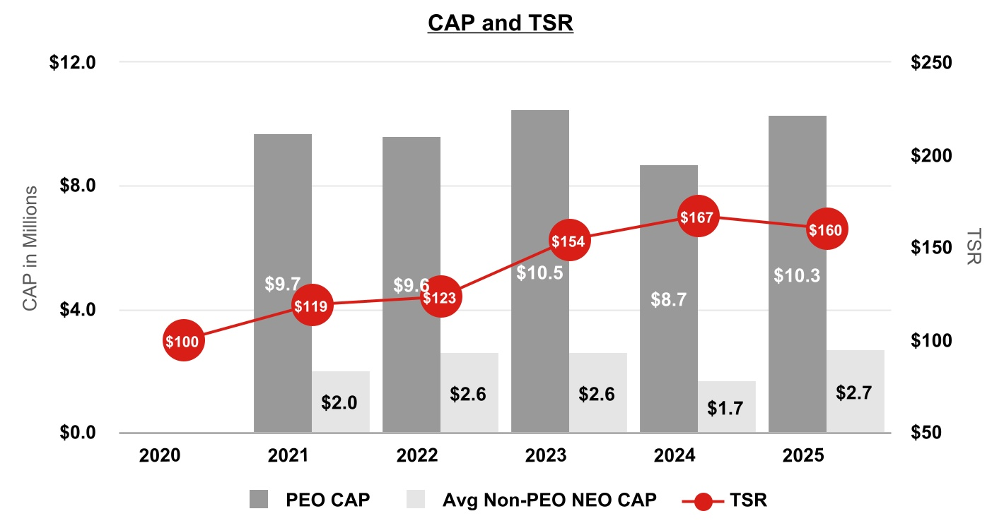
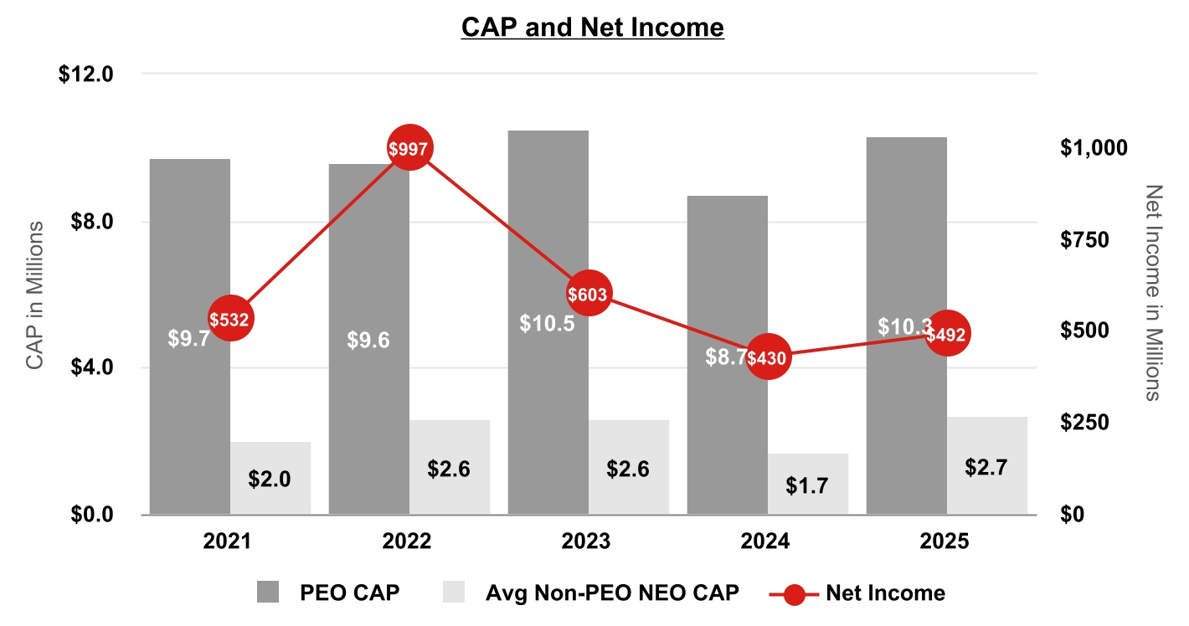
48
Table of Contents

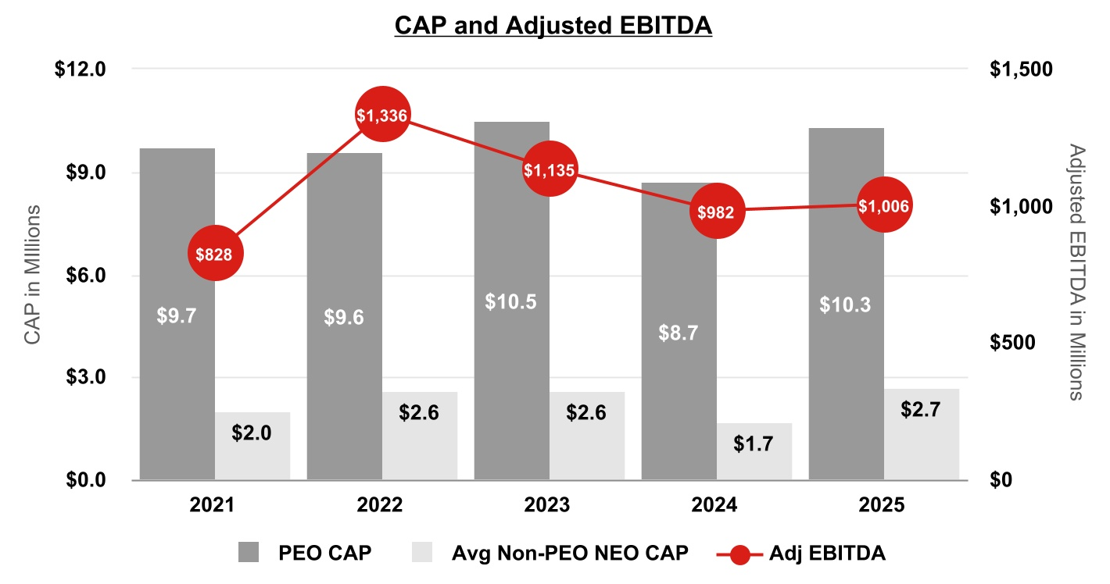
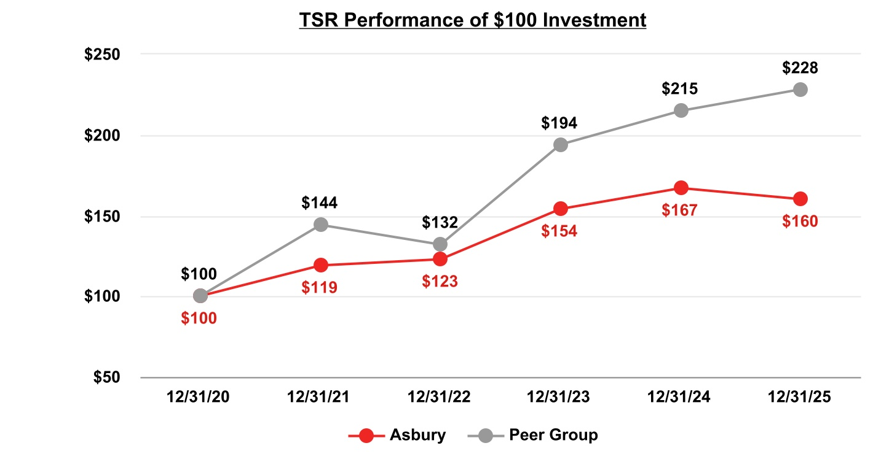
Tabular List of Performance Measures
The following table lists the three financial performance measures that the Company believes represent the most important financial performance measures used to link compensation actually paid to the named executive officers for fiscal 2025 to the Company's performance:
Most Important Performance Measures
Adjusted EBITDA
Adjusted EPS
Adjusted Operating Margin

49
Table of Contents

SECURITIES AUTHORIZED FOR ISSUANCE UNDER EQUITY COMPENSATION PLANS
Equity Compensation Plan Information
The securities outstanding under our equity compensation plans and the number of securities remaining available for issuance under our equity compensation plans, as of December 31, 2025, were as follows:
Plan Category |  |  | Number of Securities to be Issued Upon  Exercise of  Outstanding Options, Warrants and Rights (a) |  |  | Weighted Average Exercise Price of Outstanding Options, Warrants and Rights  (b) |  |  | Number of Securities Remaining Available for Future Issuance Under Equity Compensation  Plans (excluding securities  reflected in column (a))  (c)
Equity compensation plans approved by security holders |  |  | 185,259(1) |  |  | (2) |  |  | 1,223,057(3)
Equity compensation plans not approved by security holders |  |  | — |  |  | — |  |  | —
Total |  |  | 185,259 |  |  | (2) |  |  | 1,223,057
(1)The number reported in this table assumes, with respect to each performance-based equity award which is unearned, that we attain the maximum performance goals associated with such award (which may overstate potential dilution associated with the awards).
(2)Performance-based equity awards and restricted stock units granted under our equity compensation plans have no exercise price.
(3)We only have the ability to make grants of additional securities under our 2019 Plan, and such securities may be in a form other than options, warrants or rights, such as restricted stock units and performance share units.

50
Table of Contents

PROPOSAL 2 - ADVISORY APPROVAL OF NAMED EXECUTIVE OFFICER COMPENSATION
Pursuant to Section 14A of the Exchange Act, our stockholders have the right to vote to approve, on an advisory (non-binding) basis, the compensation of our named executive officers. The advisory stockholder vote is commonly referred to as the “say-on-pay” vote. At the 2025 Annual Meeting of Stockholders, approximately 97.6% of the shares voted on this proposal were voted in favor of the Company’s named executive officer compensation. We currently hold this vote annually, so our Board is again submitting a non-binding stockholder vote on our named executive officer compensation.
As described in the “Compensation Discussion & Analysis” section of this proxy statement, our compensation program is designed to appropriately reward our executive officers for their individual and collective performance and for our collective performance in achieving specified financial and other appropriate performance objectives. Please read the “Compensation Discussion & Analysis” section of this proxy statement for additional details about our executive compensation philosophy and programs, including information about the fiscal year 2025 compensation of our named executive officers as set out in the tables and accompanying narrative.
This proposal gives you, as a stockholder, the opportunity to express your views on the compensation of our named executive officers. This vote is not intended to address any specific item of compensation, but rather the overall compensation of our named executive officers and the philosophy, policies and practices described in this proxy statement. Accordingly, we are asking stockholders to approve the following resolution:
"RESOLVED, that the compensation paid to the Company’s named executive officers, as disclosed pursuant to the compensation disclosure rules of the U.S. Securities and Exchange Commission, including the ‘Compensation Discussion & Analysis,’ compensation tables and any related material disclosed in this proxy statement, is hereby APPROVED.”
Because your vote is advisory, it will not be binding on our Board and may not be construed as overruling any decision by the Board, nor will it create or imply any additional fiduciary duty of the Board. However, the Board will review the voting results and may, in its sole discretion, take into account the outcome of the vote when considering future executive compensation arrangements.
Our Board and our Compensation & Human Resources Committee believe that our commitment to responsible compensation practices justifies a vote by stockholders for the resolution approving the compensation of our named executive officers as disclosed in this proxy statement.
The Board recommends you vote FOR the approval, on an advisory basis, of the compensation of our named executive officers, as disclosed in this proxy statement pursuant to the compensation disclosure rules of the U.S. Securities and Exchange Commission.

51
Table of Contents

AUDIT COMMITTEE REPORT
The primary purpose of the Audit Committee is to assist the Board in fulfilling its responsibility to oversee: (i) management’s conduct of the Company’s financial reporting process (including the development and maintenance of effective internal control over financial reporting); (ii) the integrity of the Company’s financial statements; (iii) the Company’s compliance with certain legal and regulatory requirements; (iv) the qualifications, independence and performance of the Company’s outside auditors; and (v) the performance of the Company’s internal audit function. The Committee also is directly responsible for the appointment, retention, compensation, termination and oversight of the Company's outside auditors. The charter of the Audit Committee is available on the Company’s website at https://investors.asburyauto.com/corporate-governance.
The Audit Committee comprises Hilliard C. Terry, III (Chair), William D. Fay, Juanita T. James, Maureen F. Morrison and Shamla Naidoo. The Board has determined that each member of the Audit Committee meets the requisite independence and other qualification requirements for Audit Committee membership under SEC rules, the listing standards of the NYSE, the Audit Committee charter and the independence standards set forth in the Company’s Corporate Governance Guidelines. The Board has also determined that each of Maureen F. Morrison and Hilliard C. Terry, III is an “audit committee financial expert” within the meaning of Item 407(d)(5) of Regulation S-K under the Exchange Act.
In fulfilling its oversight role, the Audit Committee reviewed and discussed the Company’s audited consolidated financial statements for the year ended December 31, 2025 with the Company’s management and Ernst & Young LLP, the Company's independent registered public accounting firm. Management represented to the Audit Committee that the Company’s consolidated financial statements were prepared in accordance with accounting principles generally accepted in the United States. The Audit Committee also discussed with Ernst & Young LLP matters deemed significant by Ernst & Young LLP, including those matters required to be discussed pursuant to Auditing Standard No. 1301, “Communications with Audit Committees,” adopted by the Public Company Accounting Oversight Board and the SEC.
In addition, the Audit Committee has received and reviewed the written disclosures and the letter from Ernst & Young LLP pursuant to the applicable requirements of the Public Company Accounting Oversight Board regarding Ernst & Young LLP’s communications with the Audit Committee concerning independence and discussed with Ernst & Young LLP matters relating to its independence, and considered whether their provision of certain non-audit services is compatible with maintaining their independence. In the letter, Ernst & Young confirmed its independence, and the Audit Committee determined that Ernst & Young’s provision of non-audit services to the Company is compatible with maintaining their independence.
Based on the Audit Committee’s review with management and Ernst & Young LLP of the Company’s audited financial statements and Ernst & Young LLP’s report on such financial statements, and based on the discussions and written disclosures described above, the Audit Committee recommended to the Board of Directors that the audited consolidated financial statements be included in the Company’s Annual Report on Form 10-K for the year ended December 31, 2025.
Members of the Audit Committee:*
Hilliard C. Terry, III (Chair)
William D. Fay
Juanita T. James
Maureen F. Morrison
Shamla Naidoo

* B. Christopher DiSantis was appointed a member of the Audit Committee effective as of March 1, 2026. He was not a member of the Audit Committee in the fiscal year ended December 31, 2025, and did not participate in the review, discussions or recommendations for the Audit Committee Report and therefore is not named herein.

52
Table of Contents

PROPOSAL 3 - RATIFICATION OF APPOINTMENT OF INDEPENDENT REGISTERED PUBLIC ACCOUNTING FIRM
The Audit Committee has appointed Ernst & Young LLP as our independent registered public accounting firm for the year ending December 31, 2026. If the stockholders fail to ratify this appointment, the Audit Committee may, but is not required to, reconsider whether to retain that firm. Representatives from Ernst & Young LLP are expected to be present at the 2026 Annual Meeting and, if present, will have the opportunity to make a statement if they desire to and to answer appropriate questions.

Independent Registered Public Accounting Firm Fees
The following table summarizes the fees for services provided by Ernst & Young LLP for fiscal years 2025 and 2024.
 |  |  | 2025 |  |  | 2024
Audit Fees |  |  | $ | 4,183,000 |  | $ | 3,183,750
Audit-Related Fees |  |  | 95,000 |  |  | —
Tax Fees |  |  | — |  |  | —
All Other Fees |  |  | 3,600 |  |  | 5,200
Total |  |  | $ | 4,281,600 |  | $ | 3,188,950
Audit fees are comprised of fees for professional services rendered by Ernst & Young LLP for the calendar years ended December 31, 2025 and 2024, for the audits of our annual financial statements and for the reviews of the financial statements included in our Quarterly Reports on Form 10-Q for the calendar years ended 2025 and 2024, respectively. The audit fees also include fees associated with the audit of the effectiveness of our internal control over financial reporting as required by Section 404 of the Sarbanes-Oxley Act. Audit fees for 2025 include fees related to The Herb Chambers acquisition-related procedures, implementation of the Tekion DMS and the remediation of the material weakness identified as of December 31, 2024 and subsequently remediated as of December 31, 2025. Audit fees for 2024 include fees related to the first year of SOX testing and acquisition-related procedures for the Koons Automotive Group acquisition that was completed in December 2023. Audit fees exclude reimbursed expenses of $112,500 and $107,055 for 2025 and 2024, respectively, in conjunction with their services.
Audit-related fees for the year ended December 31, 2025 consist of a pre-implementation review for the Tekion DMS.
All other fees for the years ended December 31, 2025 and 2024 consist of subscription fees for accounting research software.

Audit Committee’s Pre-Approval Policies and Procedures
The Audit Committee has policies and procedures that require the pre-approval by the Audit Committee of all fees paid to, and all services performed by, our independent registered public accounting firm. Each year the Audit Committee approves the proposed services, including the nature, type and scope of services to be performed by our independent registered public accounting firm during the calendar year, and the related fees. Audit Committee pre-approval is also required for those engagements that may arise during the course of the year which are outside the scope of the initial services and fees pre-approved by the Audit Committee. The Audit Committee has delegated to the Audit Committee chair the ability to approve non-audit work of our independent registered public accounting firm.
Pursuant to the requirements of the Sarbanes-Oxley Act, the fees and services provided as noted in the table above were authorized and approved by the Audit Committee in compliance with the pre-approval policies and procedures described herein.
The Board recommends you vote FOR the ratification of the appointment of Ernst & Young LLP as our independent registered public accounting firm for the year ending December 31, 2026.

53
Table of Contents

PROPOSAL 4 — APPROVAL TO AMEND OUR CHARTER TO ELIMINATE SUPERMAJORITY VOTING REQUIREMENTS
Background
At our 2025 Annual Meeting of stockholders, the stockholders voted on a stockholder-sponsored proposal requesting that the Board take the steps necessary to eliminate each stockholder voting requirement in the Company’s Amended and Restated Certificate of Incorporation (the "Charter") and By-Laws that calls for a greater than simple majority vote. The proposal passed with the support of a majority of the votes cast at the 2025 Annual Meeting, and we are now submitting to our stockholders for approval at the 2026 Annual Meeting a management proposal to modify our Charter to remove all supermajority voting requirements.
Description of the Supermajority Elimination Amendment
The Board has carefully considered the advantages and disadvantages of maintaining the supermajority voting requirements in our Charter and By-laws, which require a supermajority vote to amend the provisions related to (1) the election process, terms, vacancies and removal of members of our Board, (2) the stockholders’ right to call special meetings and act by written consent, (3) the Company’s advance notice provisions contained in the Company’s By-Laws related to stockholder business proposals and Board nominations for both annual meetings and special meetings, and (4) amending our Charter and By-Laws, generally.
While the supermajority voting requirements are designed to ensure that the interests of all stockholders are fully protected, the Board recognizes that there are different perspectives on this matter and, after weighing these considerations, has determined that it is in the best interests of the Company and its stockholders to amend our Charter to eliminate the supermajority voting requirements (the “Supermajority Elimination Amendment”). The Board has also adopted a resolution to remove the supermajority voting requirements within the By-Laws, contingent upon stockholder approval of this Proposal 4.
Specifically, the Board proposes to amend Section 6.04 of Article VI, Section 8.01 of Article VIII, and Section 9.01 of Article IX of our Charter by replacing the 80% supermajority vote requirement with a majority vote requirement. The description in this Proposal 4 of the Supermajority Elimination Amendment to eliminate the supermajority voting requirements in the Charter is qualified in its entirety by reference to the text of the Supermajority Elimination Amendment, which is attached to this Proxy Statement as Appendix B.
Analysis of the Supermajority Elimination Amendment
Our Board regularly considers a broad range of corporate governance issues and is committed to adopting governance practices beneficial to the Company and our stockholders. The Board believes it is important to maintain stockholder confidence by demonstrating that the Board is responsive and accountable to our stockholders and committed to the principles of strong corporate governance.
A supermajority vote requirement, like the one contained in the existing Charter, is intended to facilitate corporate governance stability and provide protection against self-interested action by large stockholders by requiring broad stockholder consensus to make certain fundamental changes. While such protection can be beneficial to stockholders, corporate governance standards have evolved, and many stockholders and commentators now view this provision as limiting the Board’s accountability to stockholders and restricting the ability of stockholders to effectively participate in corporate governance.
After considering the arguments in favor of and against the existing supermajority vote requirement, and based on feedback we have solicited from our stockholders on this topic, the Board voted to propose, and to recommend to stockholders that they approve, the Supermajority Elimination Amendment, which would reduce the supermajority vote requirement to a majority vote requirement in the provisions referenced above.
Effectiveness of the Supermajority Elimination Amendment
If approved, this Proposal 4 would become effective upon the filing of a certificate of amendment to our Charter setting forth the Supermajority Elimination Amendment with the Secretary of State of Delaware, which we intend to do promptly after the required stockholder approval is obtained. If the Supermajority Elimination Amendment is not approved by our stockholders, the supermajority voting requirements within the Charter will remain in effect.
The Board has also adopted a resolution to remove the supermajority voting requirements within the By-Laws, which will become effective contingent upon stockholder approval of this Proposal 4.
54
Table of Contents

Voting Requirement to Approve Proposal
An affirmative vote of the holders of at least 80% of the voting power of the common stock then outstanding as of the Record Date, voting together as a single class, is required to adopt this Proposal 4.
Recommendation of the Board
The Board unanimously recommends that the stockholders vote FOR the approval of Proposal 4 to amend our Charter to eliminate all supermajority voting requirements.

55
Table of Contents

STOCKHOLDER PROPOSAL
The following stockholder proposal will be voted upon at the 2026 Annual Meeting if such proposal is properly presented at the 2026 Annual Meeting by or on behalf of the stockholder proponent. Stockholders submitting a proposal must appear personally or by proxy at the 2026 Annual Meeting to move the proposal for consideration. The Company has been advised that Mr. John Chevedden, beneficial owner of no fewer than 15 shares of the Company’s common stock, whose address is 2215 Nelson Avenue, No. 205, Redondo Beach, CA 90278, intends to present the proposal set forth below at the 2026 Annual Meeting. As required by SEC rules, the proposal and supporting statement are presented below in the form received from the stockholder proponent. The Board and the Company are not responsible for the contents of the stockholder proposal or supporting statement. The graphic below was provided by the stockholder proponent and not the Company.

Proposal 5 - Improve Shareholder Ability to Call for a Special Shareholder Meeting

Shareholders ask our Board of Directors to take the steps necessary to amend the appropriate company governing documents to give the owners of a combined 10% of our outstanding common stock the power to call a special shareholder meeting or the owners of the lowest percentage of shareholders, as governed by state law, the power to call a special shareholder meeting. Such a special shareholder meeting can be an online shareholder meeting.
There shall be no discriminatory rule to mandate ownership of Asbury Automotive shares for a specific period of time in order for shares to participate in calling for a special shareholder meeting or that most such shareholders be record holders. It is important to enable shareholders who recent purchased Company stock to call for a special shareholder meeting because those shareholders can be the shareholders who are most informed about the prospects of the Company since they recently did research on the Company that triggered their decision to purchase Company stock.
To guard against the Asbury Automotive Board of Directors becoming complacent shareholders need the ability to call a special shareholder meeting to help the Board adopt new strategies when the need arises.
There is no concern that allowing 10% of shares to call for a special shareholder meeting, as called for in this proposal, is too easy. It is almost unheard of for any special shareholder meeting, called for by shareholders, to ever occur at any company even though a significant number of companies allow 10% of shareholders to call for a special shareholder meeting.
Currently it takes 50% of Asbury Automotive shares to call for a special shareholder meeting. This 50% can translate into more than 60% of the shares that vote at the annual meeting.
In the vast majority of cases or in most cases, once a special meeting is called for by shareholders, the issues behind calling for a special shareholder meeting are quickly resolved.
With the widespread use of online shareholder meetings it is much easier for a company to conduct a special shareholder meeting online, in the unlikely event that a special shareholder meeting ultimately takes place, and the Asbury Automotive governing documents thus need to be updated accordingly.

Please vote yes:
Improved Shareholder Ability to Call for a Special Shareholder Meeting - Proposal 5

56
Table of Contents

Board's Statement of Opposition
After careful consideration, the Board has concluded that this proposal requesting a 10% threshold for calling special meetings is not in the best interests of the Company and its stockholders. Accordingly, the Board unanimously recommends a vote AGAINST this proposal.
A 25% ownership threshold for stockholders to call a special meeting is more consistent with market practice and protects against disproportionate influence.
We regularly consider corporate governance trends and practices that best serve our shareholders. Benchmarking data shows that the Company’s current ownership threshold of 25% is the most common approach among S&P 500 companies that offer shareholders the right to call a special meeting. On January 29, 2026, the Board amended the Company’s By-Laws to reduce the ownership threshold required for stockholders to call a special meeting from 50% to 25%, with no disqualification based on length of stock ownership. The Board believes this threshold achieves a balance between enhancing our stockholders’ ability to call a special meeting and protecting stockholders against misuse by a single large stockholder. Conversely, under the proposed 10% threshold, a single large stockholder could unilaterally call a special meeting to advance its own specific short-term interests that may not be widely shared by the remaining stockholders or align with the long-term interests of the Company and its stockholders.
Special meetings require substantial Company resources and time.
Our existing special meeting rules provide stockholders with the ability to call special meetings under appropriate circumstances in order to avoid waste of Company and shareholder resources. Convening a special meeting of stockholders in advance of the regularly scheduled annual meeting process imposes significant administrative and operational costs on the Company regardless of whether the meeting is held in person or virtually. A substantial amount of attention is required from the Board and senior management to prepare for and conduct a special meeting, diverting them from overseeing strategic objectives and operating the business and thereby undermining the long-term interests of the Company and its stockholders. We believe that a failure to aggregate stock ownership sufficient to reach the 25% ownership threshold is a strong indicator that sufficient shareholder interest does not exist to call a special meeting. On the other hand, an ownership threshold of 10% as set forth in the proposal could result in outsized attention and resources being diverted to accommodate the specific interests of a single stockholder in considering a matter that may be of little or no interest to the majority of stockholders.
The Company is committed to active engagement and responding to the views and concerns of our stockholders.
We provide multiple avenues for stockholders to engage with us between annual meetings and routinely engage with our key stockholders. Among other things, our Stockholder Communication Policy provides established procedures for stockholders to communicate directly with the Board, with our non-management directors, or with a particular director. See “Communications with the Board” under the “Governance of the Company” section in this proxy statement for additional details on how stockholders, regardless of ownership amount, can influence Company practices without lowering the special meeting threshold.
The Board believes that the current special meeting right for stockholders addresses the concerns raised by the proposal, rendering the proposal unnecessary given the reasons discussed above.
The Board recommends you vote AGAINST Proposal 5 to amend Company governing documents to give the owners of a combined 10% of our outstanding common stock the power to call a special meeting.

57
Table of Contents

OTHER MATTERS
Management is not aware of any other matters to be brought before the 2026 Annual Meeting, but if other matters come before the meeting, the proxy holders intend to take such action as in their judgment is in the best interest of the Company and its stockholders.

Stockholder Proposals for the 2027 Annual Meeting
This proxy statement relates to the Company’s 2026 Annual Meeting, which is anticipated to take place on May 4, 2026. In order to be eligible for inclusion in the Company’s proxy materials for the 2027 Annual Meeting of Stockholders, any stockholder proposal must be submitted in writing to the Company’s Corporate Secretary and received at the Company’s corporate headquarters by the close of business on November 24, 2026 or such later date as the Company may determine and announce in connection with the actual scheduling of the 2027 Annual Meeting of Stockholders. To be considered for presentation at the 2027 Annual Meeting of Stockholders, although not included in the Company’s proxy statement, any stockholder proposal, including nominations of directors, must be received at the Company’s corporate headquarters not earlier than January 4, 2027, but on or before the close of business on February 3, 2027, or such later date as the Company may determine and announce in connection with the actual scheduling of the 2027 Annual Meeting of Stockholders and must comply with the notice procedures set forth in the Company's By-laws. The procedure for nominating directors is described above under “Governance of the Company—Nomination of Directors.”
All stockholder proposals for inclusion in the Company’s proxy materials will be subject to the requirements of the proxy rules adopted under the Exchange Act and, as with any stockholder proposal (regardless of whether it is included in the Company’s proxy materials), including nominations of directors, the Company’s Restated Certificate of Incorporation, the Company’s By-laws and Delaware law.

Compliance with Universal Proxy Rules for Director Nominations
In addition to satisfying the requirements under the Company’s By-laws, if a stockholder intends to comply with the universal proxy rules and to solicit proxies in support of director nominees other than the Company’s nominees, the stockholder must provide notice that sets forth the information required by Rule 14a-19 under the Exchange Act, which notice must be postmarked or transmitted electronically to the Company at the Company’s corporate headquarters no later than 60 calendar days prior to the one-year anniversary date of the annual meeting (for the 2027 Annual Meeting of Stockholders, no later than March 5, 2027). If the date of the 2027 Annual Meeting of Stockholders is changed by more than 30 calendar days from such anniversary date, however, then the stockholder must provide notice by the later of 60 calendar days prior to the date of the 2027 Annual Meeting of Stockholders and the 10th calendar day following the date on which public announcement of the date of the 2027 Annual Meeting of Stockholders is first made.

Delivery of Proxy Materials to Households
Under the rules of the SEC, the Company is permitted to use a method of delivery, often referred to as “householding.” Householding permits the Company to mail a single set of proxy materials to any household in which two or more different stockholders reside and are members of the same household or in which one stockholder has multiple accounts. The Company did not household materials for the 2026 Annual Meeting. If the Company households materials for future meetings, then only one copy of the Company’s annual report and proxy statement will be sent to multiple stockholders of the Company who share the same address and last name, unless the Company has received contrary instructions from one or more of those stockholders. In addition, the Company has been notified that certain intermediaries (i.e., banks, brokers or other nominees) will household proxy materials for the 2026 Annual Meeting. For voting purposes, a separate proxy card will be included for each account at the shared address. The Company will deliver promptly, upon oral or written request, a separate copy of the annual report and proxy statement to any stockholder at the same address. If you wish to receive a separate copy of the annual report and proxy statement, you may contact the Company’s Investor Relations Department (i) by mail at our corporate headquarters currently located at 6655 Peachtree Dunwoody Road, Atlanta, GA 30328, (ii) by telephone at 770-418-8211, or (iii) by e-mail at ir@asburyauto.com. You may also contact your bank, broker or other nominee to make a similar request. Stockholders sharing an address who now receive multiple copies of the Company’s annual report and proxy statement may request delivery of a single copy by contacting the Company as indicated above, or by contacting their bank, broker or other nominee, provided the broker, bank or other nominee has elected to household proxy materials.

Additional Information
The Company files annual, quarterly and current reports, proxy materials and other information with the SEC. You may inspect the Company’s filings at the regional offices of the SEC or over the Internet at the SEC’s website at www.SEC.gov. Additional information can also be found on the Company’s website at www.AsburyAuto.com. Information contained on any website referenced in this proxy statement is not incorporated by reference in this proxy statement.
58
Table of Contents

If you would like to receive a copy of any exhibits listed in the Company’s Annual Report on Form 10-K for the year ended December 31, 2025, please contact the Company's Investor Relations Department (i) by mail at our corporate headquarters currently located at 6655 Peachtree Dunwoody Road, Atlanta, GA 30328, (i) by telephone at 770-418-8211, or (iii) by email at ir@asburyauto.com and the exhibits will be provided to you upon the payment of a nominal fee (which fee will be limited to the expenses the Company incurs in providing you with the requested exhibits).

59
Table of Contents

APPENDIX A
Non-GAAP Financial Measures and Reconciliation
The Proxy Statement contains non-GAAP financial measures within the meaning of Regulation G promulgated by the U.S. Securities and Exchange Commission and includes a reconciliation of these non-GAAP financial measures to the most directly comparable financial measures calculated in accordance with GAAP.
We use certain non-GAAP financial measures that are included in this proxy statement (a) to explain our results to stockholders and the investment community and (b) in the internal evaluation and management of our business. We believe that these non-GAAP financial measures and the information they provide are useful to investors because these measures (a) permit investors to view the Company’s performance using the same tools that management uses to evaluate the Company’s past performance, and (b) determine certain elements of management incentive compensation. These measures include adjusted earnings before non-floor plan interest, taxes, depreciation and amortization (“Adjusted EBITDA”), "Adjusted operating margin," and "Adjusted diluted earnings per share" ("EPS"). Further, management assesses the organic growth of our revenue and gross profit on a same store basis. We believe that our assessment on a same store basis represents an important indicator of comparative financial performance and provides relevant information to assess our performance at our existing locations. Same store amounts consist of information from dealerships for identical months in each comparative period, commencing with the first month we owned the dealership. Additionally, amounts related to divested dealerships are excluded from each comparative period.
Non-GAAP measures do not have definitions under GAAP and may be defined differently by and not be comparable to similarly titled measures used by other companies. As a result, any non-GAAP financial measures considered and evaluated by management are reviewed in conjunction with a review of the most directly comparable measures calculated in accordance with GAAP. Management cautions investors not to place undue reliance on such non-GAAP measures, but also to consider them with the most directly comparable GAAP measures. In their evaluation of results from time to time, management excludes items that do not arise directly from core operations, or are otherwise of an unusual or non-recurring nature. Because these non-core, unusual or non-recurring charges and gains materially affect Asbury's financial condition or results in the specific period in which they are recognized, management also evaluates, and makes resource allocation and performance evaluation decisions based on, the related non-GAAP measures excluding such items. In addition to using such non-GAAP measures to evaluate results in a specific period, management believes that such measures may provide more complete and consistent comparisons of operational performance on a period-over-period historical basis and a better indication of expected future trends. Management discloses these non-GAAP measures, and the related reconciliations, because it believes investors use these metrics in evaluating longer-term period-over-period performance, and to allow investors to better understand and evaluate the information used by management to assess operating performance. Amounts presented have been calculated using non-rounded amounts for all periods presented and therefore certain amounts may not compute or tie to prior year financial statements due to rounding.
60
Table of Contents

Reconciliation of adjusted earnings before interest, taxes, depreciation and amortization ("EBITDA"): |  |  | For the Twelve Months Ended December 31,
 |  |  | 2025 |  |  |  |  |  | 2024
 |  |  | (Dollars in millions)
Net Income |  |  | $ | 492.0 |  |  |  |  | $ | 430.3
Depreciation and amortization |  |  | 82.4 |  |  |  |  |  | 75.0
Income tax expense |  |  | 170.2 |  |  |  |  |  | 145.0
Swap and other interest expense (non-floor plan interest) |  |  | 187.5 |  |  |  |  |  | 179.3
Earnings before interest, taxes, depreciation and amortization ("EBITDA") |  |  | $ | 932.1 |  |  |  |  | $ | 829.6
Non-core items - expense (income):
Gain on dealership divestitures, net |  |  | $ | (80.2) |  |  |  |  | $ | (8.6)
Proceeds from franchise termination |  |  | — |  |  |  |  |  | (1.9)
Asset impairments |  |  | 141.0 |  |  |  |  |  | 149.5
Hail damage |  |  | — |  |  |  |  |  | 7.1
Hurricane Milton losses |  |  | — |  |  |  |  |  | 6.4
Insurance recovery |  |  | (15.0) |  |  |  |  |  | —
Professional fees associated with acquisition |  |  | 15.4 |  |  |  |  |  | —
Tekion implementation expenses |  |  | 8.6 |  |  |  |  |  | —
Fixed assets write-off |  |  | 3.8 |  |  |  |  |  | —
Total non-core items |  |  | 73.5 |  |  |  |  |  | 152.4
Adjusted EBITDA |  |  | $ | 1,005.6 |  |  |  |  | $ | 982.0

Reconciliation of Adjusted Operating Margin: |  |  | For the Twelve Months Ended December 31,
 |  |  | 2025 |  |  |  |  |  | 2024
 |  |  | (Dollars in millions)
Adjusted income from operations:
Income from operations |  |  | $ | 860.6 |  |  |  |  | $ | 835.6
Proceeds from franchise termination |  |  | — |  |  |  |  |  | (1.9)
Asset impairments |  |  | 141.0 |  |  |  |  |  | 149.5
Hail damage |  |  | — |  |  |  |  |  | 7.1
Hurricane Milton losses |  |  | — |  |  |  |  |  | 6.4
Insurance recovery |  |  | (15.0) |  |  |  |  |  | —
Professional fees associated with acquisition |  |  | 15.4 |  |  |  |  |  | —
Tekion implementation expenses |  |  | 8.6 |  |  |  |  |  | —
Fixed assets write-off |  |  | 3.8 |  |  |  |  |  | —
Adjusted income from operations |  |  | $ | 1,014.4 |  |  |  |  | $ | 996.7
Total Revenue |  |  | $ | 17,999.0 |  |  |  |  | $ | 17,188.6
Operating Margin |  |  | 4.8% |  |  |  |  |  | 4.9%
Adjusted Operating Margin |  |  | 5.6% |  |  |  |  |  | 5.8%
61
Table of Contents

Reconciliation of adjusted diluted EPS: |  |  | For the Twelve Months Ended December 31,
 |  |  | 2025 |  |  |  |  |  | 2024
 |  |  | (In millions, except per share data)
Net Income |  |  | $ | 492.0 |  |  |  |  | $ | 430.3
Non-core items - (income) expense:
Gain on dealership divestitures, net |  |  | (80.2) |  |  |  |  |  | (8.6)
Proceeds from franchise termination |  |  | — |  |  |  |  |  | (1.9)
Asset impairments |  |  | 141.0 |  |  |  |  |  | 149.5
Hail damage |  |  | — |  |  |  |  |  | 7.1
Hurricane Milton losses |  |  | — |  |  |  |  |  | 6.4
Insurance recovery |  |  | (15.0) |  |  |  |  |  | —
Professional fees associated with acquisition |  |  | 15.4 |  |  |  |  |  | —
Tekion implementation expenses |  |  | 8.6 |  |  |  |  |  | —
Fixed assets write-off |  |  | 3.8 |  |  |  |  |  | —
Acquisition-related deferred tax true-up |  |  | 2.3 |  |  |  |  |  | —
Income tax effect on non-core items above |  |  | (17.7) |  |  |  |  |  | (37.6)
Total non-core items |  |  | $ | 58.1 |  |  |  |  | $ | 114.8
Adjusted net income |  |  | $ | 550.1 |  |  |  |  | $ | 545.1
Adjusted diluted earnings per share (EPS):
Diluted EPS |  |  | $ | 25.13 |  |  |  |  | $ | 21.50
Total non-core items |  |  | $ | 2.97 |  |  |  |  | $ | 5.74
Adjusted diluted EPS |  |  | $ | 28.10 |  |  |  |  | $ | 27.24
Weighted average common shares outstanding - diluted |  |  | 19.6 |  |  |  |  |  | 20.0

62

APPENDIX B 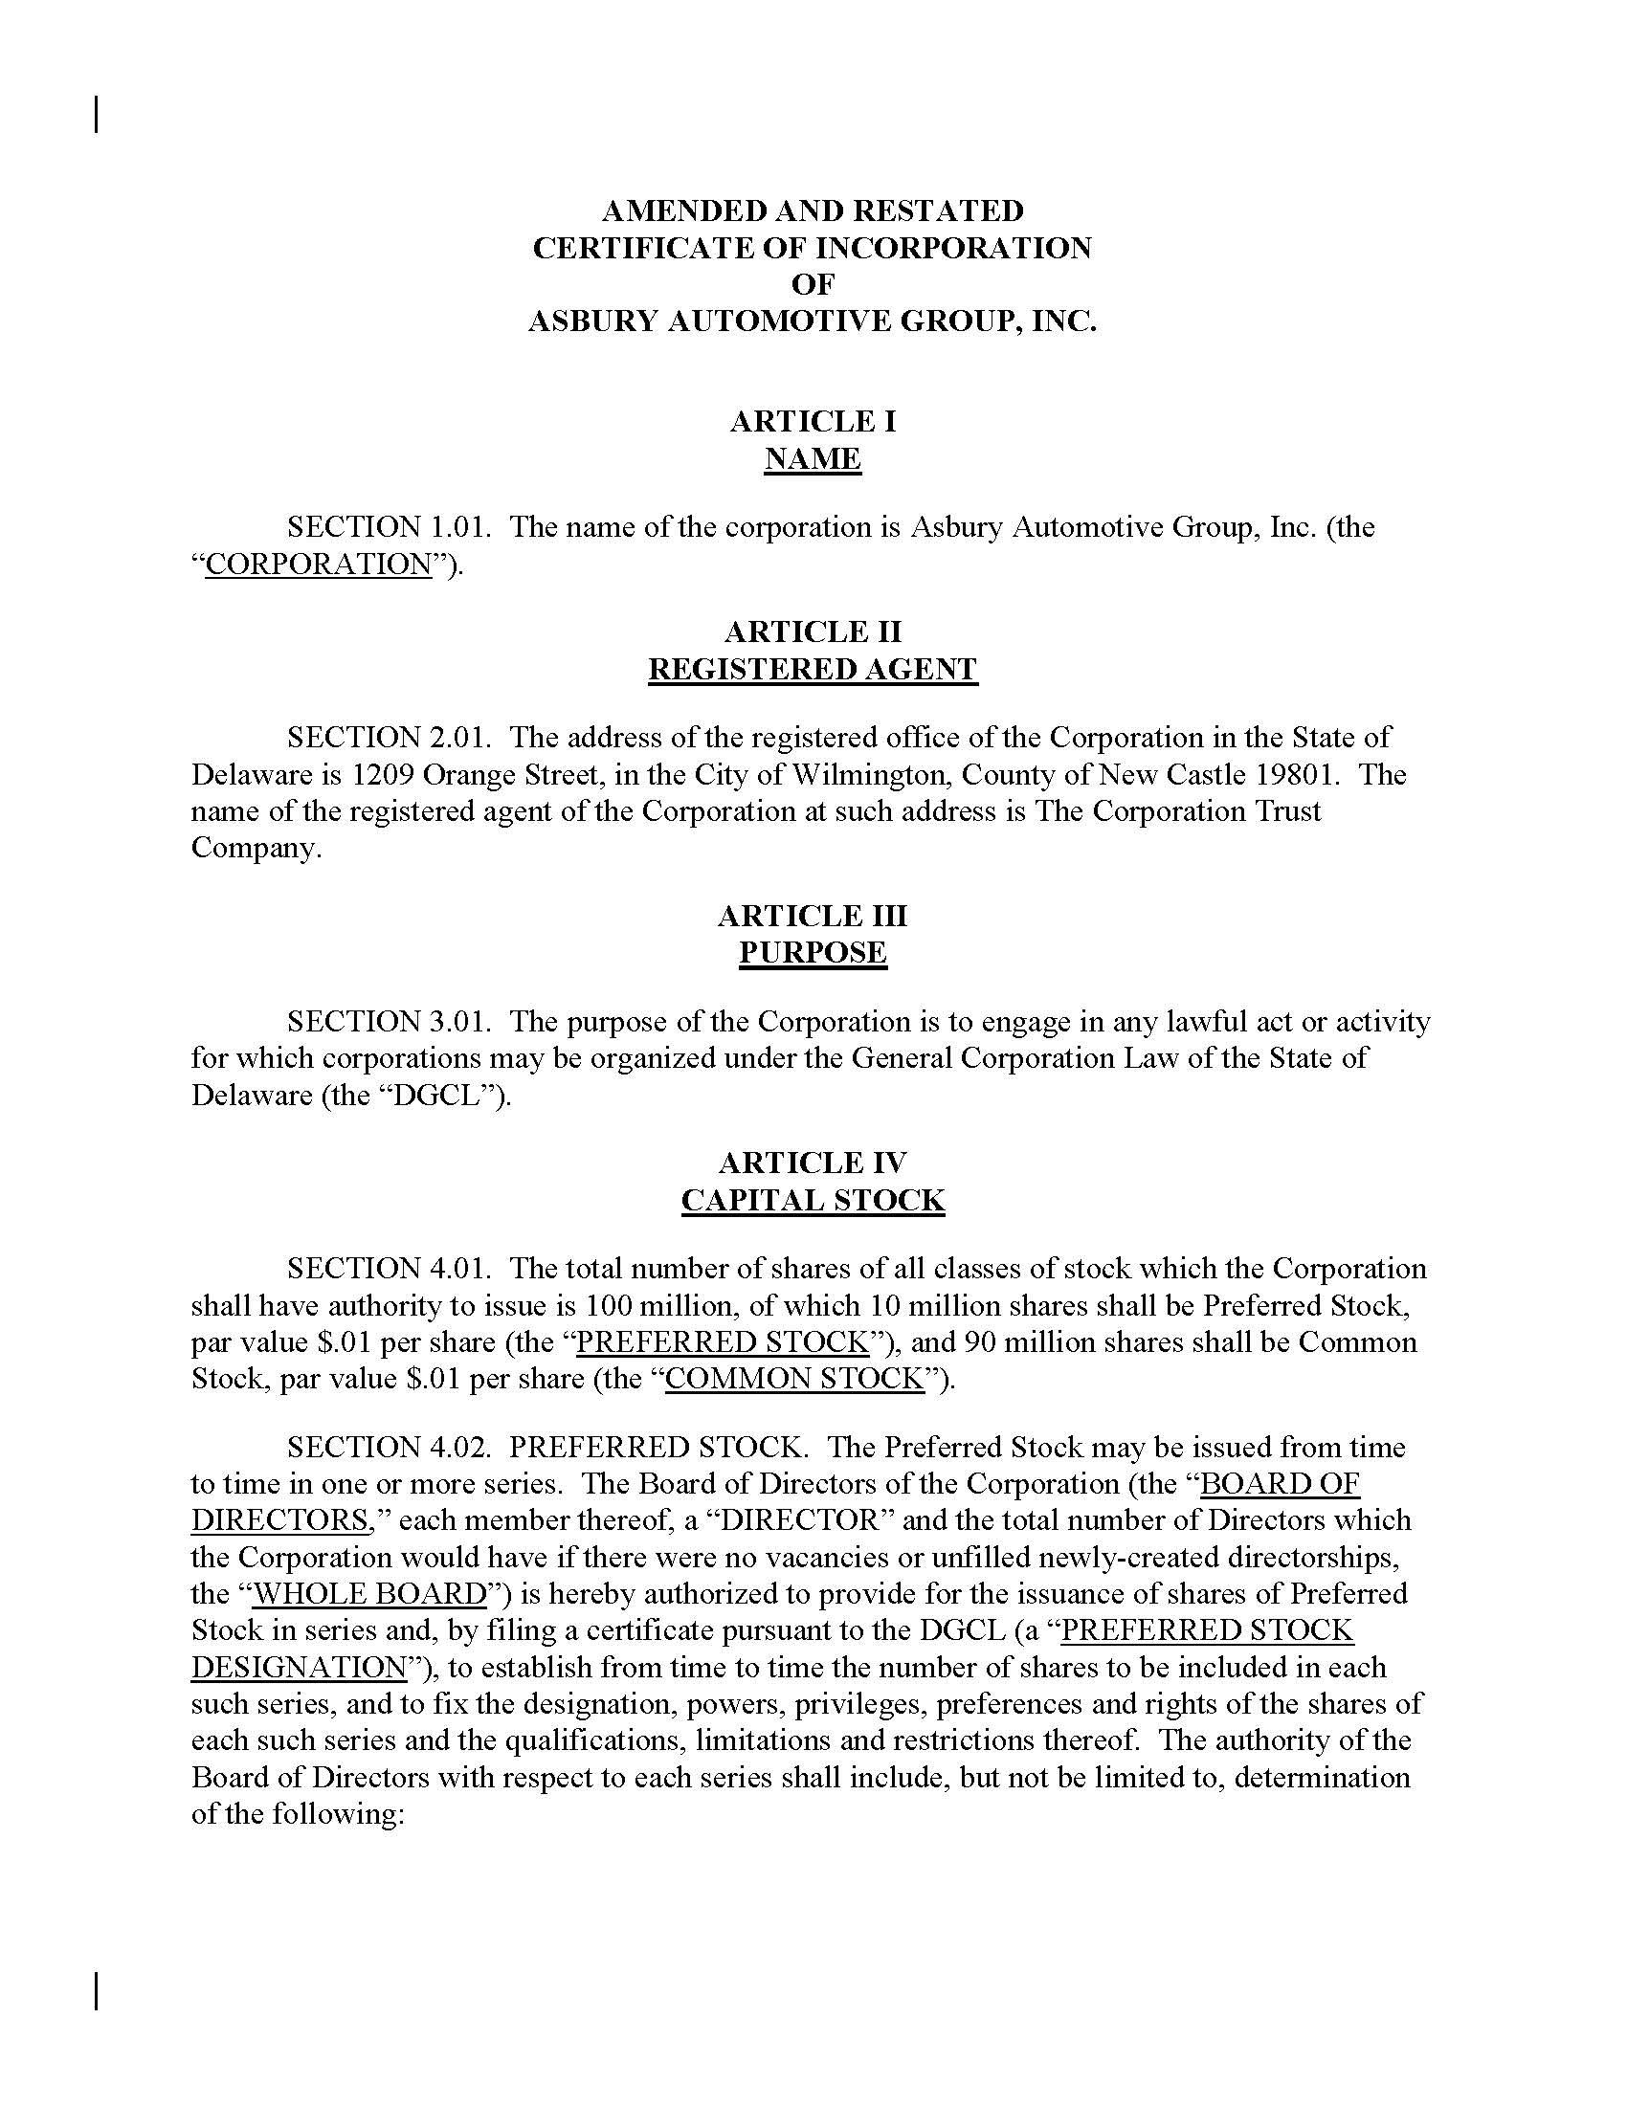

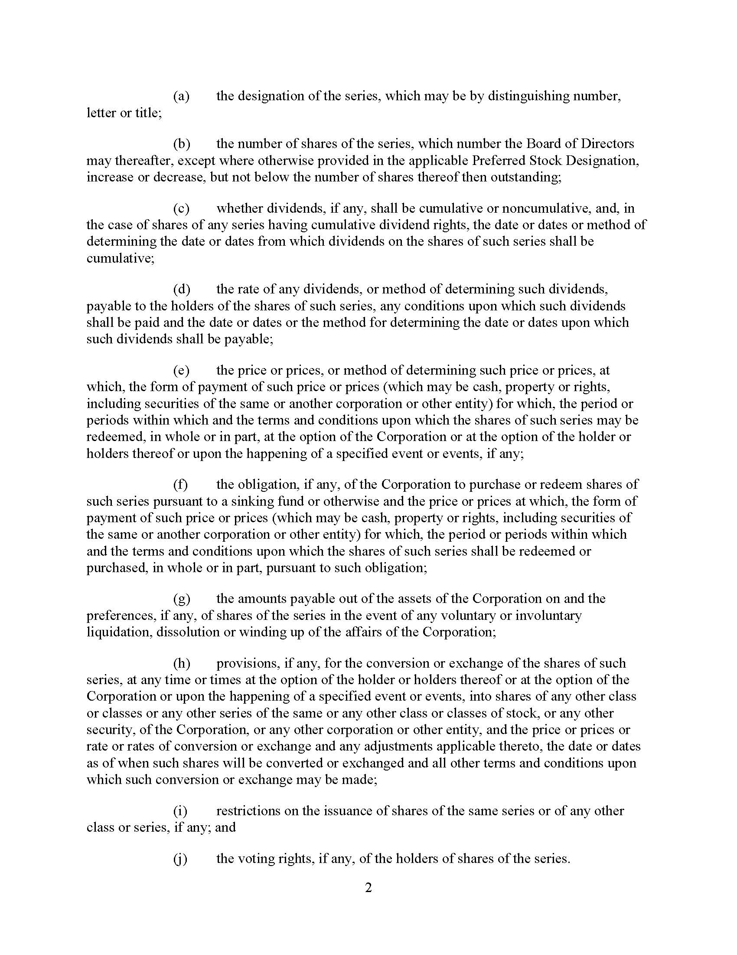
64

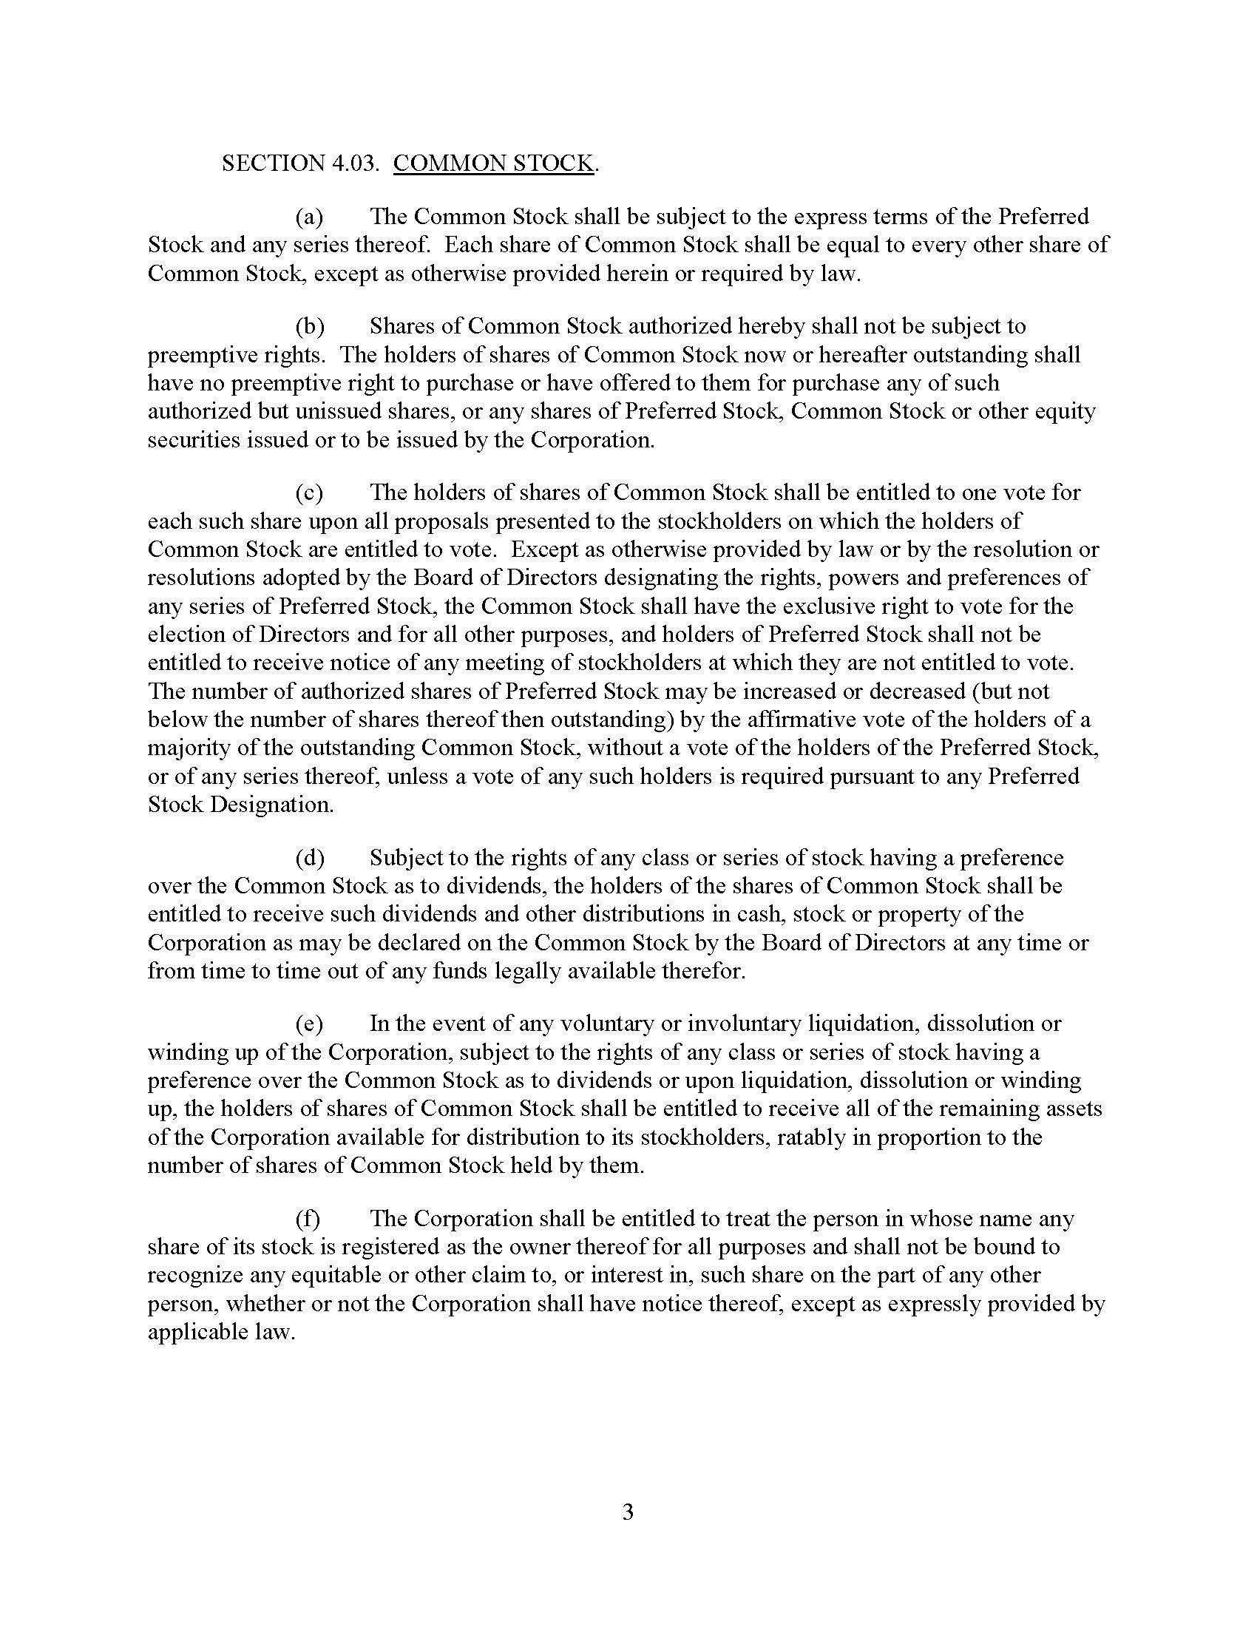
65

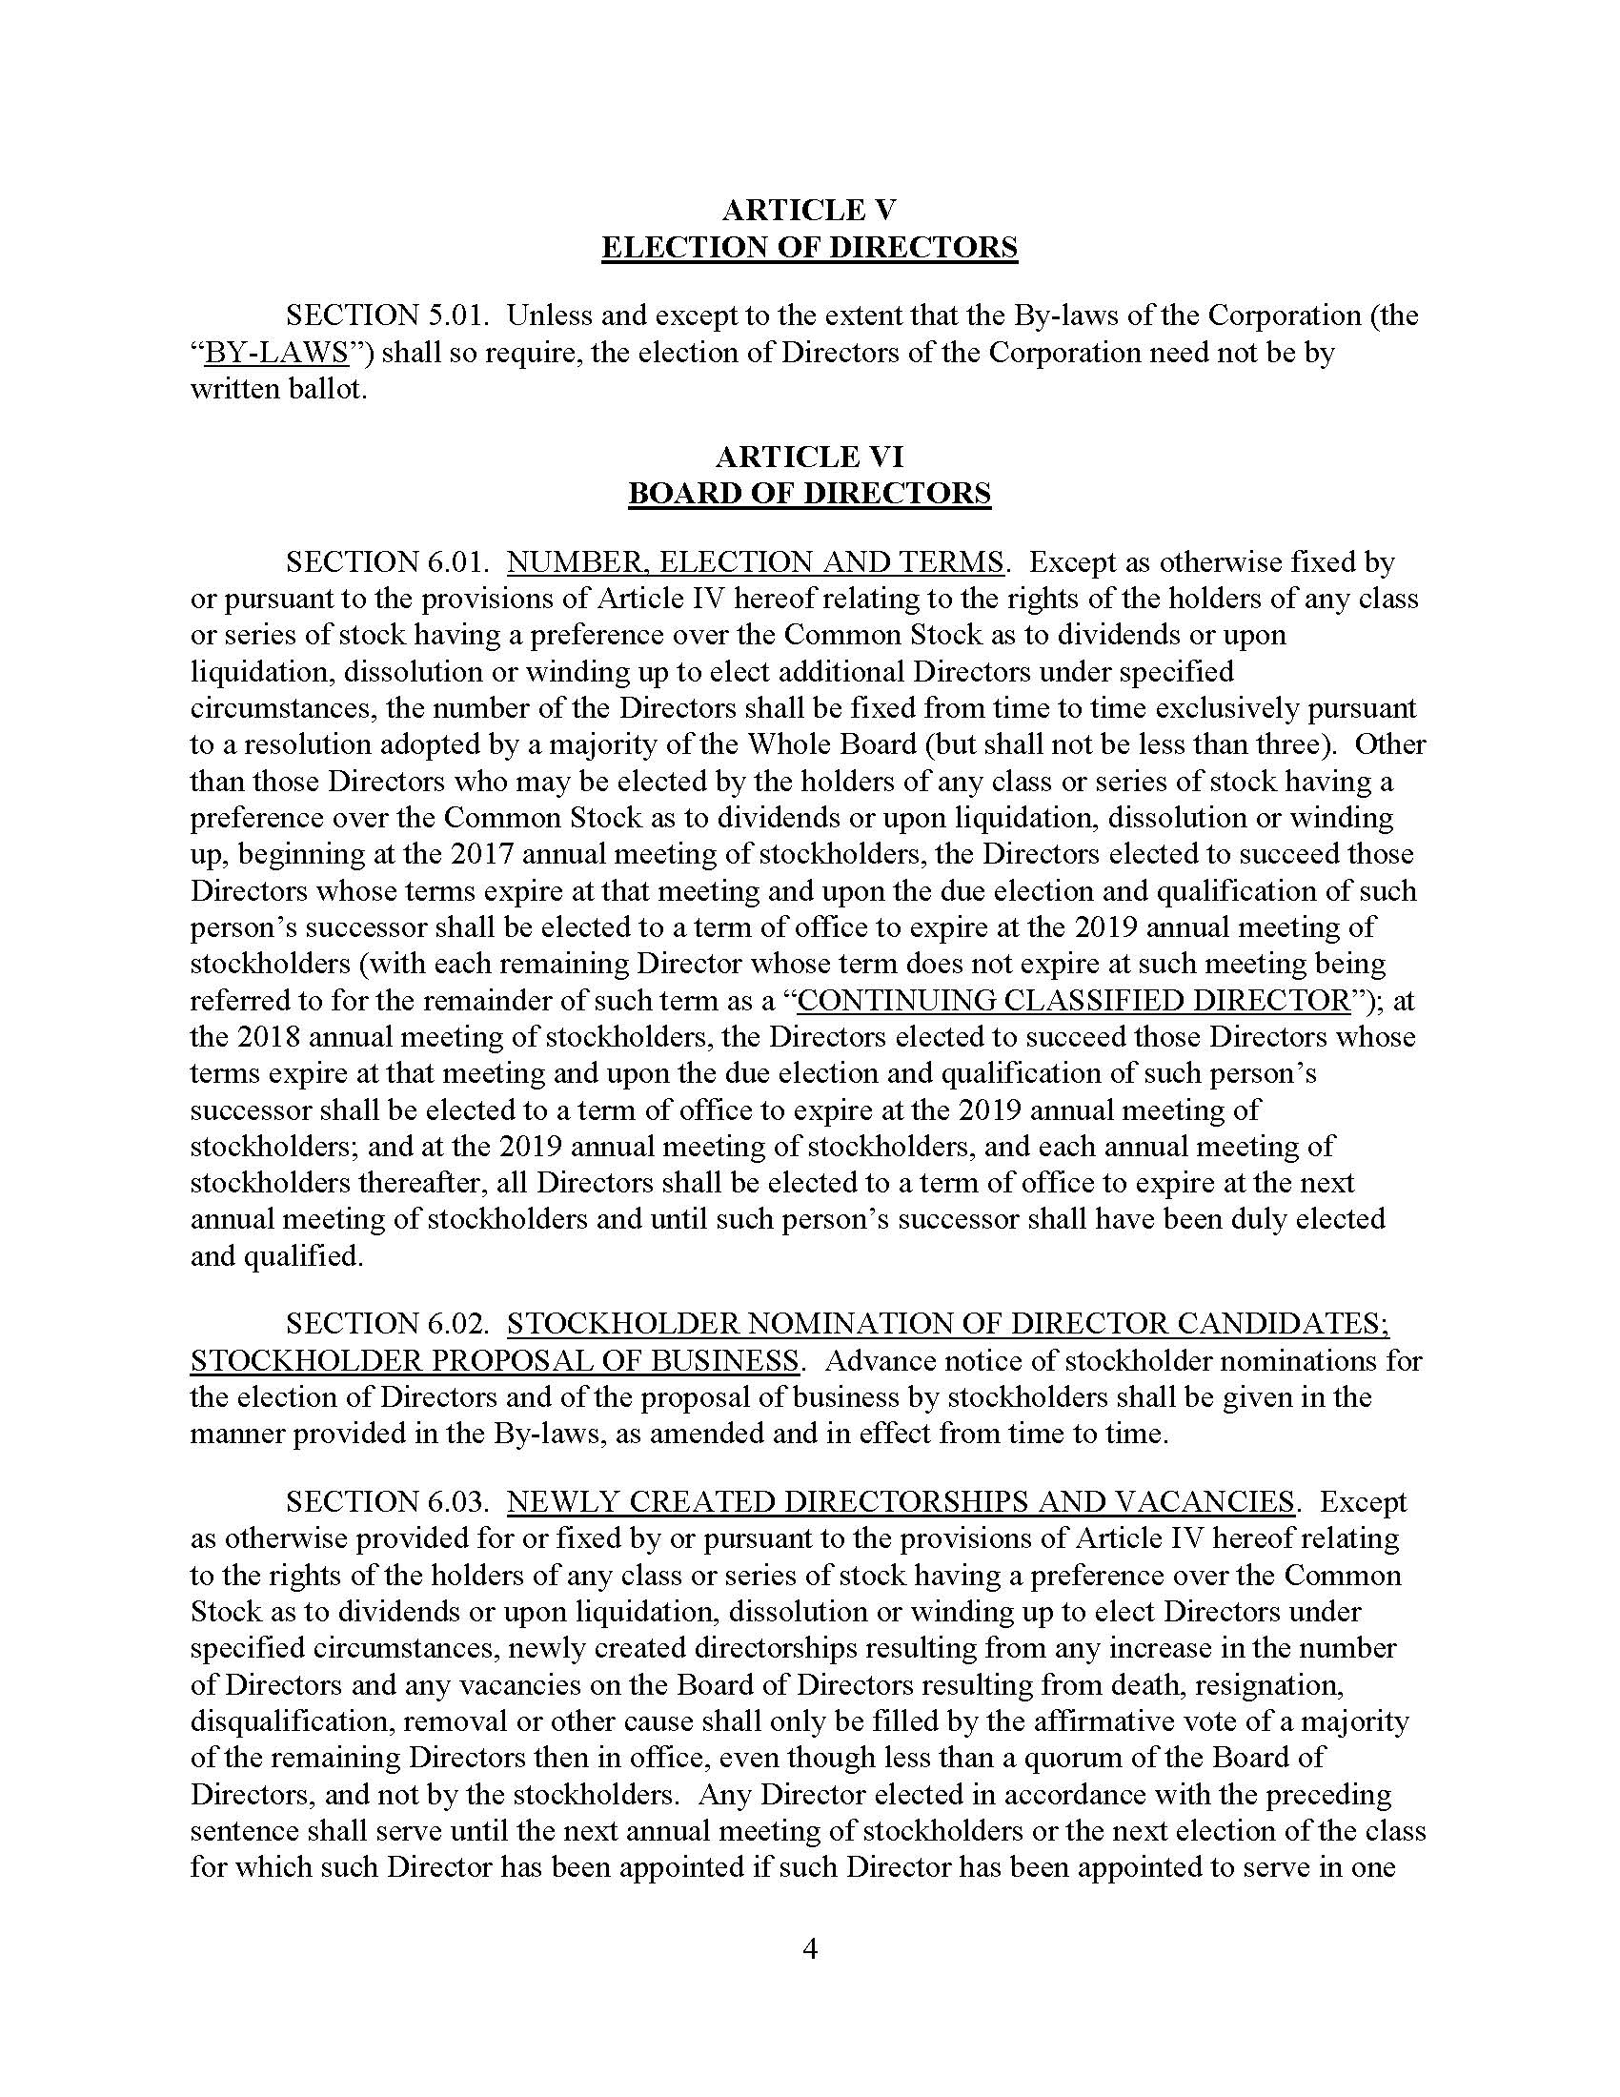
66

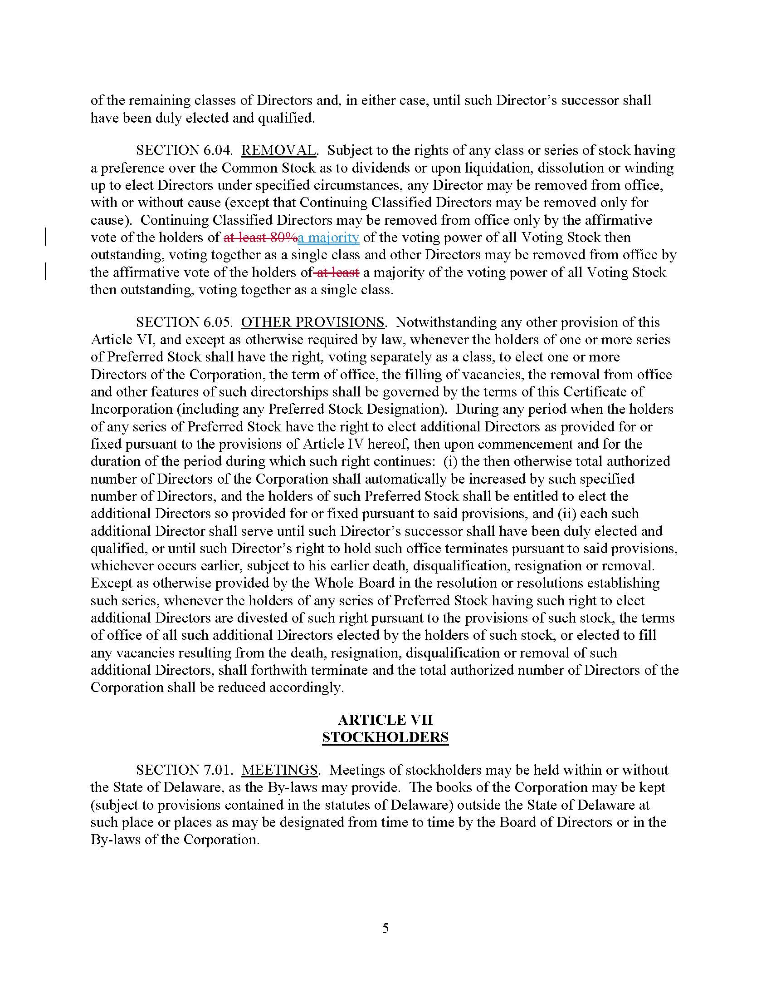
67

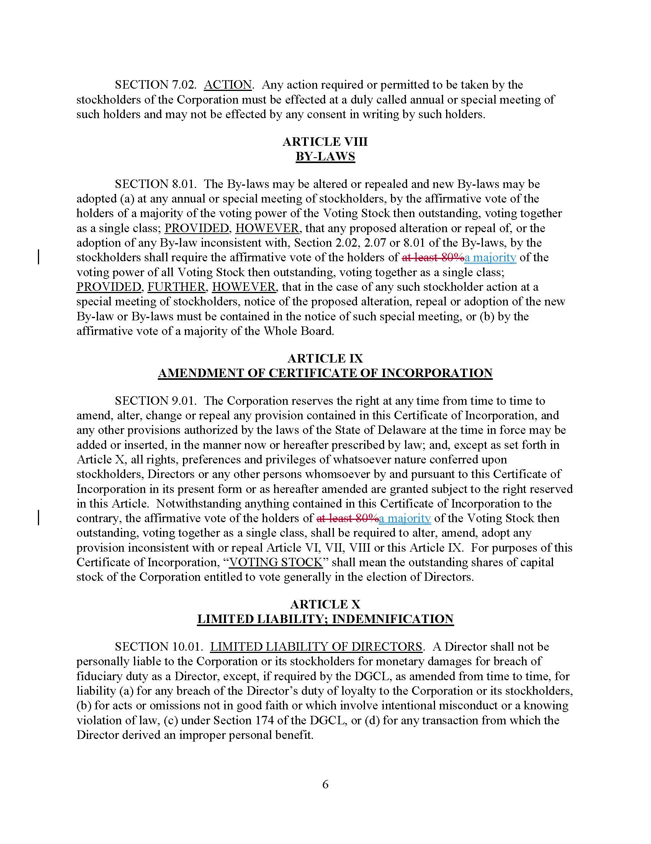
68

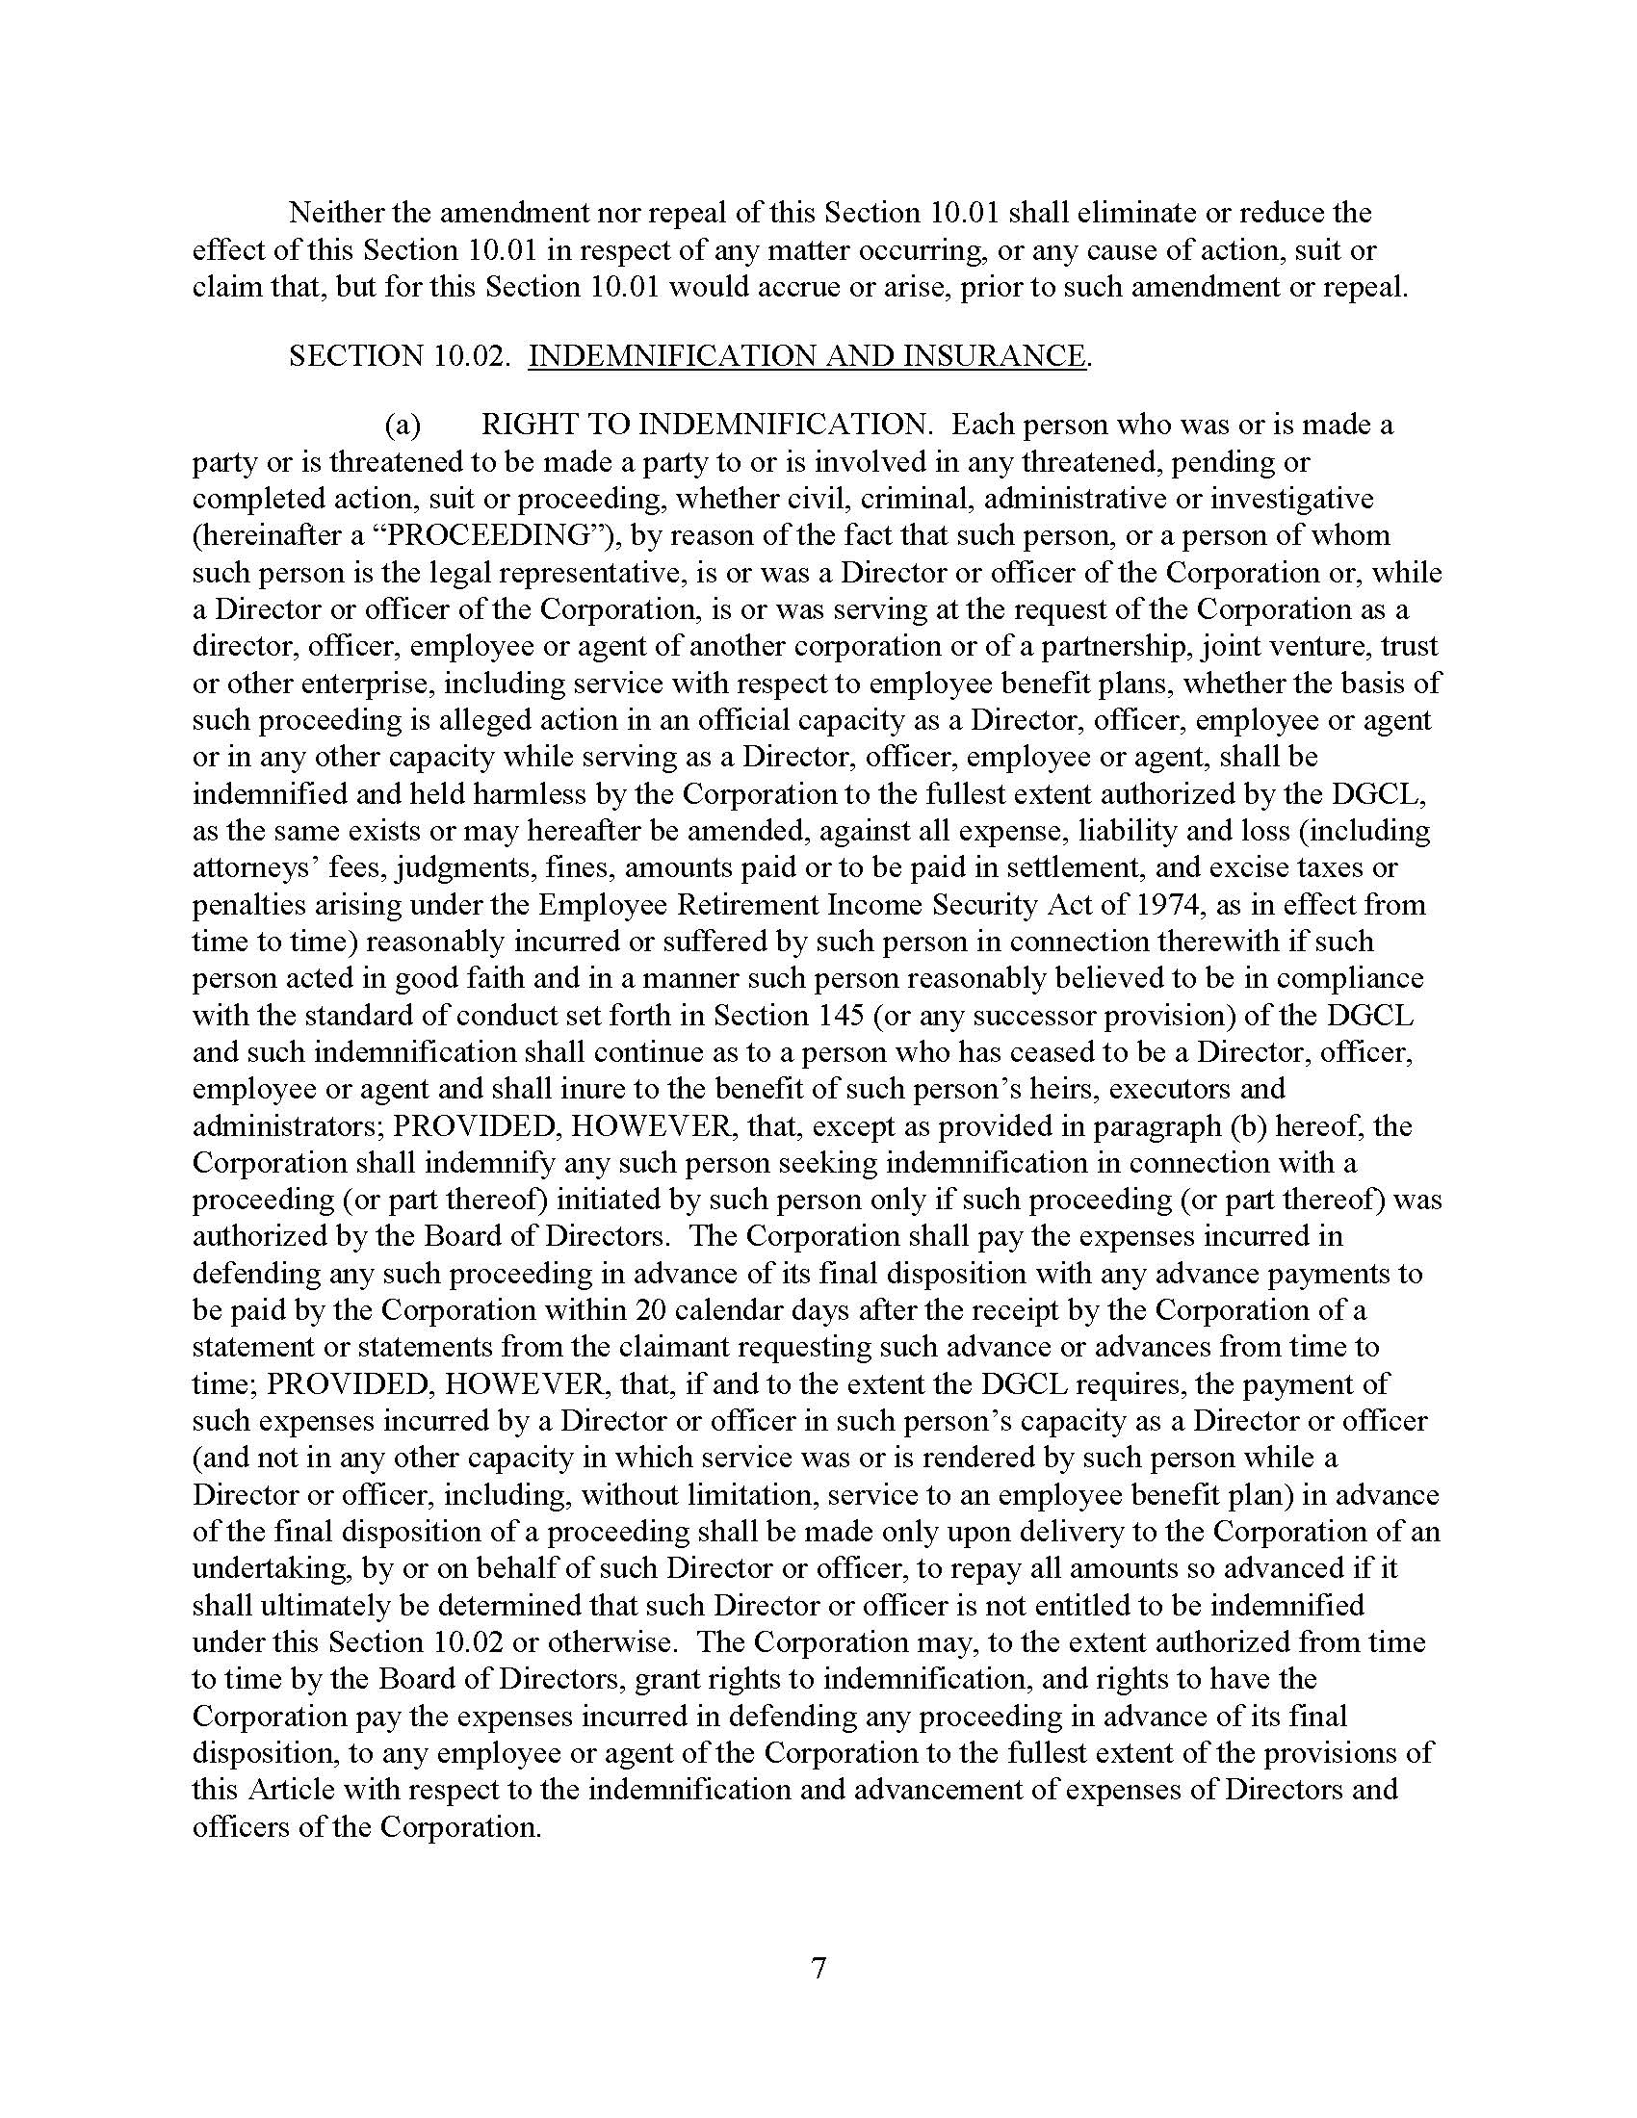
69

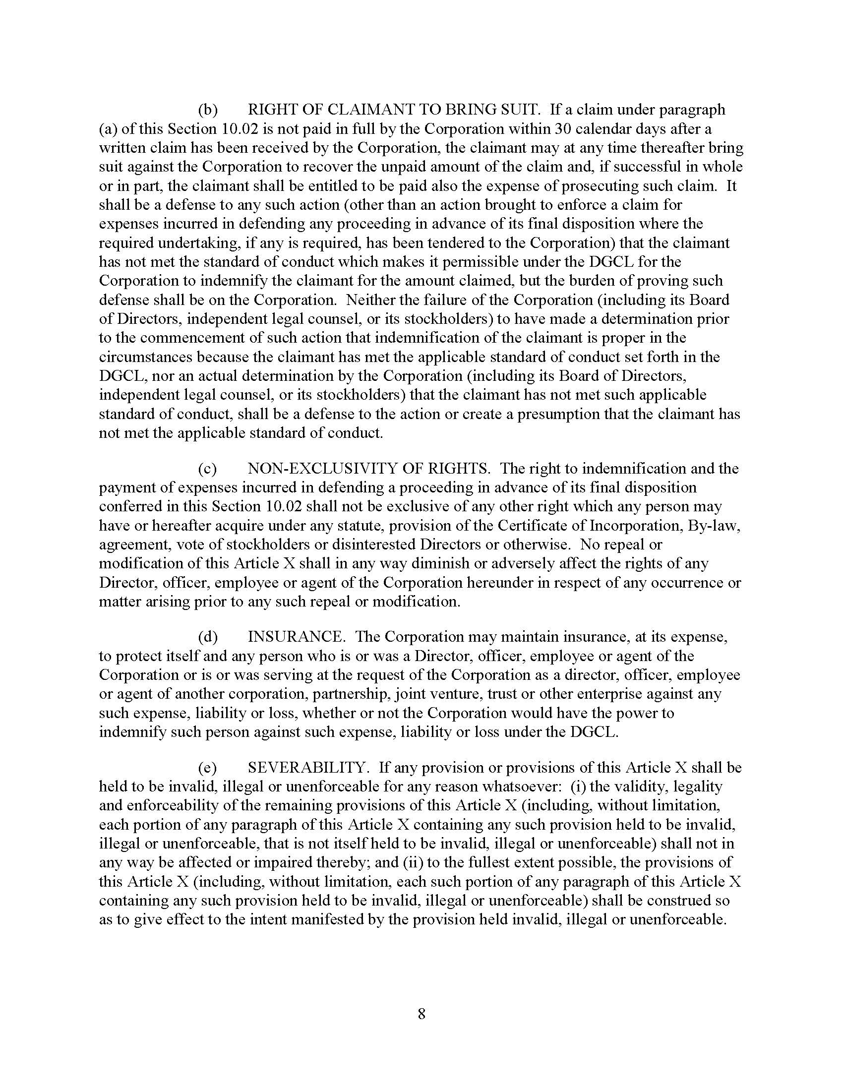

70

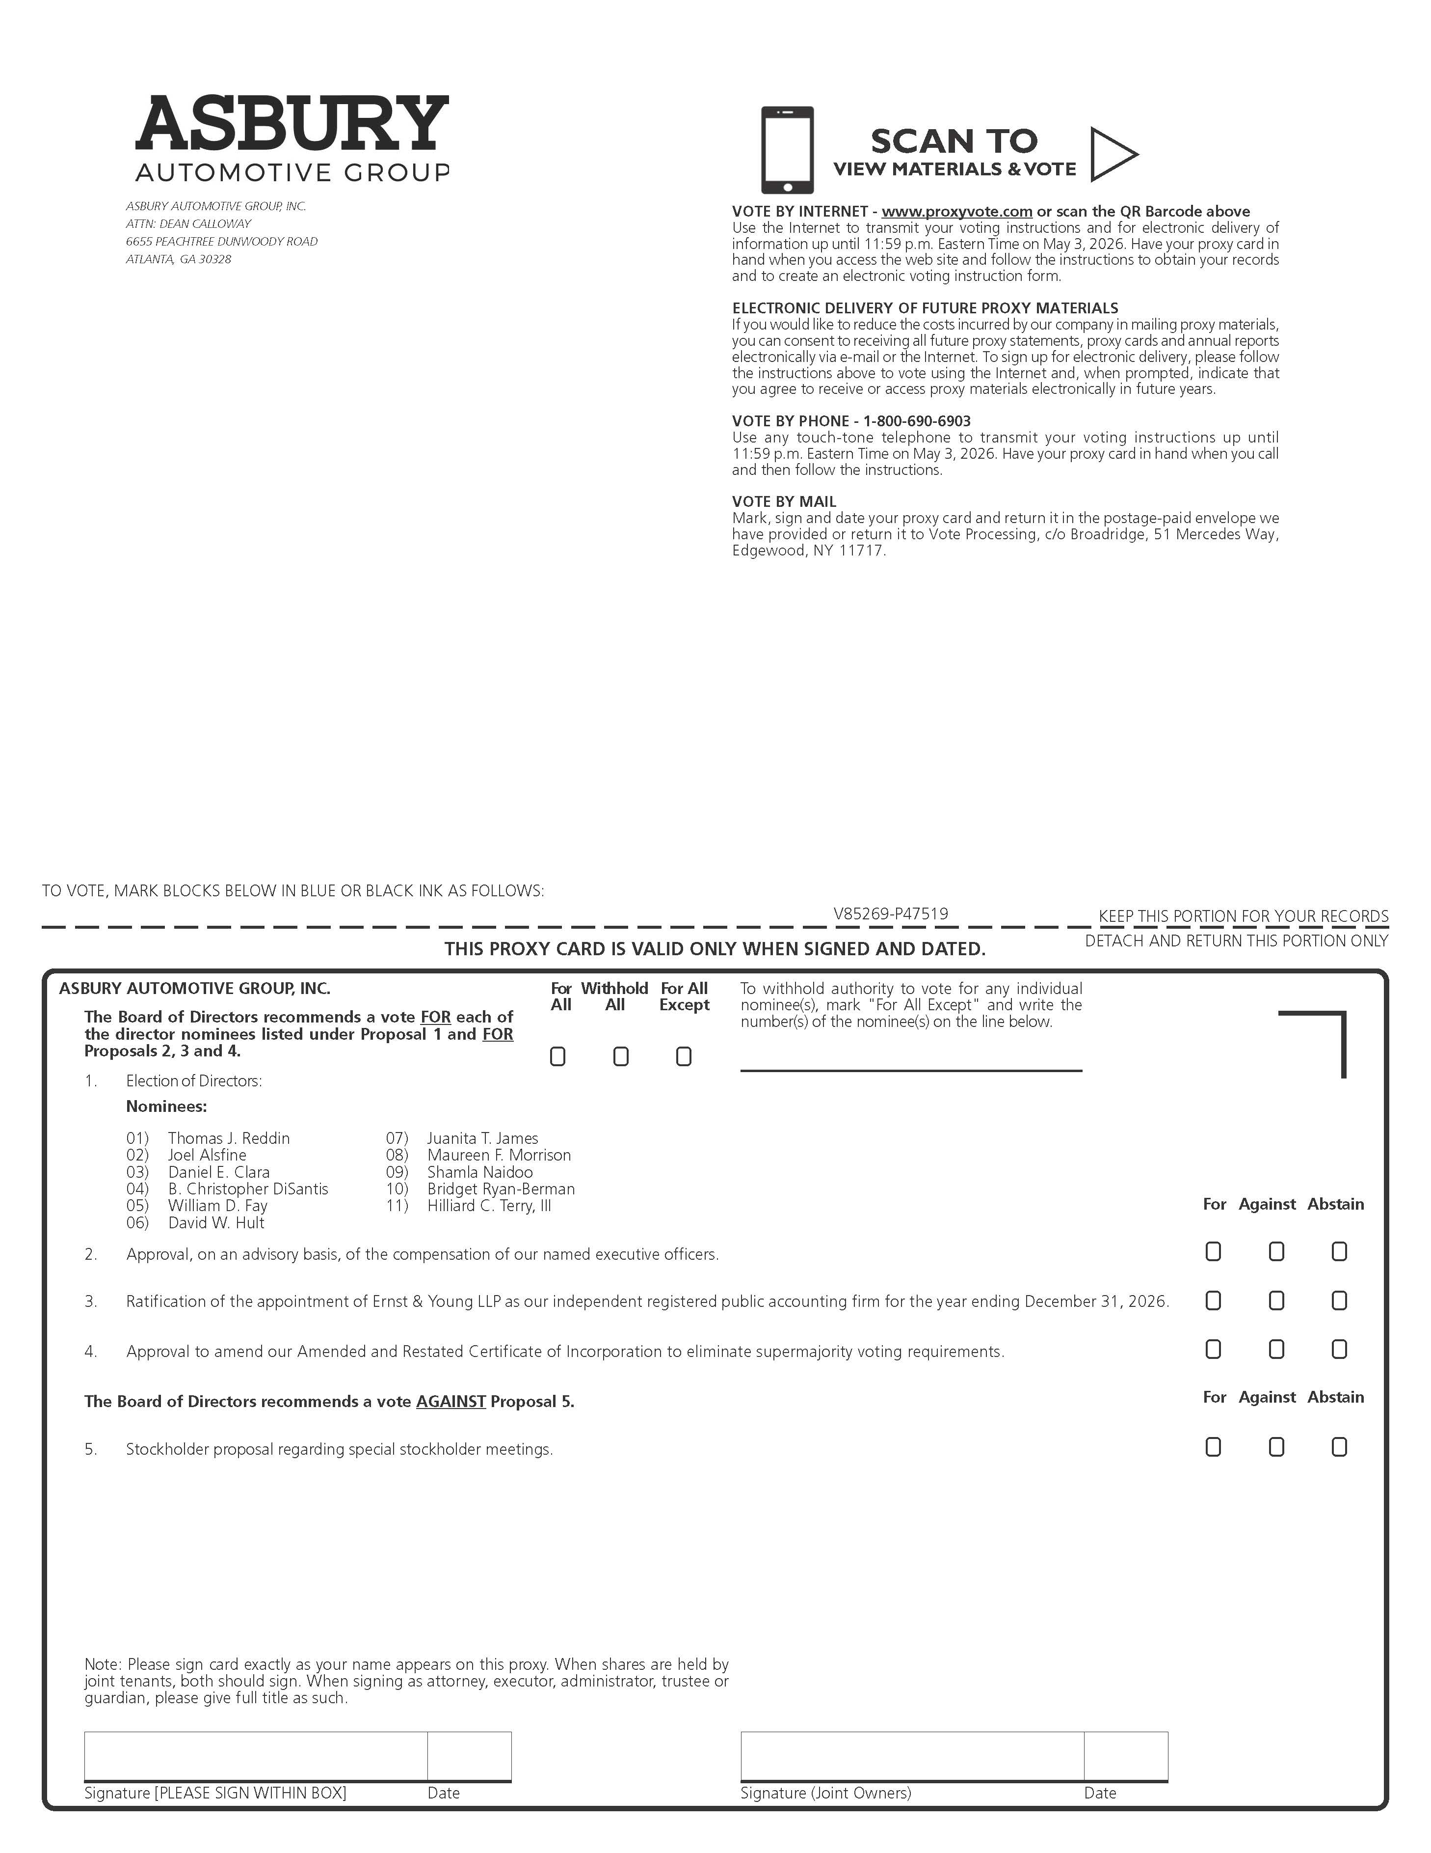
71

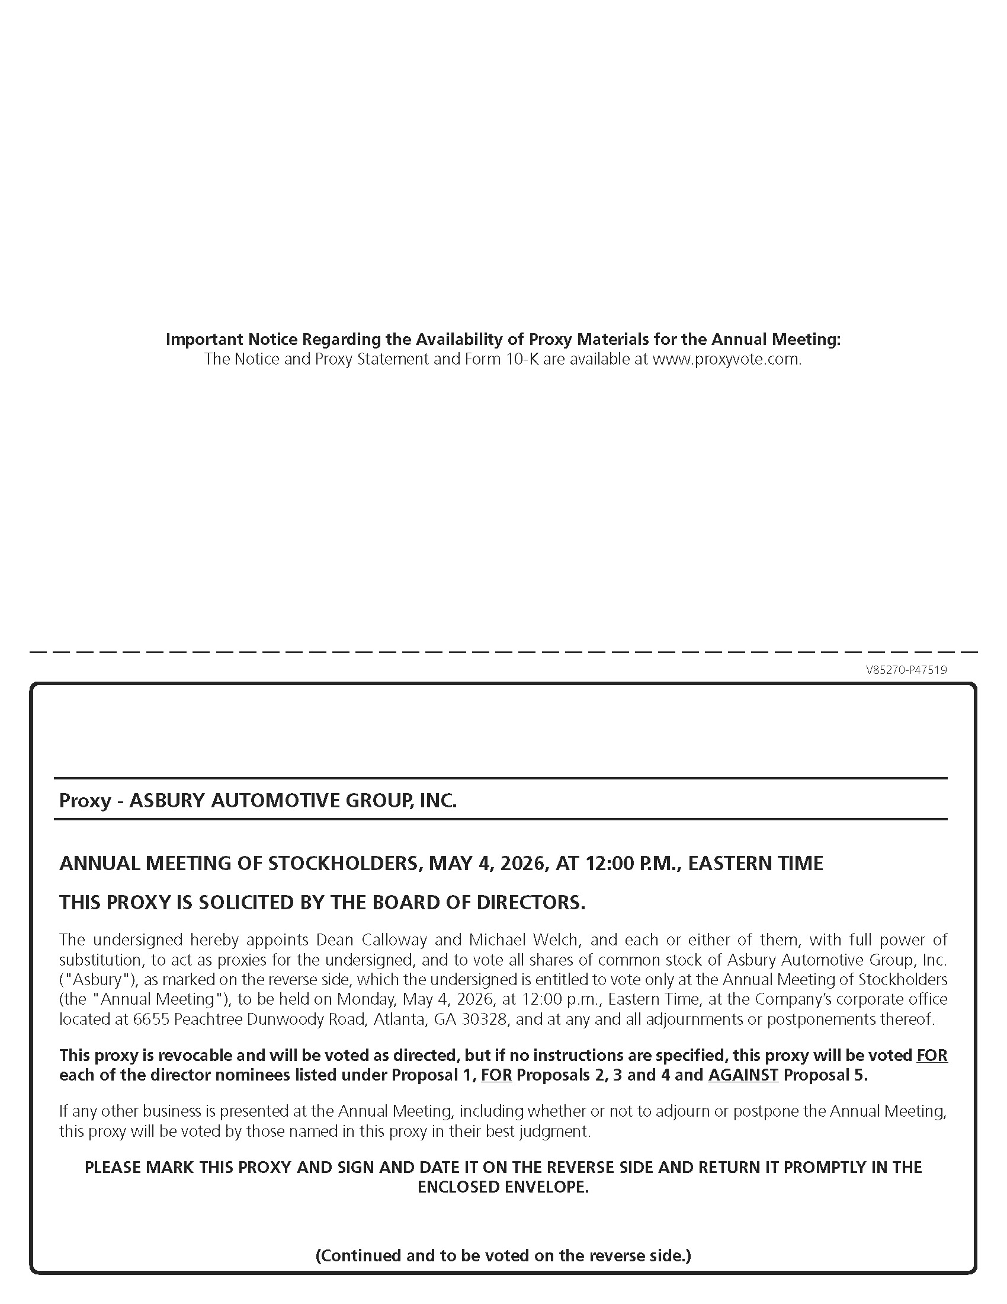
72

